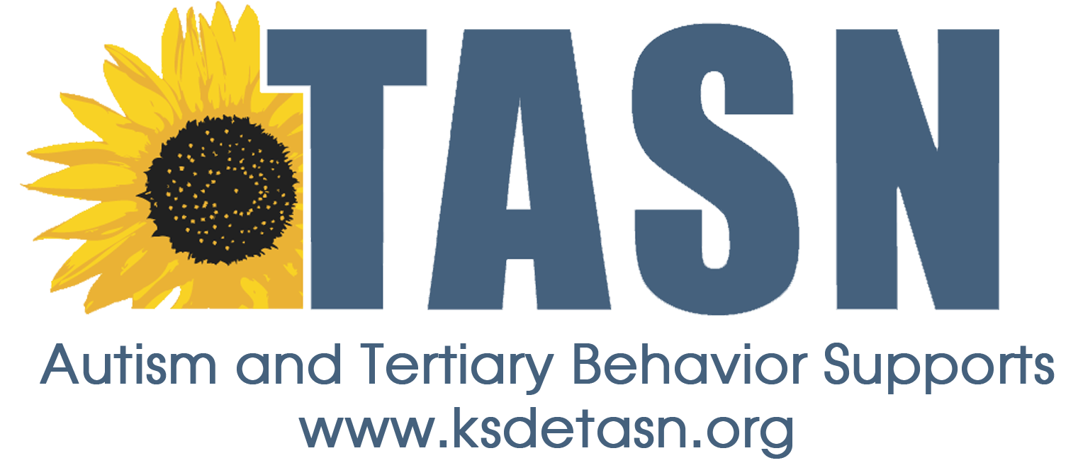
TASN ATBS SCHOOL MENTAL HEALTH INITIATIVE
WEBINAR STUDY QUESTION FORM

Webinar Title: The Interconnected Systems Framework: Integrating Mental Health through Multi-Tiered systems of Positive Behavior Support in Schools
Presenter: Lucille Eber, Ed.D
Webinar Date: April 18, 2017, 45 minutes

To earn a Certificate of Attendance complete and submit the Webinar Study Question Form to JENNIFER HOUSER (jenh@tasnatbs.org ).

1. Name:
2. Email Address:
3. School District:
4. Role (Teacher, para, SLP, etc.):

Study Questions:
- What elements/features of an interconnected system are evident or emerging in your districts/schools?

- What action/steps could move your school(s) towards more efficient and effective integrated ‘behavioral health’ system in your state/district/schools?

