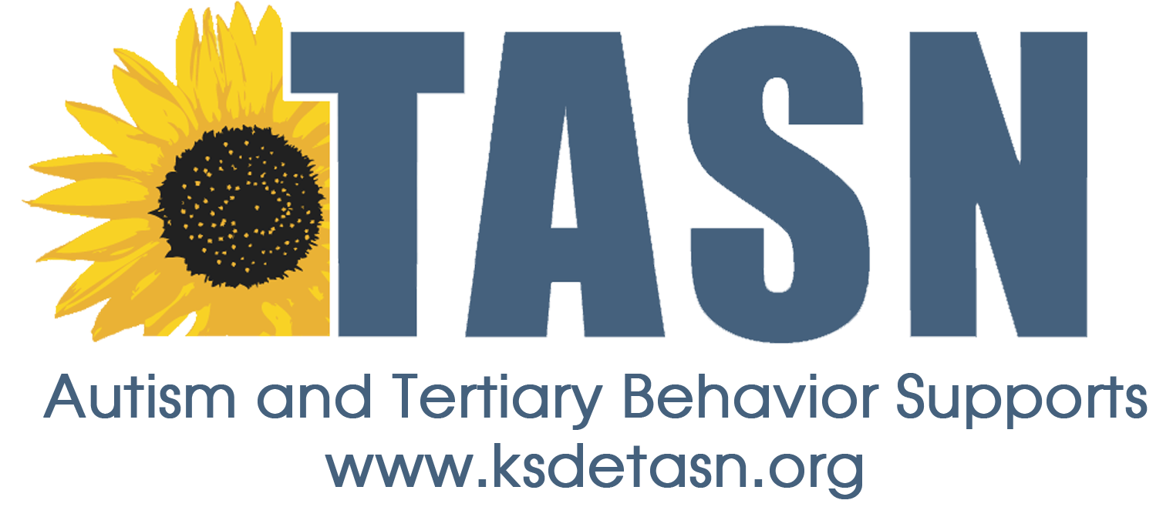
TASN ATBS SCHOOL MENTAL HEALTH INITIATIVE
WEBINAR STUDY QUESTION FORM

Webinar Title: An Integrated Approach to Restorative Practices
Presenter: Ali Berlinski & Sheri Tiamiyu
Webinar Date: April 13, 2017, 45 minutes

To earn a Certificate of Attendance complete and submit the Webinar Study Question Form to JENNIFER HOUSER (jenh@tasnatbs.org ).

1. Name:
2. Email Address:
3. School District:
4. Role (Teacher, para, SLP, etc.):

Study Questions:
- Name three ways Restorative Practices promotes a paradigm shift.

- What are some uses for a community circle?

