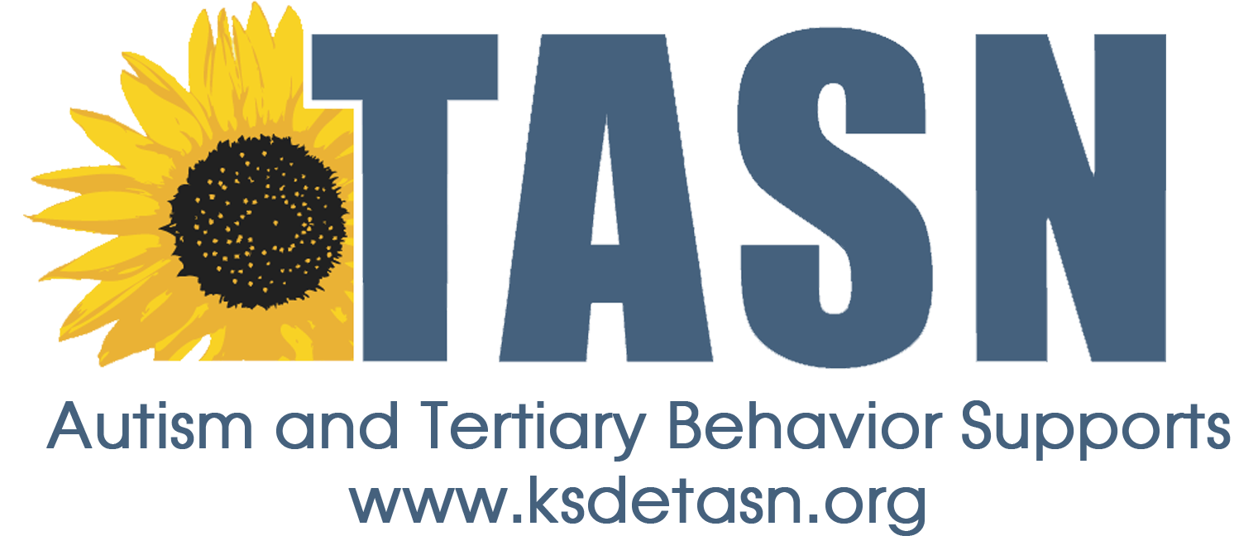
TASN ATBS SCHOOL MENTAL HEALTH INITIATIVE
WEBINAR STUDY QUESTION FORM

Webinar Title: Guidance for Trauma Screening in Schools
Presenter: Eric Rossen, PhD, NCSP & Katie Eklund, PhD, NCSP
Webinar Date: March 30, 2017, 45 minutes

To earn a Certificate of Attendance complete and submit the Webinar Study Question Form to JENNIFER HOUSER (jenh@tasnatbs.org ).

1. Name:
2. Email Address:
3. School District:
4. Role (Teacher, para, SLP, etc.):

Study Questions:
- What are some unintended consequences that you might anticipate from implementing universal trauma screening in your school or district

- Identify at least 5 considerations when determining whether to implement trauma screening

