Milk Manager

(adapted from “Meaningful Jobs” – Scott May, Principal, Apollo Elementary, Goddard, Kansas)
The Kansas vision for education includes postsecondary and career preparation, social engagement, and communication as the foundational structures of education in our schools and classrooms. From simple jobs in the earliest grades through high school internships, meaningful work supports the academic and social competencies that lead to post-school success.
“Meaningful jobs allow students the opportunity to contribute in a way that both the students and the adults see value. Everyone likes to contribute to their family or workplace in meaningful ways. These responsibilities give students with disabilities or behavior concerns the opportunities to have repeated positive interactions with others and learn from those experiences." - Scott May

The ideas and supports included in these resources are ready to be edited to support growth and independence for individual students.

Job Description
The Milk Manager delivers milk to kindergarten students at snack time.
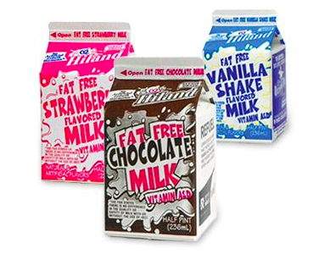

Job Duties
Report to your supervisor
Using the provided checklist, count out how many milk cartons are needed for each classroom
Using the rolling cart, deliver the milk to each classroom
Take inventory of the cartons that are left in the cooler

Sample visual supports
Below are checklists and visual supports that might be used to support the student in preparation for this important school job. Some students will benefit from having a checklist with pictures or photos to complete the steps of the job, while others might only need a checklist with words. As you can see, these steps can easily be modified to fit the needs of the student and to align with the requirements of the job in your school. This job could also include a peer to support the student in social competency skills.

Milk Manager
 | Step: | √
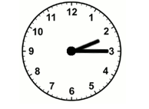 | - Report to Mrs. King at 2:15
 | - Get milk checklist for Class A
 | - Count how many white milks are needed and put on cart
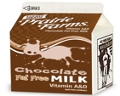 | - Count how many chocolate milks are needed and put on cart
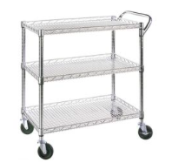 | - Deliver milk cartons to Class A
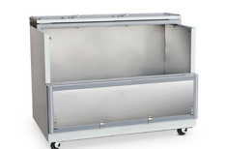 | - Go back to milk cooler
 | - Repeat steps 2-6
 | - Count how many cartons of milk are left in the cooler and write down on inventory sheet
 | - Return to class

Milk Manager Job
Step: | √
- Report to Mrs. King at 2:15
- Get milk checklist for Class A
- Count how many white milks are needed and put on rolling cart
- Count how many chocolate milks are needed and put on rolling cart
- Deliver milk cartons to Class A
- Go back to milk cooler
- Repeat steps 2-6
- Count how many cartons of milk are left in the cooler and write down on inventory sheet
- Return to class

Delivering Milk
When I arrive at the kindergarten classroom I will knock on the door. When the teacher answers the door, I will say “Hi, I’m here to deliver the milk.” I will put the milk cartons on the counter and will roll the cart to the door. If the teacher says, “Thank you” I will say “You’re welcome”. I will roll the cart back to the milk cooler.

The content of this presentation was developed under an agreement from the Federal Department of Education to the Kansas Department of Education. However, those contents do not necessarily represent the policy of the Department of Education, and you should not assume endorsement by the Kansas Department of Education or the Federal Government. TASN Autism and Tertiary Behavior Supports does not discriminate on the basis of race, color, national origin, sex, disability, or age in its’ programs and activities. The following person has been designated to handle inquiries regarding the non-discrimination policies: Deputy Director, Keystone Learning Services, 500 E. Sunflower, Ozawkie, KS 66070, 785-876-2214.

