Gardener/Landscaper

(adapted from “Meaningful Jobs” – Scott May, Principal, Apollo Elementary, Goddard, Kansas)

The Kansas vision for education includes postsecondary and career preparation, social engagement, and communication as the foundational structures of education in our schools and classrooms. From simple jobs in the earliest grades through high school internships, meaningful work supports the academic and social competencies that lead to post-school success.

“Meaningful jobs allow students the opportunity to contribute in a way that both the students and the adults see value. Everyone likes to contribute to their family or workplace in meaningful ways.  These responsibilities give students with disabilities or behavior concerns the opportunities to have repeated positive interactions with others and learn from those experiences."  - Scott May

The ideas and supports included in these resources are ready to be edited to support growth and independence for individual students.

# Job Description

The gardener/landscaper plants, waters, and takes care of plants inside of and outside of the school.

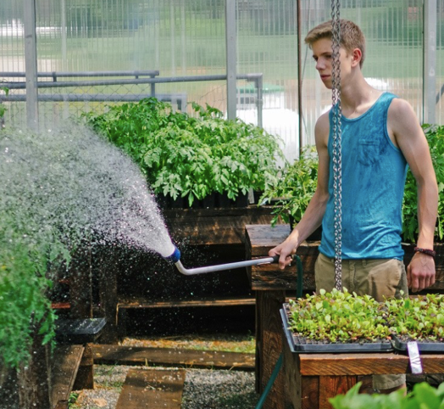

**Job Duties**

|  |  |
| --- | --- |
|  | Report to the supervisor for your job assignment |
|  | Water plants in office and lobby |
|  | Check for dead leaves and trim |
|  | Water plants outside (seasonal) |
|  | Plant seeds/plants (seasonal) |
|  | Fertilize and mulch outside plants (seasonal) |

**Sample of watering and pruning checklist**

This job could be a daily or weekly task and could be done in collaboration with peers. The student can use a checklist to record when watering and/or pruning is completed.

|  |  |
| --- | --- |
| Week of 9/4 | |
|  |  |
|  | Lobby: water and prune plants |
|  | Office: water and prune plants |
|  | Pots outside front doors: water and prune plants |
|  | Plants by school sign: water and prune plants |

**Sample visual supports**

**(Used with permission from** [**2017 EduLync LLC**](http://www.edulync.com/?utm_source=TASN)**)**

Below are checklists and visual supports that might be used to support the student in preparation for this important school job. Some students will benefit from having a checklist with pictures or photos to complete the steps of the job, while others might only need a checklist with words. As you can see, these steps can easily be modified to fit the needs of the student and to align with the requirements of the job in your school.

**Watering Plants Checklist**

\_\_\_\_Fill watering can to the **FILL** line

\_\_\_\_Water Plant #**1**

\_\_\_\_Water Plant #**2**

\_\_\_\_Water Plant #**3**

\_\_\_\_Empty watering can in sink

\_\_\_\_Put watering can away

**Watering Plants Checklist**

\_\_\_\_Fill watering can to the line 

\_\_\_\_Water Plant #**1 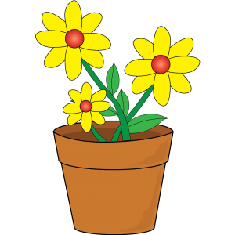**

\_\_\_\_Water Plant #**2 **

\_\_\_\_Empty watering can in sink 

\_\_\_\_Put watering can away 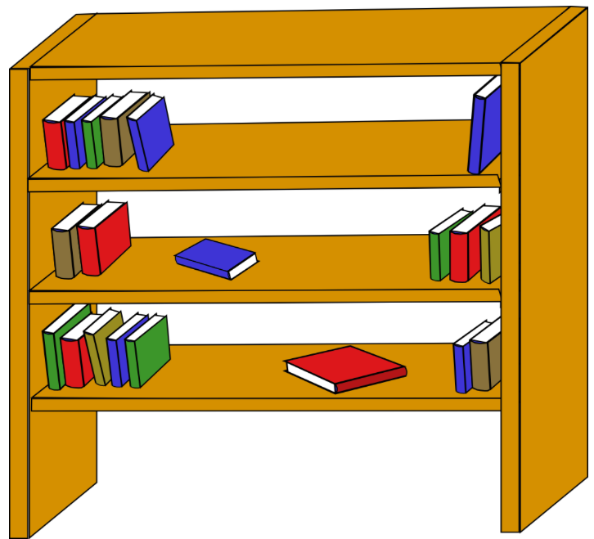

**Watering Plants Checklist**

\_\_\_\_Fill bucket to line 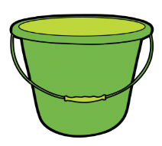

\_\_\_\_Get cup 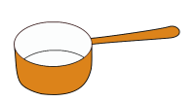

\_\_\_\_1 scoop in Plant #**1 **

\_\_\_\_3 scoops in Plant #**2 **

\_\_\_\_Empty bucket in sink 

\_\_\_\_Put bucket and cup away 

The icons below could be used in checklists with words like those seen above, or by themselves as shown in the photos here.

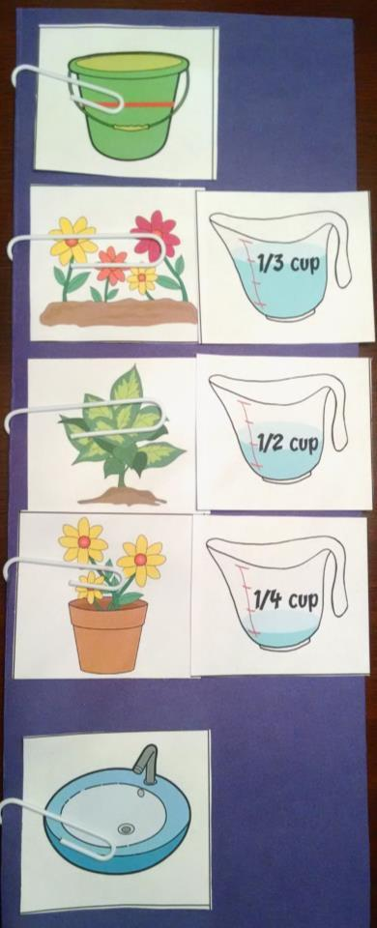 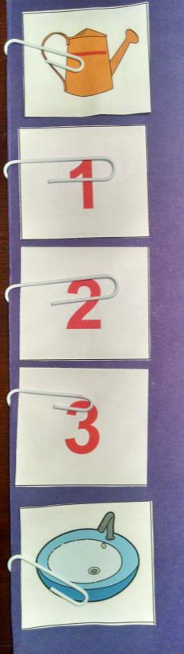

The plant supplies and plants might also be labeled to coordinate with the visual support the student is using.

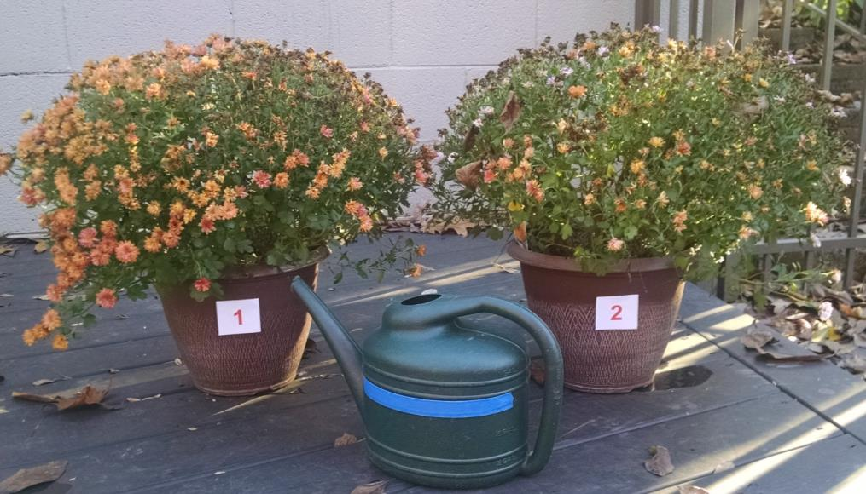 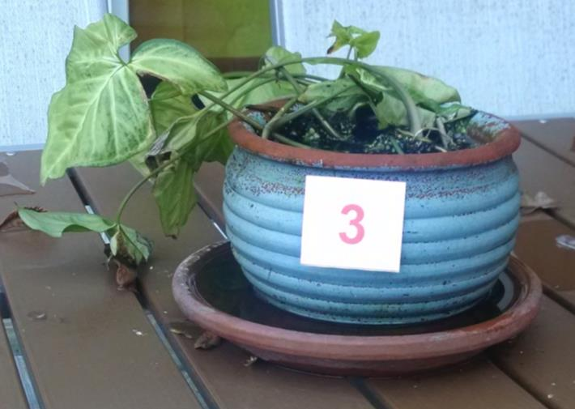

|  |  |  |
| --- | --- | --- |
| yard-watering can | action-words-water plants_02 | action-words-water plants |
| flowerpot | flower bed | plants-plant |
| action-words-water plants_03 | water plants | water flowers |
| 1 | 2 | 3 |

|  |  |  |
| --- | --- | --- |
|  | home-bucket_04 | home-sink bathroom_02 |
| measure-measuring cup | measure-measuring cup | measure-measuring cup |
| measure-one third cup | measure-one third cup | measure-one third cup |
| **4** | **5** | **6** |

A flip book could also be created to show the student the task one step at a time. Real photos or the icons shown below could be used.

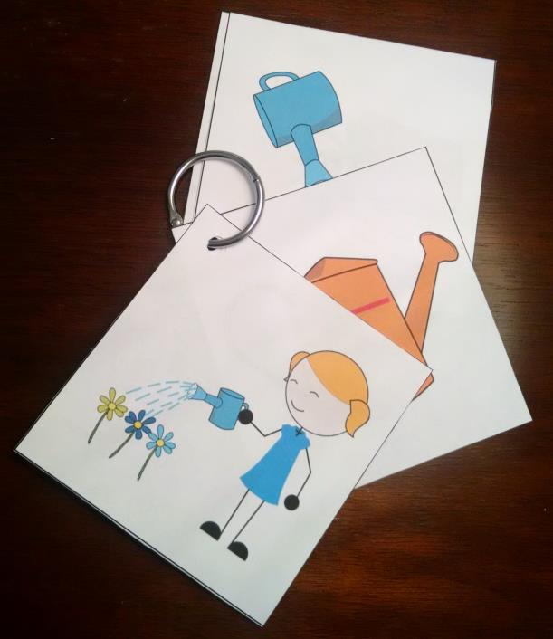

|  |  |
| --- | --- |
|  | flowerpot |
| action-words-water plants | Copy and re-size images from the previous slides or customize and use your own images. |

|  |  |
| --- | --- |
| **1** | **2** |
| **3** | Copy and re-size images from the previous slides or customize and use your own images. |



The content of this presentation was developed under an agreement from the Federal Department of Education to the Kansas Department of Education.  However, those contents do not necessarily represent the policy of the Department of Education, and you should not assume endorsement by the Kansas Department of Education or the Federal Government. TASN Autism and Tertiary Behavior Supports does not discriminate on the basis of race, color, national origin, sex, disability, or age in its’ programs and activities.  The following person has been designated to handle inquiries regarding the non-discrimination policies:  Deputy Director, Keystone Learning Services, 500 E. Sunflower, Ozawkie, KS  66070, 785-876-2214.