Fire Drill Assistant

(adapted from “Meaningful Jobs” – Scott May, Principal, Apollo Elementary, Goddard, Kansas)
The Kansas vision for education includes postsecondary and career preparation, social engagement, and communication as the foundational structures of education in our schools and classrooms. From simple jobs in the earliest grades through high school internships, meaningful work supports the academic and social competencies that lead to post-school success.
“Meaningful jobs allow students the opportunity to contribute in a way that both the students and the adults see value. Everyone likes to contribute to their family or workplace in meaningful ways. These responsibilities give students with disabilities or behavior concerns the opportunities to have repeated positive interactions with others and learn from those experiences." - Scott May

The ideas and supports included in these resources are ready to be edited to support growth and independence for individual students.

Job Description
The Fire Drill Assistant helps the principal hold monthly fire drills.

Job Duties
Report to the principal on the first day of each month to find out the date and time of the fire drill for that month.
On the day of the fire drill:
Report to the principal to pick up the fire drill procedures list and walkie-talkie
Notify classrooms with students who have special needs
When the principal gives the direction, the fire drill assistant pulls the alarm
Walk with the principal to complete the drill tasks
Consult with the principal to determine which class did the best job of following directions
Return all fire drill materials to the office and complete written report with results of the drill

Sample visual supports
Below is a social narrative and checklist that might be used to support the student in preparation for this important school job. Some students will benefit from having a checklist with visual pictures or photos to complete the steps of the job on the day of the fire drill. As you can see, these steps can easily be modified to fit the needs of the student and to align with the requirements of the job in your school.

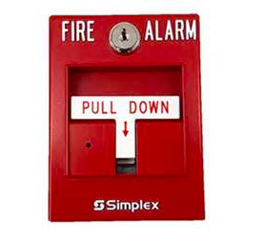
Fire Drill Assistant Job
I will be the Fire Drill Assistant for the months of August, September, and October. On the first day of each of these months I will need to check in with Mr. Dean to find out the date and time of that month’s fire drill. When I go see Mr. Dean, I will say “Mr. Dean, I am here to find out the date and time of this month’s fire drill”. When he tells me the date and time I will write it down on a sticky note. When I get back to class I will write it in my planner. This will help me remember when to report for my job. This checklist will help me remember the steps:
- Report to Mr. Dean on the first day of the month. _____
- Ask Mr. Dean the date of the fire drill. _____
- Ask Mr. Dean the time of the fire drill. _____
- Write the date and time on a sticky note. _____
- Write the date and time in my planner. _____

Fire Drill Assistant Job
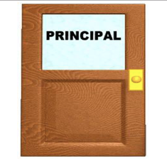 | - Report to Mr. Dean’s office
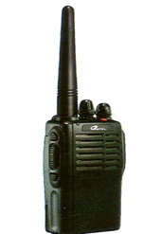 | - Pick up walkie-talkie
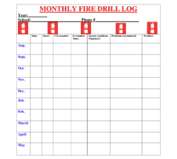 | - Pick up fire drill procedures checklist
 | - Walk to Mrs. Anderson’s and Mr. Bond’s room and say, “There will be a fire drill today at ______.”
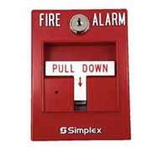 | - When Mr. Dean says “go”- pull the fire alarm
 | - Walk with Mr. Dean to complete fire drill tasks
 | - Talk with Mr. Dean to decide which class did the best job of following directions
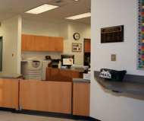 | - Take walkie-talkie back to office and put in cabinet
 | - Finish fire drill procedures checklist with results of the drill and put on Mr. Dean’s desk
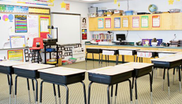 | - Return to class

The content of this presentation was developed under an agreement from the Federal Department of Education to the Kansas Department of Education. However, those contents do not necessarily represent the policy of the Department of Education, and you should not assume endorsement by the Kansas Department of Education or the Federal Government. TASN Autism and Tertiary Behavior Supports does not discriminate on the basis of race, color, national origin, sex, disability, or age in its’ programs and activities. The following person has been designated to handle inquiries regarding the non-discrimination policies: Deputy Director, Keystone Learning Services, 500 E. Sunflower, Ozawkie, KS 66070, 785-876-2214.

