Burns, David D. Feeling Good: The New Mood Therapy. Quill, 2000.

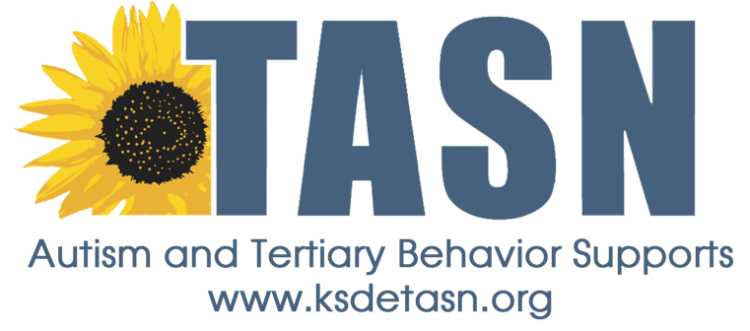

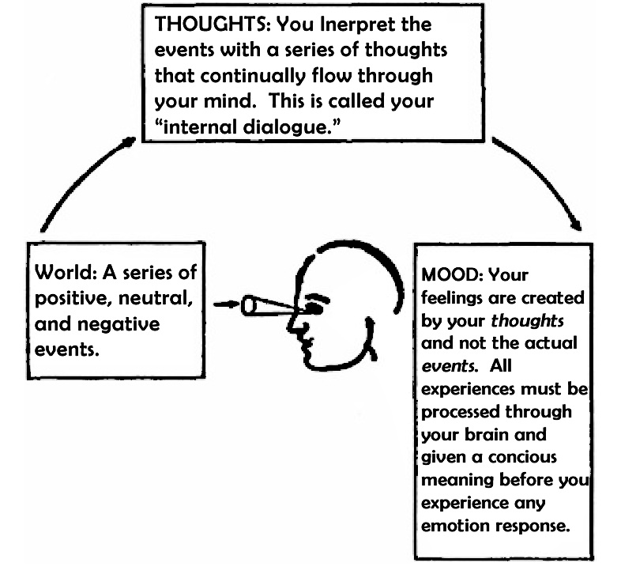
This Photo by Unknown Author is licensed under CC BY-SA

Burns, David D. Feeling Good: The New Mood Therapy. Quill, 2000.

The contents of this handout were developed under an agreement from the Federal Department of Education to the Kansas Department of Education. However, those contents do not necessarily represent the policy of the Department of Education, and you should not assume endorsement by the Kansas Department of Education or the Federal Government.

TASN Autism and Tertiary Behavior Supports is funded through Part B funds administered by the Kansas State Department of Education's Special Education and Title Services. TASN Autism and Tertiary Behavior Supports does not discriminate on the basis of race, color, national origin, sex, disability, or age in its programs and activities. The following person has been designated to handle inquiries regarding the nondiscrimination policies: Deputy Director, Keystone Learning Services, 500 E. Sunflower, Ozawkie KS 66070, 785.876.2214

