Paper Manager

(adapted from “Meaningful Jobs” – Scott May, Principal, Apollo Elementary, Goddard, Kansas)
The Kansas vision for education includes postsecondary and career preparation, social engagement, and communication as the foundational structures of education in our schools and classrooms. From simple jobs in the earliest grades through high school internships, meaningful work supports the academic and social competencies that lead to postschool success.
“Meaningful jobs allow students the opportunity to contribute in a way that both the students and the adults see value. Everyone likes to contribute to their family or workplace in meaningful way. These responsibilities give students with disabilities or behavior concerns the opportunities to have repeated positive interactions with others and learn from those experiences." - Scott May

The ideas and supports included in these resources are ready to be edited to support growth and independence for individual students.

Job Description
The paper filler manager checks copy machines in the building and loads paper in copy machines that are low.
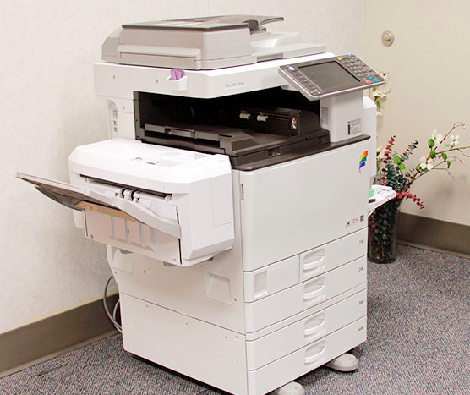
Job Duties
Report to supervisor
Check all copy machines for paper
Fill the copy machines that need more paper
Get extra reams and deliver to the rooms where the paper was low
Complete report to supervisor about which copy machines needed the most paper
Return to classroom

Sample of Paper Filler checklist
Student can use a checklist to check off which copy machines were checked and filled. This checklist might be on a clipboard with pencil attached with Velcro or string. This job can be done alone or in collaboration with a peer.
Copy Machines
Room 102 Office
Room 104 Teacher’s workroom
Room 106 Counselor’s office
Room 210 Library
Room 211 Computer lab

Sample visual supports
Some students would be able to use a simple checklist while others might need a checklist with words and photos. Some students might check off each step of the task with a pencil, while others would attach a Velcro check mark to indicate they finished that step.
Paper Filler Job | √
- Report to Mrs. Martin
- Get copy machine checklist
- Open drawers of copy machine
- Fill drawers with paper
- Shut drawers of copy machine
- Write down which copy machines needed paper
- Deliver paper to rooms that were low
- Return to class

Paper Filler Job
- Report to Mrs. Martin
- Get copy machine checklist | 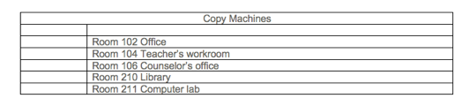
- Open drawers of copy machine | 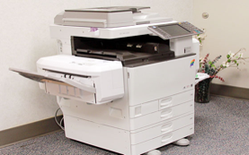
- Fill drawers with paper
- Shut drawers of copy machine

- Write down which copy machines needed paper

- Deliver paper to rooms that were low

- Return to class | 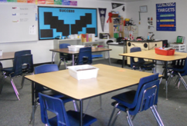

School jobs provide a fun and easy way for students with special needs to collaborate with their peers. Below is an example of a social narrative written for a student to encourage initiations and interactions.
Asking a Friend to Help

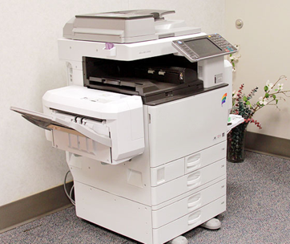

Being the Paper Filler Manager is an important job. When it’s my turn to have this job, I will put paper in all of the school copy machines and deliver paper to the rooms that are low.

When it’s my turn to be the Paper Filler Manager, I can pick a friend to help me. This friend will go with me to help. When it’s time to go to work I can walk over to a friend and say, “Jordan, will you help me with my job today?” If he says he can, then we will walk to Mrs. Martin’s office. If he says he can’t, I can choose another friend to ask.

When we get to Mrs. Martin’s office we will check in. She will give us the copy machine checklist then we will go to work. We can take turns filling the drawers of the copy machines with paper. After we fill the drawers with paper, we will deliver paper to the rooms that were low.

It is nice to have a friend to help. When we are done with our job, I can say, “Thanks, Jordan, for helping me”.

The content of this presentation was developed under an agreement from the Federal Department of Education to the Kansas Department of Education. However, those contents do not necessarily represent the policy of the Department of Education, and you should not assume endorsement by the Kansas Department of Education or the Federal Government. TASN Autism and Tertiary Behavior Supports does not discriminate on the basis of race, color, national origin, sex, disability, or age in its’ programs and activities. The following person has been designated to handle inquiries regarding the non-discrimination policies: Deputy Director, Keystone Learning Services, 500 E. Sunflower, Ozawkie, KS 66070, 785-876-2214.

