Door Knob Cleaner

(adapted from “Meaningful Jobs” – Scott May, Principal, Apollo Elementary, Goddard, Kansas)
The Kansas vision for education includes postsecondary and career preparation, social engagement, and communication as the foundational structures of education in our schools and classrooms. From simple jobs in the earliest grades through high school internships, meaningful work supports the academic and social competencies that lead to post-school success.
“Meaningful jobs allow students the opportunity to contribute in a way that both the students and the adults see value. Everyone likes to contribute to their family or workplace in meaningful ways. These responsibilities give students with disabilities or behavior concerns the opportunities to have repeated positive interactions with others and learn from those experiences." - Scott May

The ideas and supports included in these resources are ready to be edited to support growth and independence for individual students.

Job Description
The doorknob cleaner cleans doorknobs in the school.
Job Duties
Report to supervisor
Get disinfecting wipes and classroom checklist from closet
Wipe each knob 3-4 times
Check each classroom on the list as you clean the knobs
When all knobs are clean, put checklist and wipes in closet.
Return to classroom

Sample of classroom checklist
Student can use a checklist to record the doorknobs that have been cleaned each day. This checklist might be on a clipboard with pencil attached with Velcro or string.
Monday
Room 203 (Mrs. Black 2nd grade)
Room 205 (Mrs. Brown 2nd grade)
Room 207 (Mr. Green 2nd grade)
Room 209 (Mr. White 3rd grade)
Room 211 (Mr. Smith’s 3rd grade)
Room 213 (Nurse’s office)
Tuesday
Room 202 (Mrs. Reddy 1st grade)
Room 204 (Mrs. Freddy 1st grade)
Room 206 (Mr. Bradley Kindergarten)
Room 208 (Mrs. Now Kindergarten)
Room 210 (Supply Closet)

Sample visuals
These photos could be used to create additional visual supports for this job.
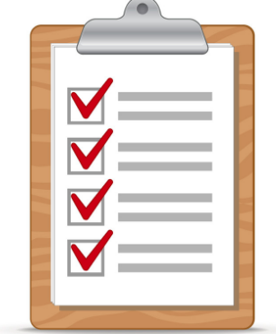

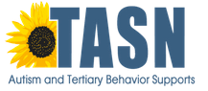
The content of this presentation was developed under an agreement from the Federal Department of Education to the Kansas Department of Education. However, those contents do not necessarily represent the policy of the Department of Education, and you should not assume endorsement by the Kansas Department of Education or the Federal Government. TASN Autism and Tertiary Behavior Supports does not discriminate on the basis of race, color, national origin, sex, disability, or age in its’ programs and activities. The following person has been designated to handle inquiries regarding the non-discrimination policies: Deputy Director, Keystone Learning Services, 500 E. Sunflower, Ozawkie, KS 66070, 785-876-2214.

