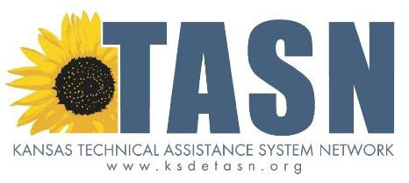Recruitment and Training
Teacher of the Deaf Endorsement

Students who are deaf/hard of hearing (DHH) are underserved and often misidentified. This is in part due to the lack of qualified teachers of the deaf (TOD) and other professionals with training and experience in working with DHH students.

The goal of the KSDE TASN Teacher of the Deaf Endorsement Project is to support teachers with current Kansas licensure in general or special education to obtain an endorsement as a TOD. By building capacity of Kansas teachers to address the unique needs of the DHH population, our students will be provided equal access to the curriculum via evidence-based practices.

Benefits for the District & Students
• Candidates remain in current teaching positions while they obtain TOD endorsement
• Reimbursed costs for coursework, books, and tests*
Estimated costs for complete program $12,080-16,000
• Increase teacher’s skill set to serve a wider variety of students
• Improved identification of DHH students & instructional interventions
• Mentoring support provided for up to three years after completion of endorsement
• Professional development provided during summer immersion program at the Kansas
School for the Deaf
• “Grow Your Own” increases likelihood of teachers remaining in the district
• Evidence-based practices implemented for each student – including DHH students
• Local support available for students and their families
• Staff that are qualified to administer required assessments

Benefits for the Candidate
• Keep your current teaching position while taking online coursework
• Flexible scheduling – enroll in as many courses each semester as your availability allows
• Tests (e.g., GRE) and books are reimbursed immediately*
• Tuition reimbursed after submission of transcripts to verify successful completion of courses*
• Increased skill set to help more students and families
• Bilingual skills – fluency in American Sign Language (ASL) and English
• Summer student teaching practicum
• Summer immersion professional development at the Kansas School for the Deaf

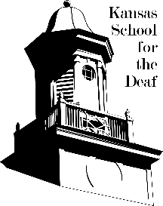For more information about the TOD Endorsement Project:
• Website: https://ksdetasn.org/tod
• Email: TOD@kssdb.org
• Phone: (913) 210-8112

*full or partial reimbursement pending available grant funds

2/15/17

