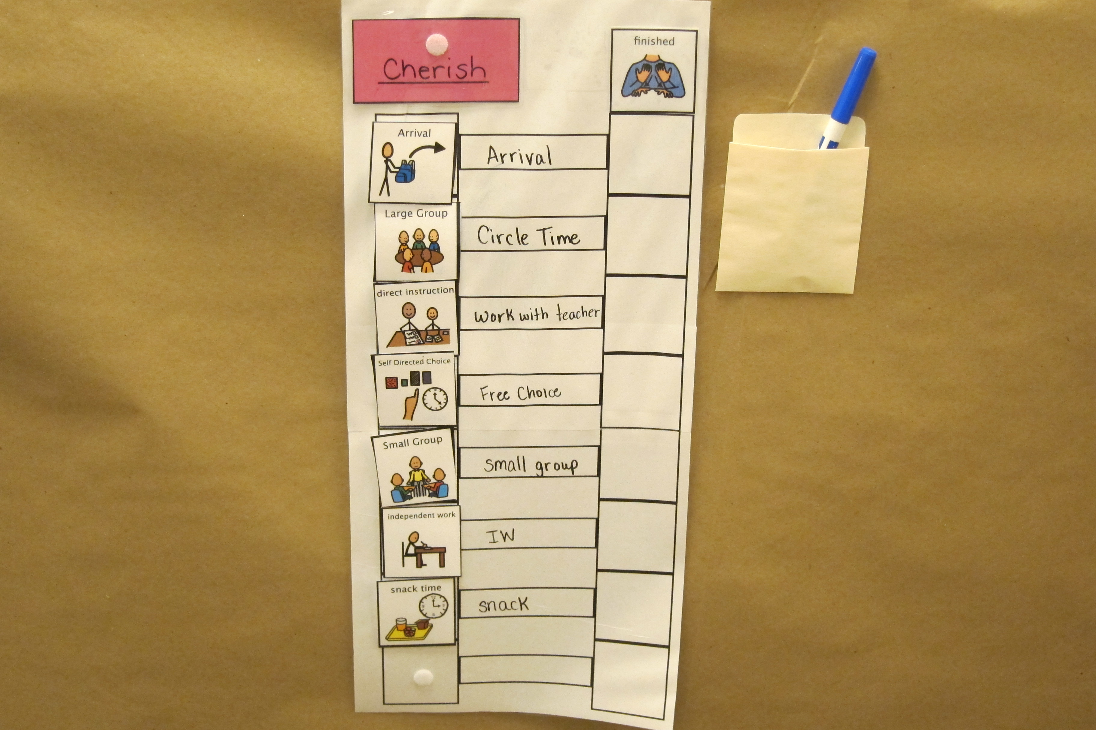
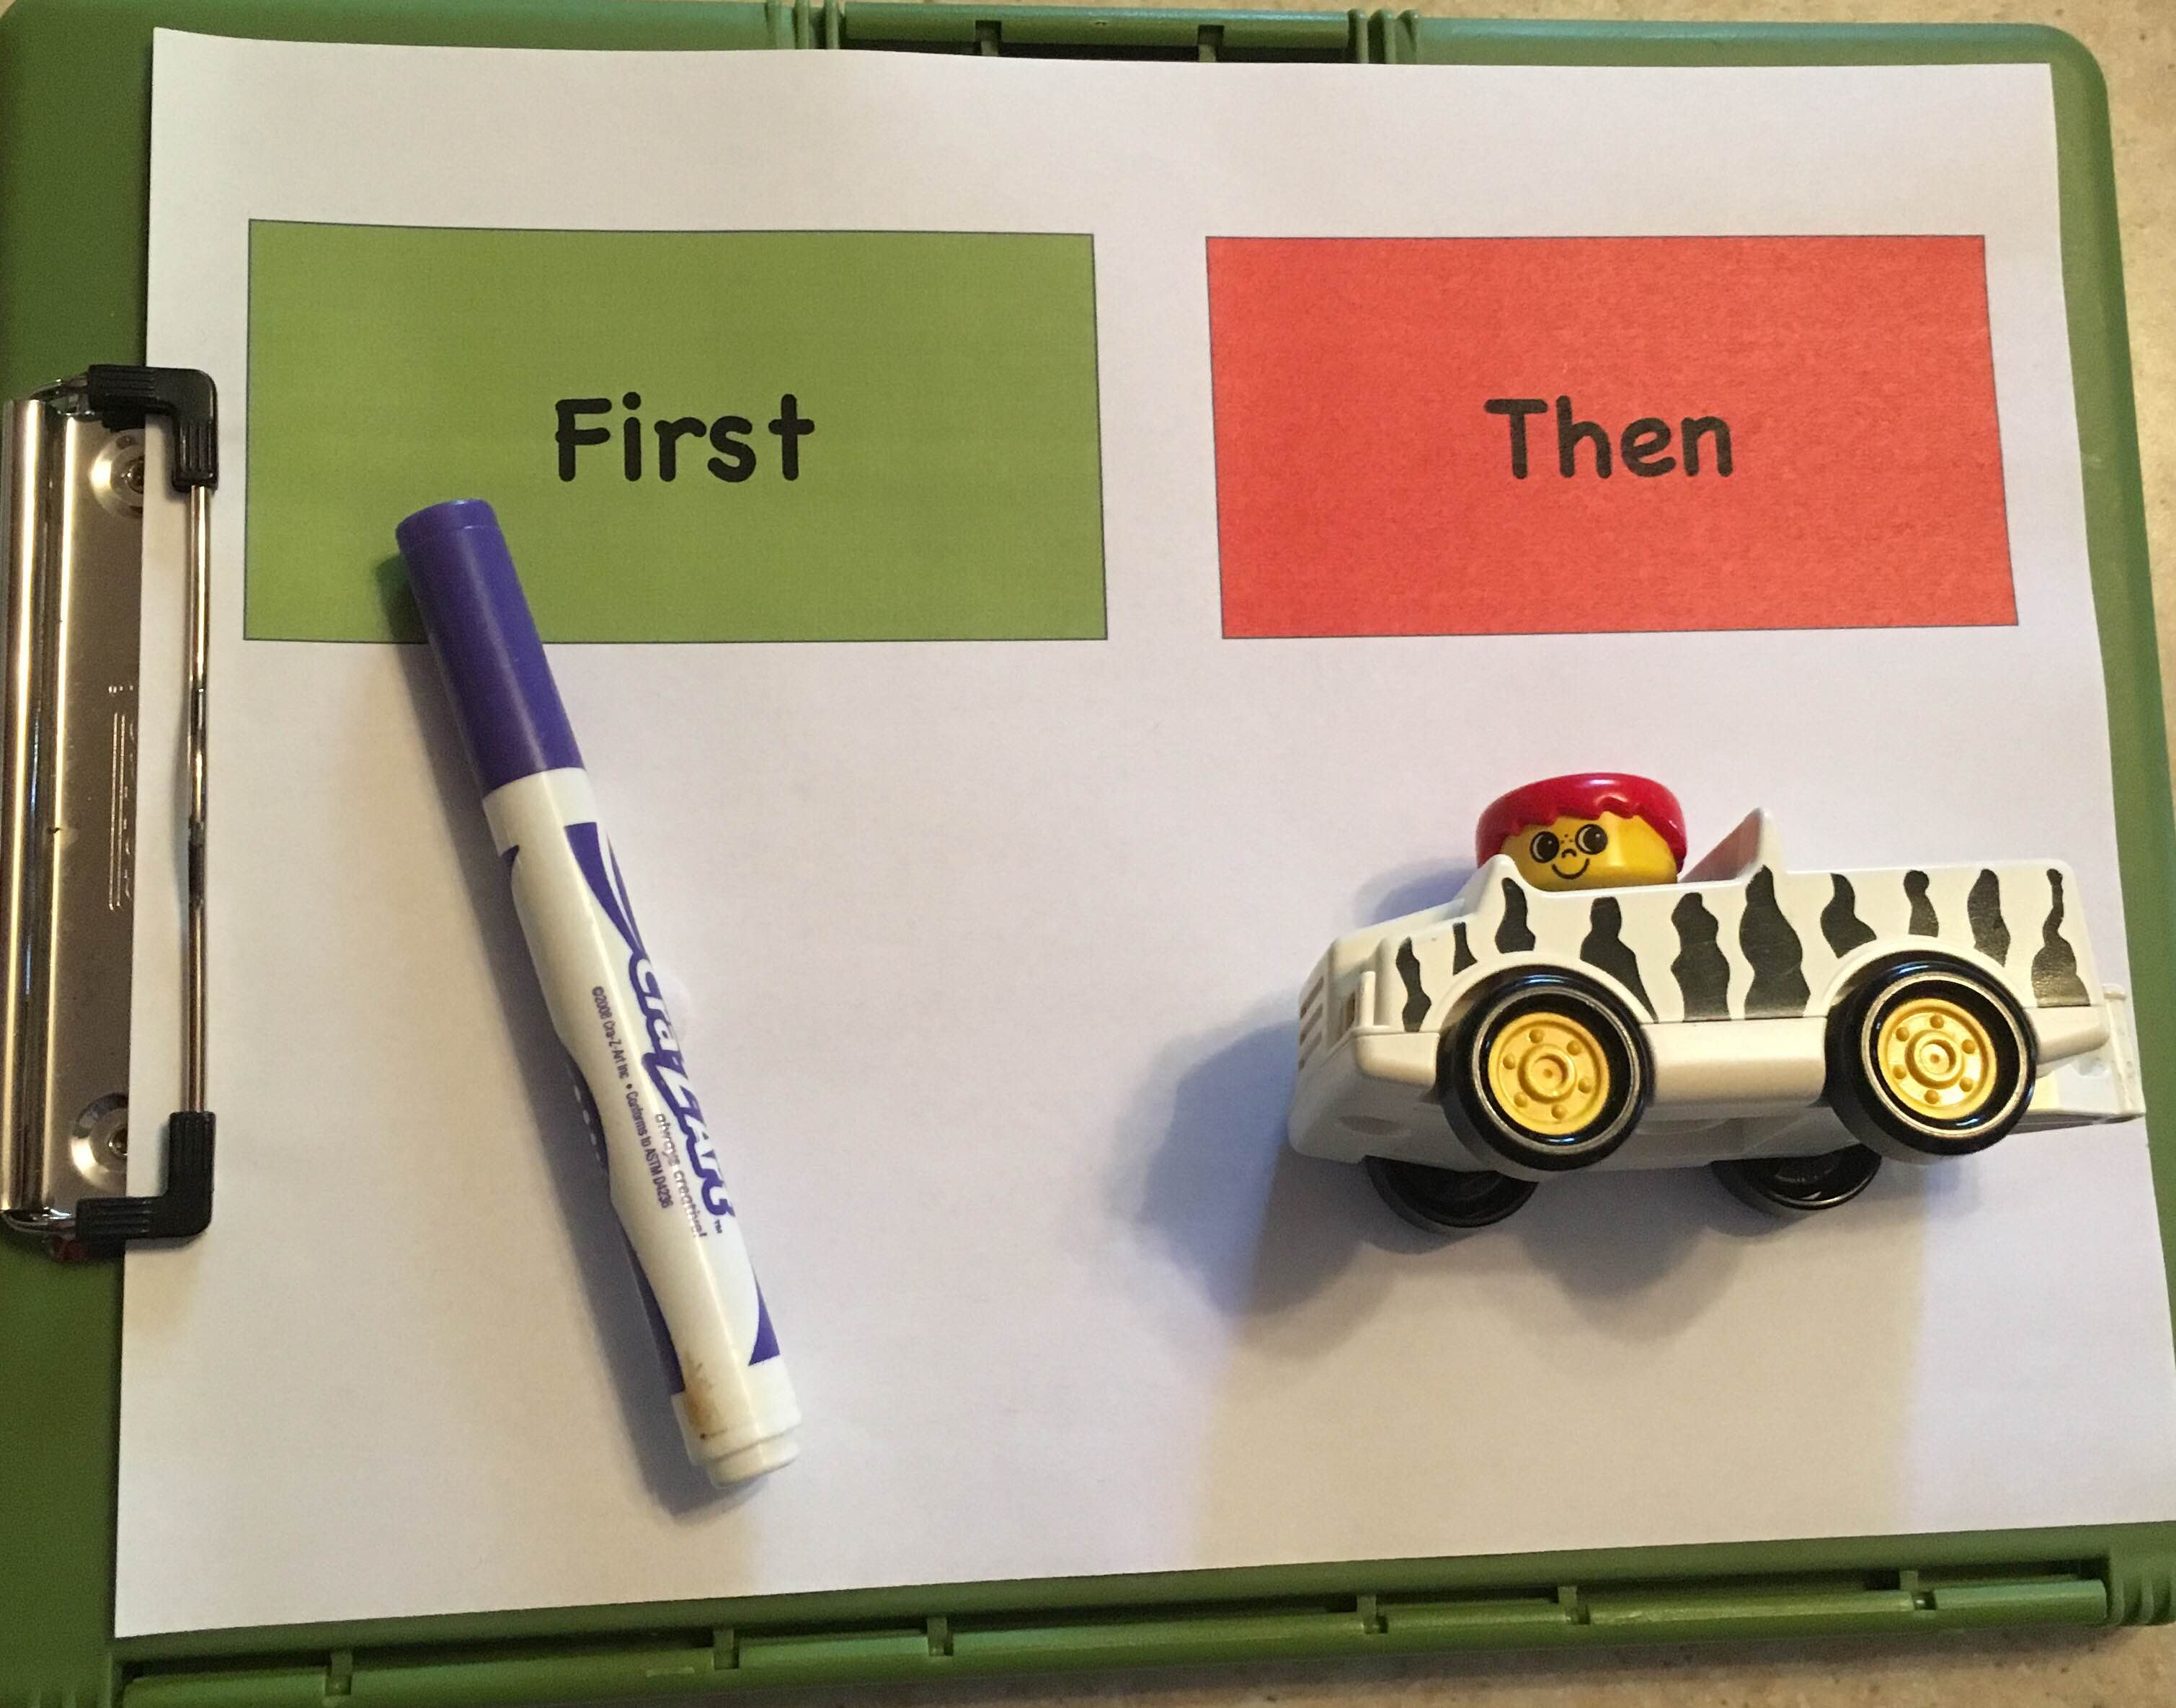
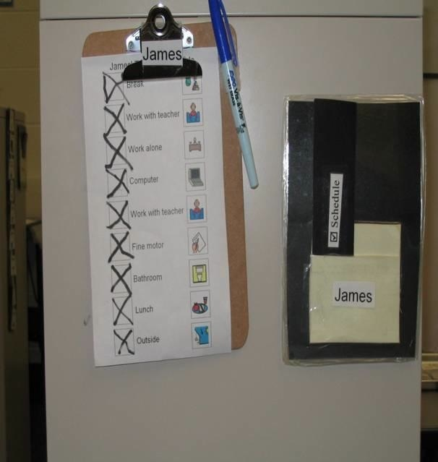
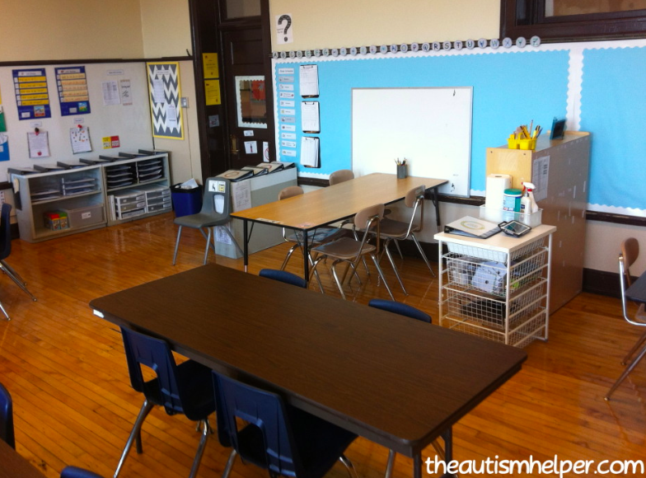
Why
(PTA National Standards for Family School Partnerships, 2009)

Family Engagement and Structured Teaching
  - June 2019
Relationships with families are one of the evidence-based practices identified by the Kansas Board of Education as critical to student success. We know from research that there are positive student outcomes when families have strong relationships with their child’s school and staff and are engaged in their child’s school experience. The Kansas Board of Education also endorses the PTA National Standards for Family School Partnerships. These standards provide the foundation from which to build strong family partnerships in your own building and classroom.

What

We created this packet to help you communicate to the families of the students you serve information you learned at the Structured Teaching Summer Institute, how your classroom might change as a result of this training, and what individual supports you might put in place for students. This is an editable document, so please adapt it to meet your own needs.
Dear Families,

Change this heading to represent your classroom
  - Sample letter to send to families
In June I attended a week-long training on the principles of structured teaching and am excited to share with you what I learned! In this letter I will explain what structured teaching is, why the elements of structured teaching benefit students with autism and other developmental disabilities, and what changes you might see in my classroom this year. I would also like to set up times for all of you to come visit our classroom before school begins, so please watch for an email from me to set that up.
Structured teaching is a framework in which the physical environment is well organized and highly structured using visual supports to make daily activities predictable and understandable. This framework supports students in having a clear understanding of the classroom schedules, activities, routines, and expectations in order to be as independent as possible.
Many students have challenges with transitions, organization, attention, and communication, but have great strengths in processing visual information. The structured teaching framework supports students in these areas by helping them understand and predict what is happening in and the expectations for an environment through the use of visual structure.
You will see some differences in our classroom when you come visit. These differences include changes to the layout of the classroom (dividers to separate areas, labels on all areas, individual and small group work areas), individual schedules developed for the students, and work systems with visually structured tasks for the students.
Below I am providing a photo and brief description of the elements of structured teaching. I am looking forward to talking with you soon!
Sincerely,

Physical Structure
Physical structure refers to how classroom materials and furniture are arranged in order to provide meaning and structure to activities and settings.
Individual Schedules  Individual schedules are a visual method to tell the student which activities will make up their day and the order in which they will occur. |  | 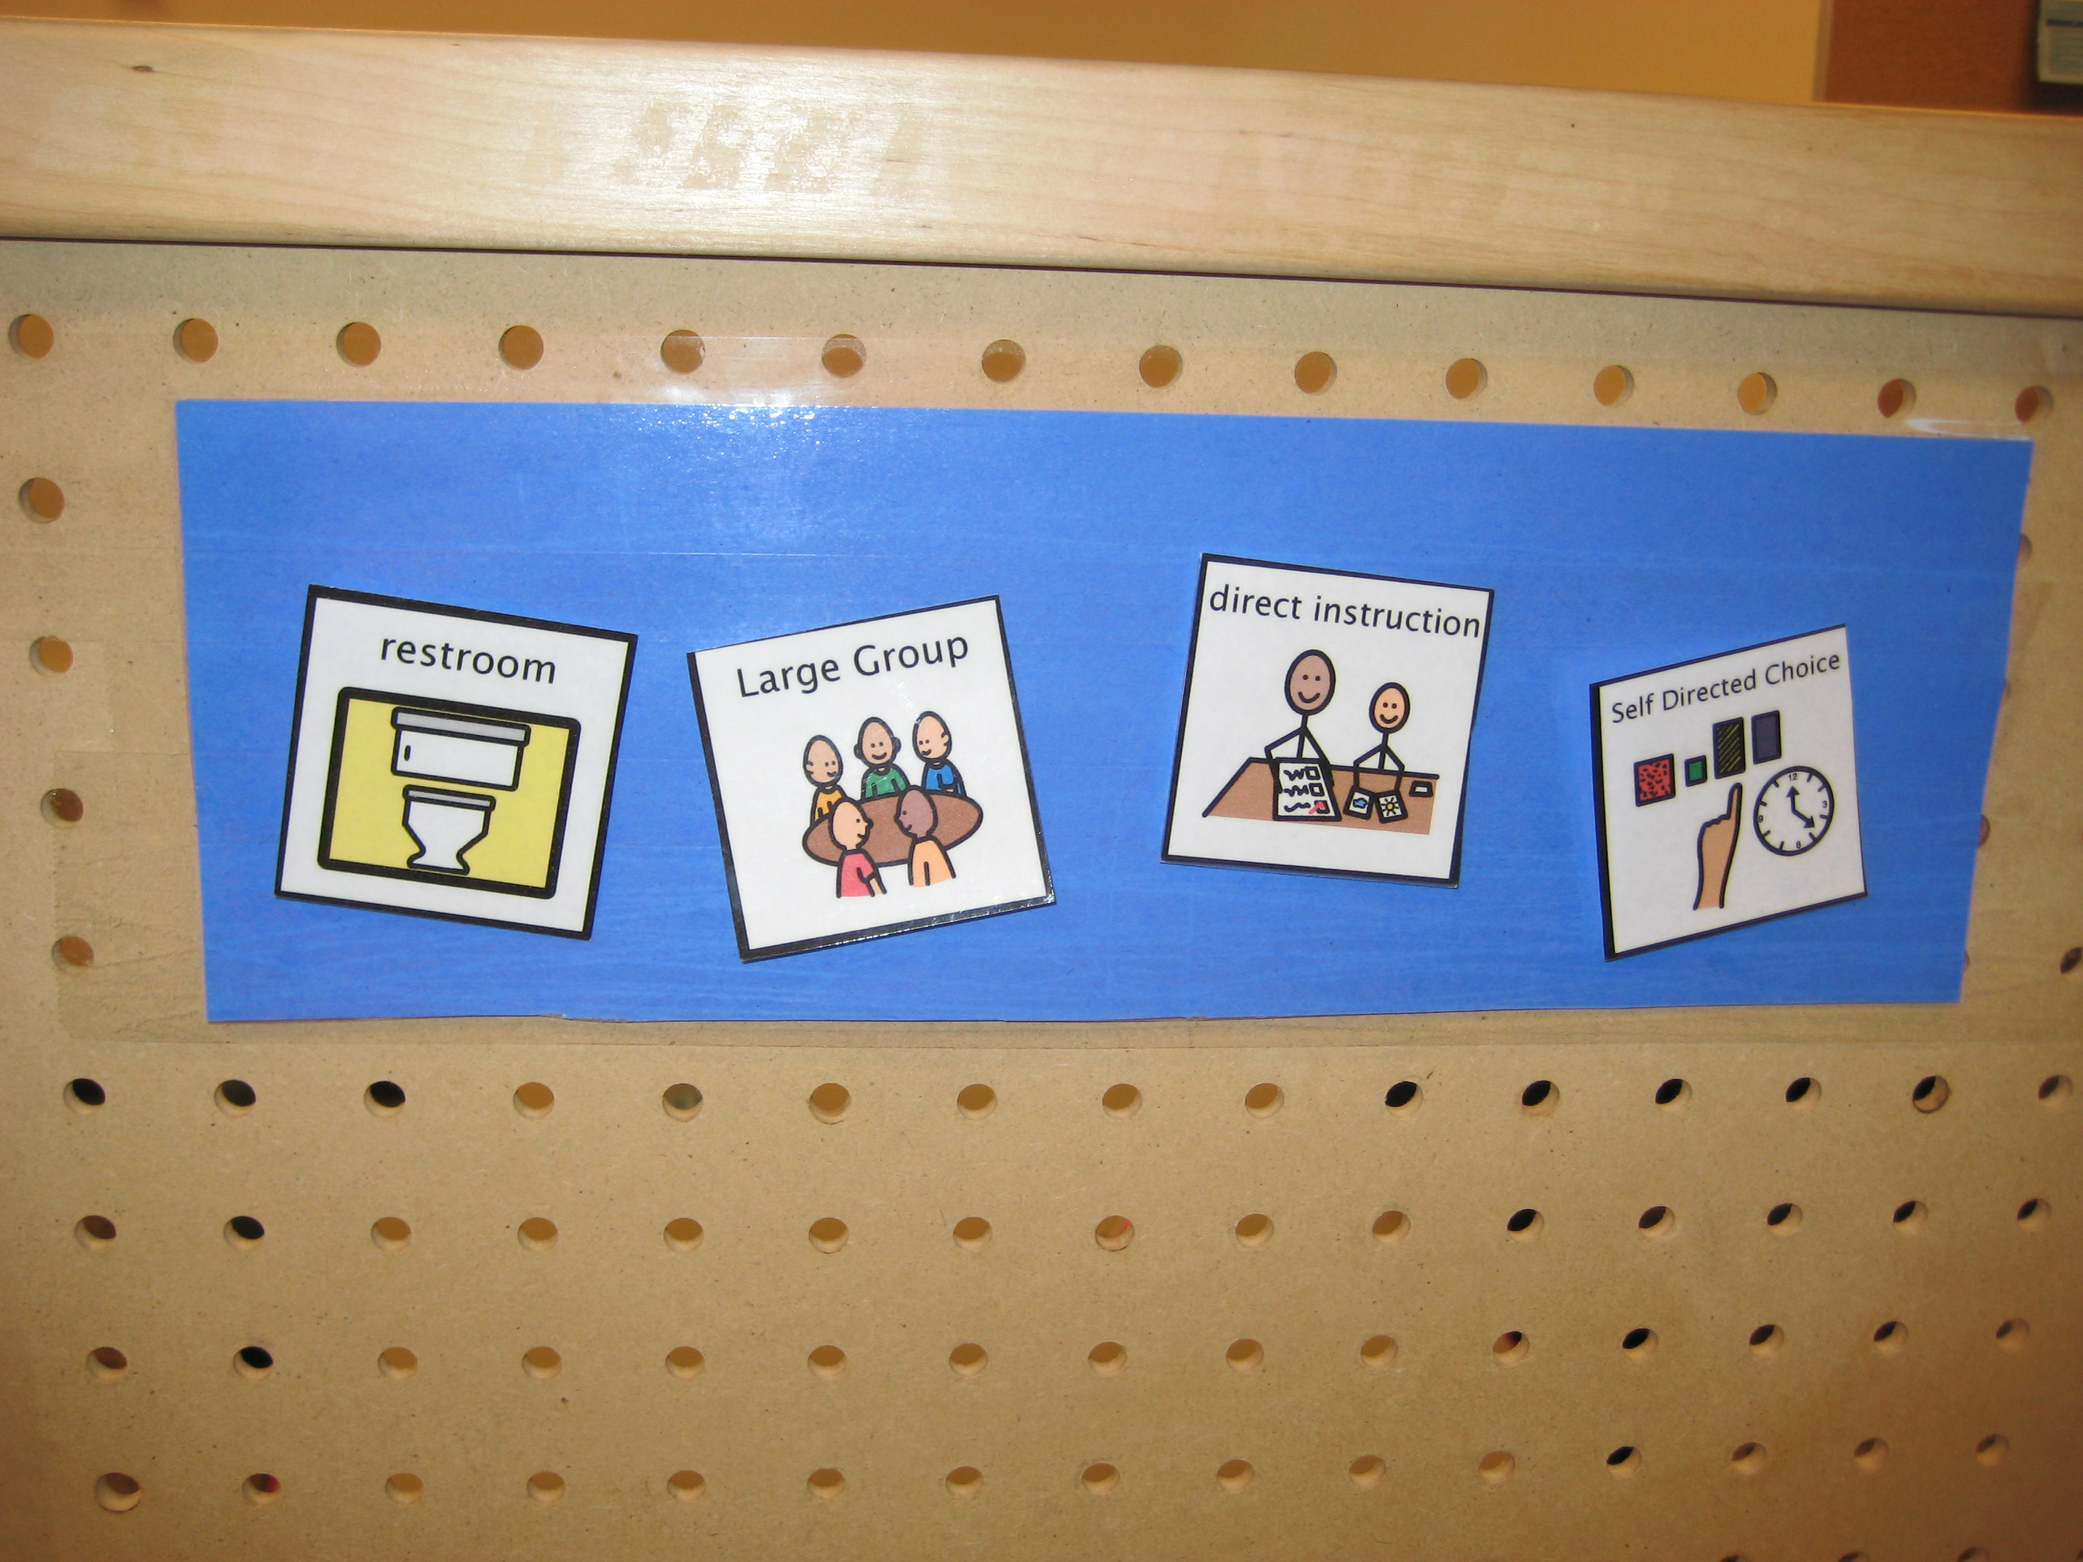
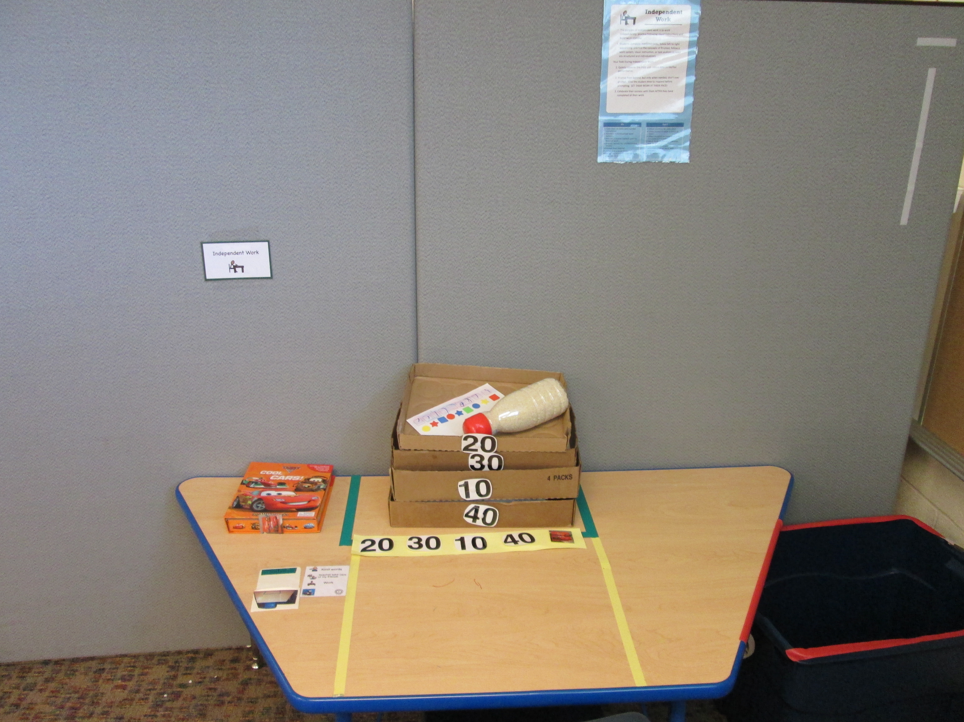 |  | Work Systems  Work systems are a systematic and organized presentation of tasks and material used to provide opportunities to practice previously taught skills, concepts, or activities. These systems provide visual information about what work needs to be done, how much work needs to be done, when the work is completed, and what will happen next.
Visual Structure of Tasks  The visual structure of tasks refers to the process of incorporating visual cues in a task or activity. |  | 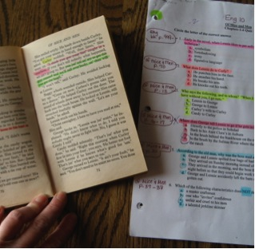

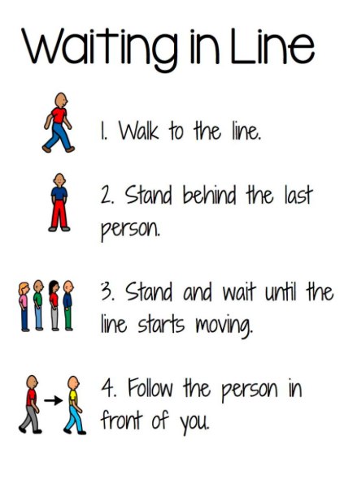 |  | Routines  Routines refer to a sequence of events that are regularly followed. Within the structured teaching framework, routines are used to provide students with a strategy to understand and predict the events around them and may be put in a visual format similar to the example on the left. (Mesibov, et. al., 2004)
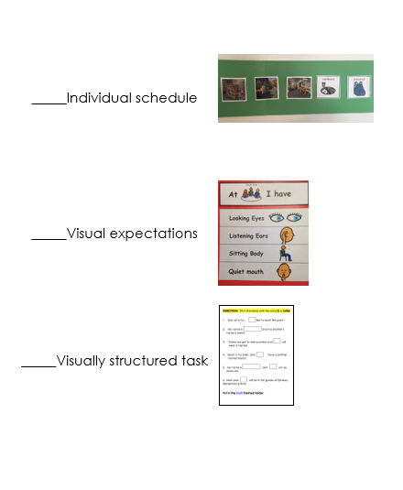
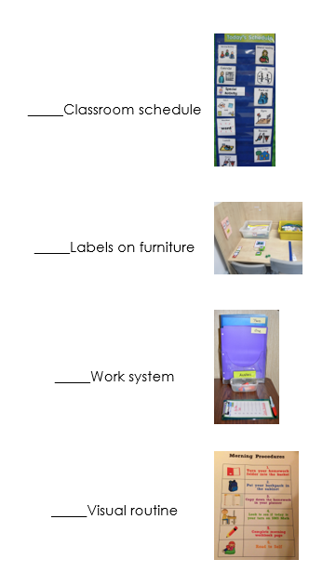

Classroom Visit Scavenger Hunt!
  - As you walk around our classroom, check off items on the checklist below as you find them. When you are done, bring this to me and I’ll show you your child’s specific schedule and work system. If you can’t find something don’t hesitate to ask me!

Events:

Additional Ideas to Increase Family Engagement
  - Sharing Structured Teaching

- Dine and Learn
  - Share what you learned at Summer Institute at a “breakfast meeting” on a Saturday morning, an evening supper event, or at an after-school snack time (and let the students help prepare the food!).
- Family Night events
- Family volunteer opportunities
  - Set aside time where families can volunteer to help create tasks, cut out laminated materials, etc.!
- Open House events
- Student-led conferences or student “showcase” events
  - Allow the student to share about the supports he/she uses in the classroom.
Technology:
- Social Media
  - Create a closed Facebook group for your classroom to share photos and videos of your students using their individual schedules, work systems, etc.
- Apps
  - Use applications such as Bloomz or Remind to communicate and share with families.
Written:
- Class newsletters
- Postcards or notes home

Reference
Mesibov, G.B., Shea, V., and Schopler, E. (2004). The teacch approach to autism spectrum disorders. New York, NY: Springer Science+Business Media, Inc.
PTA National Standards for Family-School Partnerships: An Implementation Guide (2009). Retrieved from: https://s3.amazonaws.com/rdcms-pta/files/production/public/National_Standards_Implementation_Guide_2009.pdf.

