Vending Cart Delivery

(Thanks to Ashley Linz, Specialized Programs- Connection C Teacher at Monticello Trails Middle School, for sharing this idea!)

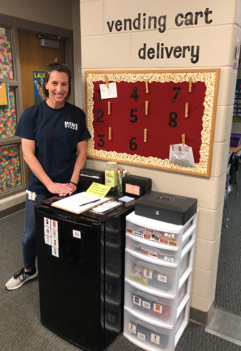
The Kansas vision for education includes postsecondary and career preparation, social engagement, and communication as the foundational structures of education in our schools and classrooms. From simple jobs in the earliest grades through high school internships, meaningful work supports the academic and social competencies that lead to post-school success.
“Meaningful jobs allow students the opportunity to contribute in a way that both the students and the adults see value. Everyone likes to contribute to their family or workplace in meaningful ways. These responsibilities give students with disabilities or behavior concerns the opportunities to have repeated positive interactions with others and learn from those experiences." - Scott May

The ideas and supports included in these resources can be edited to support growth and independence for individual students.

Job Description
Students stock vending items, fill and deliver orders, and count/graph sales.
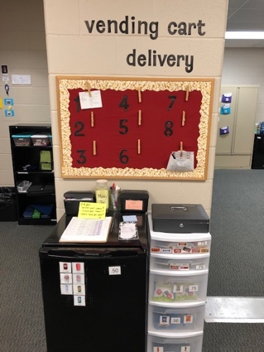

Job Duties
- Stock refrigerator
- Stock non-perishable items
- Collect orders from staff lounge
- Deliver orders
- Count and graph money

Visual Supports
Staff have the option of purchasing snacks and drinks in Mrs. Linz’ classroom. In the photo below, you can see that staff are reminded to write their name, circle their item, and mark how they paid.
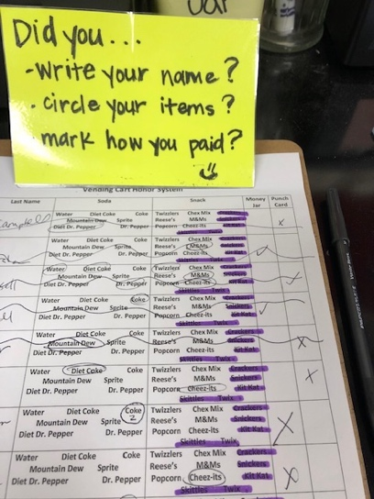
Staff also have the option of placing orders in the staff lounge where Mrs. Linz’ students collect them every hour. Examples of the order forms and the system the students use to collect orders are below. The pink form is for staff who want to place a special order for a co-worker. Staff can pay for items as they go or pay ahead and use a punch card to keep track of their orders.
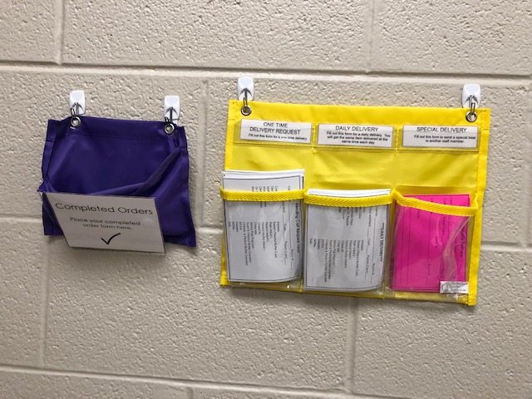
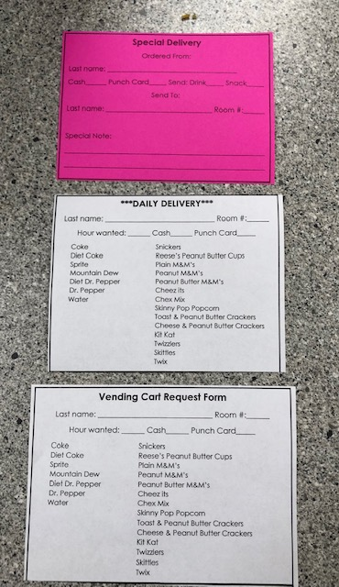

To incorporate math skills, Mrs. Linz has a student graph the soda sales each week.
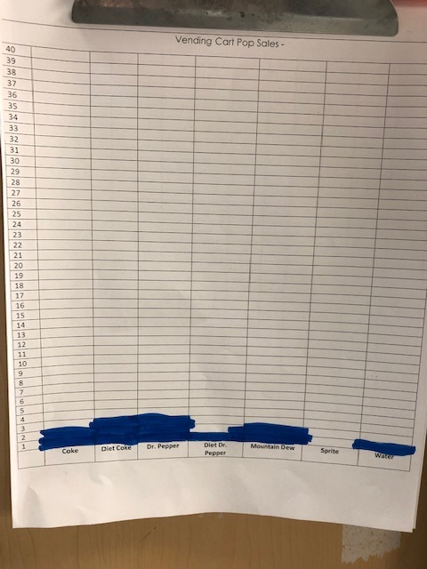

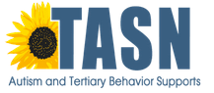
The content of this presentation was developed under an agreement from the Federal Department of Education to the Kansas Department of Education. However, those contents do not necessarily represent the policy of the Department of Education, and you should not assume endorsement by the Kansas Department of Education or the Federal Government. TASN Autism and Tertiary Behavior Supports does not discriminate on the basis of race, color, national origin, sex, disability, or age in its’ programs and activities. The following person has been designated to handle inquiries regarding the non-discrimination policies: Deputy Director, Keystone Learning Services, 500 E. Sunflower, Ozawkie, KS 66070, 785-876-2214.

