Structured Teaching from the Ground Up
We are very happy to highlight 6th grade functional classroom teacher Abigail Easter from Goddard. Abigail has attended several TASN trainings and most recently participated in the Summer Institute on Structured Teaching as an intern and the Individualizing Instruction in Social Competencies Training. She shared some recent pictures of her newly designed classroom with some added structure.
My History in Special Education
I have been a life skills trainer at KETCH working with adults with developmental disabilities. I also have worked as a special education para in structured learning, IR/IS, and life skills classrooms. My first teaching job was in a 5th and 6th grade structured learning classroom. I did the best I could with an amazing instructional coach (Melissa Woods). I now teach 6th grade functional applied academics.

My first year of teaching I started attending TASN trainings. These trainings opened my eyes to the best ways to teach and structure education for both students with autism and those with other disabilities.
The best training that I attended was Summer Institute, where we learned structured teaching from the ground up and were allowed to practice what we were taught.

My instruction before structured teaching training
- Students got what was pretty and looked good; supports were not individualized, and the schedules all matched. My classroom looked like a photo off of Pinterest and I wasn’t thinking about what each student needed to be successful.
- Task boxes were "just there," without task strips or instructions. I just expected the students to know what to do.
- The structure was thrown around, without purpose or function. (Picture a toddler with paper and glue.)

My instruction after structured teaching training
- All structure is now thought out, planned, and fully implemented.
- Structure and educational materials are individualized for each student’s needs.
- My daily schedules are well planned so students can have a better experience participating with inclusion classes and everyone is covered for special education services.
- My students understand what they are supposed to do and when to do it.
- Each area of my classroom has a purpose and the students can access it and use it appropriately.
- My classroom now is student centered and items in the room are used for a purpose.
  - We ask what are we trying to accomplish and how can my students accomplish this best with the tools and space provided?
- I have a "structure-teach-take data-restructure-reteach" mindset now.
  - How can I modify what I have in place to make it most effective for individual students? What can I put in place to make them more successful? My job is never done, I can always change something or implement something new. It would be hard to get in a rut with my revolving mindset now.

Another strategy that I have implemented from the Social Competency TASN trainings are my social competencies lessons. I cover a new social competency each week. The students have an interactive notebook that we write in and glue content in every week. We also supplement with activities to help students understand the concept targeted.

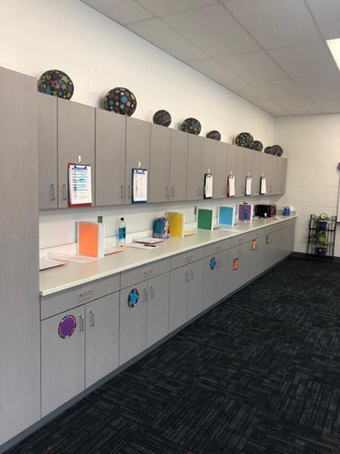
Here is a photo of my home base for all students. They have color coded baskets, (so I don’t have to worry about papers without names) and workbooks and schedules are also color coded. Each student has a drawer and a cabinet for their belongings to keep materials organized.

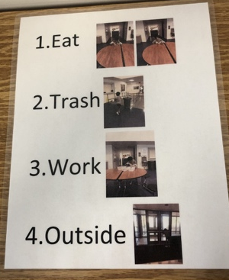
This structure supports a student who was not going to lunch with his class until this year. He did not understand the expectations in the lunchroom. A simple schedule supported successful inclusion.

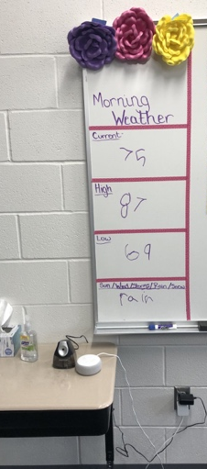
Here is our weather chore. We ask Alexa (Echo Dot) what the weather is like outside and we write it on the board.

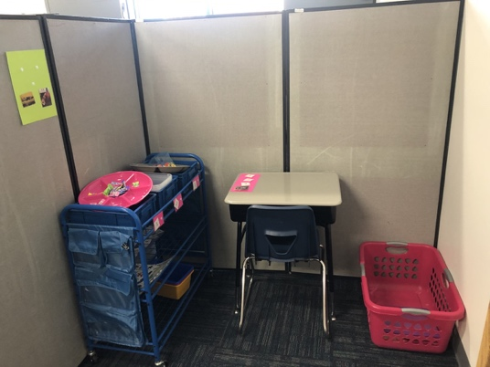

One student’s independent workspace.

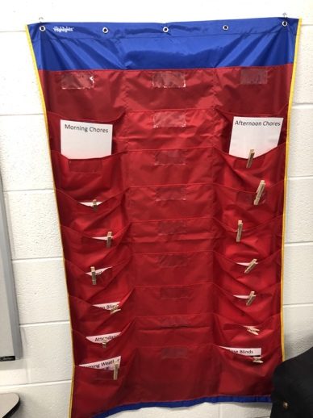
Here is our chore chart. The student’s names are on clothes pins and they move once a week. In each pocket is a chore that they have to complete, both morning and afternoon

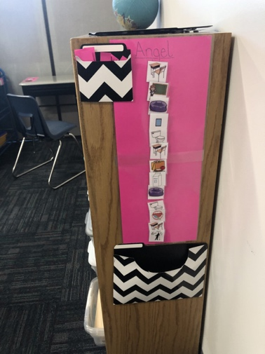
Example of a student’s individual schedule.

The contents of this article were developed under an agreement from the Federal Department of Education to the Kansas Department of Education. However, those contents do not necessarily represent the policy of the Department of Education, and you should not assume endorsement by the Kansas Department of Education or the Federal Government.

TASN Autism and Tertiary Behavior Supports is funded through Part B funds administered by the Kansas State Department of Education's Special Education and Title Services. TASN Autism and Tertiary Behavior Supports does not discriminate on the basis of race, color, national origin, sex, disability, or age in its programs and activities. The following person has been designated to handle inquiries regarding the nondiscrimination policies: Deputy Director, Keystone Learning Services, 500 E. Sunflower, Ozawkie KS 66070, 785.876.2214

The content of this article was developed under an agreement from the Federal Department of Education to the Kansas Department of Education. However, those contents do not necessarily represent the policy of the Department of Education, and you should not assume endorsement by the Kansas Department of Education or the Federal Government.

TASN Autism and Tertiary Behavior Supports is funded through Part B funds administered by the Kansas State Department of Education's Special Education and Title Services. TASN Autism and Tertiary Behavior Supports does not discriminate on the basis of race, color, national origin, sex, disability, or age in its programs and activities. The following person has been designated to handle inquiries regarding the nondiscrimination policies: Deputy Director, Keystone Learning Services, 500 E. Sunflower, Ozawkie KS 66070, 785.876.2214

