 | Looks like: | Description
Descending | 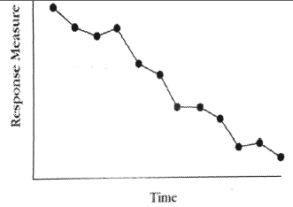 | - Shows the behavior is already changing.  - Generally, one should NOT implement intervention when baseline is descending,  - But can do so if the behavior you are trying to change is something you want to increase & the descending trend shows it is worsening.  - If descending baseline is due to a behavior you want to decrease, then you should wait because the behavior is already improving.
Ascending | 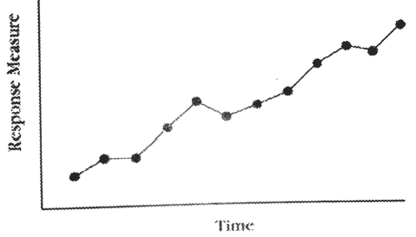 | - Shows the behavior is already changing.  - Generally, one should NOT implement intervention when baseline is ascending.  - But can do so if the behavior you are trying to change is something you want to decrease (a challenging beh) and the ascending trend shows it is worsening.  - If ascending baseline is due to a behavior you want to increase, then you should wait because the behavior is already improving.
Variable | 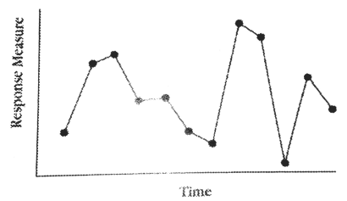 | - No clear trend  - If one’s data is variable, one should wait it out and should not introduce the intervention.  - Variability is assumed to be due to environmental variable
Stable | 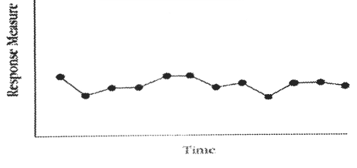 | - No evidence of ascending or descending trend  - All of the values of the responses fall in a small range of values.  - Data is stable, so you can introduce your intervention!
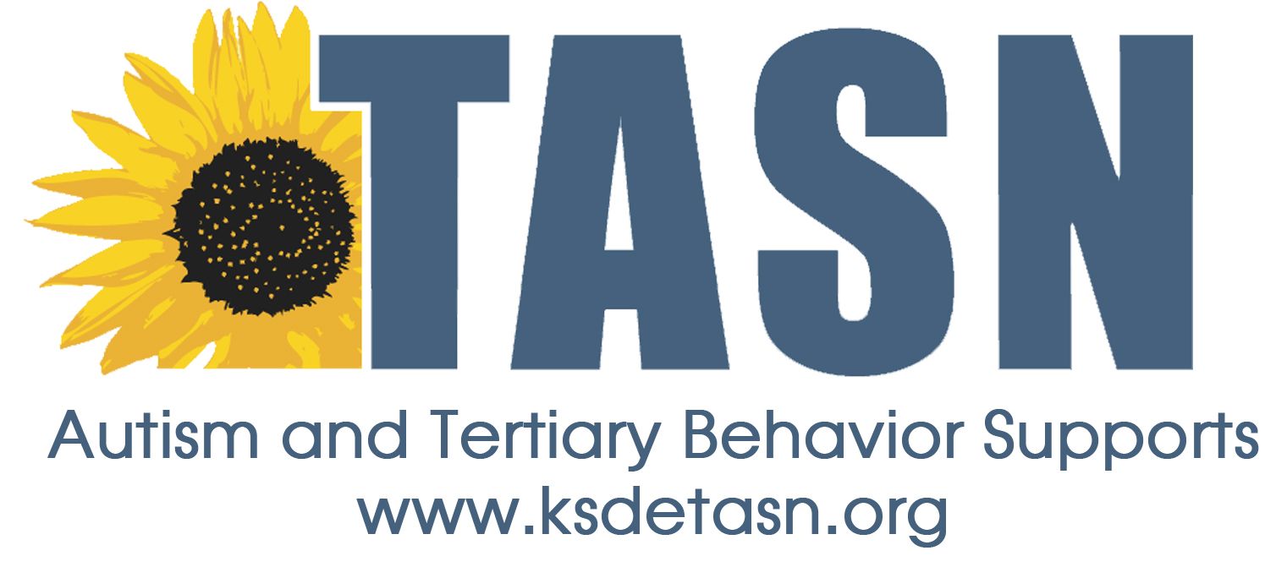 PATTERNS OF BASELINE DATA

TASN Autism and Tertiary Behavior Supports is funded through Part B funds administered by the Kansas State Department of Education's Early Childhood, Special Education and Title Services. TASN Autism and Tertiary Behavior Supports does not discriminate on the basis of race, color, national origin, sex, disability, or age in its programs and activities. The following person has been designated to handle inquiries regarding the non-discrimination policies: Deputy Director, Keystone Learning Services, 500 E. Sunflower, Ozawkie, KS 66070, 785-876-2214.

Patterns of Baseline Data.docx
Pal: 4-20-15

