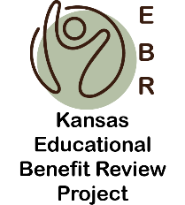
Using the Educational Benefit Review (EBR)

Process for Staff Development

1 to 1.5 Hour Sessions
Session 1 | Overview and Purpose of EBR – this session is designed to provide an overview of the EBR Process, a understanding of what and where the concept of educational benefit comes, and an understanding of the goals for spending time using and EBR process.
Session 2 | Step 1- Charting the most current IEP. Small teams chart the most current IEP. Teams are given the homework of charting IEPs 2 & 3 before the next session (Step 2). Forms 1 & 2
Session 3 | Steps 3 & 4 – Teams come back together to analyze information across and within all three IEPs, using Forms 3 & 4 to discuss educational benefit.
Session 4 | Step 5 – Bring the teams back together to discuss common patterns that were found across IEPs and discuss a plan for next steps.
Session 5 | Follow Up Training for staff on IEP elements that need to be addressed, along with any policy and guidance changes.

