Ratio of Reinforcement Data Sheet

Directions: Enter date, initials of staff providing the reinforcement, and type of task (ie: puzzles, carpet time, center tubs). Mark a check in a box for the number of reinforcers provided during that task and the number of problem behaviors displayed during that task. To keep track of how often to provide reinforcement, circle or highlight boxes using an average of the student’s variable ratio (VR) BEFORE starting the work session. When the work session is finished, write the total number of checks for reinforcers given and problem behaviors displayed.
Problem Behavior: Refers to not attending to staff-led activities or staff verbal, gestural or visual requests. This looks like standing up from seated position, walking around the room, crying, throwing materials, spinning materials when expected to work, and hitting. Non-Examples would include walking to the location requested within the time expected or spinning items identified as reinforcers when provided access by staff.
Date | Staff Initials | Type of Task | # of Reinforcers Provided | # of Problem Behaviors
 |  |  | 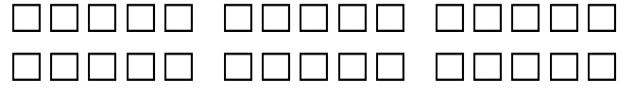  Total: | Total:
 |  |  | Total: | Total:
 |  |  | Total: | Total:
 |  |  | Total: | Total:
 |  |  | Total: | Total:
 |  |  | Total: | Total:
TASN Autism and Tertiary Behavior Supports is funded through Part B funds administered by the Kansas State Department of Education's Early Childhood, Special Education and Title Services. TASN Autism and Tertiary Behavior Supports does not discriminate on the basis of race, color, national origin, sex, disability, or age in its programs and activities. The following person has been designated to handle inquiries regarding the non-discrimination policies: Deputy Director, Keystone Learning Services, 500 E. Sunflower, Ozawkie, KS 66070, 785-876-2214.

