Social Competencies: Implementation Guide

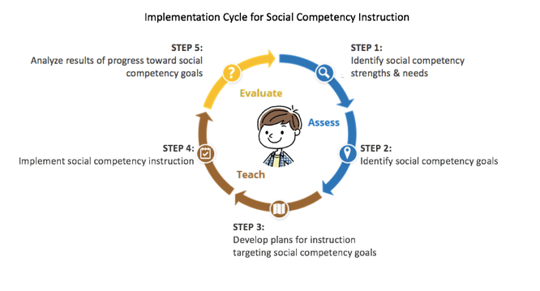

Assess: Step 1: Identify social competency strengths and needs:

Assess: Step 2: Identify social competency goals:

Teach: Step 3: Develop plans for instruction targeting social competency goals:

Teach: Step 4: Implement social competency instruction:

Evaluate: Step 5: Analyze results of progress toward social competency goals:

Notes and Next Steps:

The content of this presentation was developed under an agreement from the Federal Department of Education to the Kansas Department of Education. However, those contents do not necessarily represent the policy of the Department of Education, and you should not assume endorsement by the Kansas Department of Education or the Federal Government
TASN Autism and Tertiary Behavior Supports does not discriminate on the basis of race, color, national origin, sex, disability, or age in its’ programs and activities. The following person has been designated to handle inquiries regarding the non-discrimination policies: Deputy Director, Keystone Learning Services, 500 E. Sunflower, Ozawkie, KS 66070, 785-876-2214.

