PROTOCOL TO IMPROVE SPEECH INTELLIGIBILITY

CANDIDATES: Learners with poor echoic skills and poor intelligibility, e.g. poor articulation, low volume, etc.

PROTOCOL/STEPS:

- ASSESSMENT
- Sound Inventory
- Articulation Across Operants
- Recording Types of Errors
- Kaufman Assessment

- TARGET SELECTION
- During Mand Condition
- During Echoic Condition

- TEACHING PROCEDURES
- Manding
- Differential Reinforcement During Manding
- Automatic Reinforcement Procedures
- Kaufman Echoic Teaching Procedures
- Echoic Procedure: Not Kaufman

I. ASSESSMENT

- Conduct a sound inventory for 1-3 sessions for non-vocal learners with limited phonemic production. (See Attached “Pre-pairing/Sound/Inventory” Form)

- For those learners who are vocal, the instructor will record on the “Articulation Inventory Across Operants” form (trial by trial data) the learner’s articulation across all of the operants (i.e., mands, tacts, echoics, intraverbals), paying specific attention to the learner’s mand repertoire. On this data sheet the instructor should:
    - Record the specific response.
    - Record the operant for that response.
    - For mands, record the prompt level necessary to evoke that response (“prompt level” column).
    - Record what the learner actually says (in the “what was actually said” column).

- In addition, record the kinds of errors you hear:
      - Vowel Neutralization (e.g., “water’ sounds like “wah-wah”, “cookie” sounds like “cuh-cuh”, etc.)
      - Consonant Deletions (e.g. “car” sounds like “ca”, “dog” sounds like “daw”, etc.
      - Substitutions (e.g., “car” sounds like “tar”, “go” sounds like “dough” etc.)
      - Vowel Addition (e.g. “in” sounds like “in-nuh”, “cat” sounds like “ca-tuh”, etc)

- Lastly, conduct a Kaufman assessment as an echoic profile. Use the Primary Kaufman assessment along with the final and initial consonants in the advanced box. (See “Kaufman Speech Praxis Assessment Sheet”).

- Pre-requisite for conducting the Kaufman: the learner should make many speech sounds, in particular, CV and CVC words as either mands or echoics, or both.

II TARGET SELECTION

- Review the Kaufman results and identify errors. Identify potential mands that have the same syllable form and target them for mand training. Of course there must be an MO for the reinforcer as a pre-requisite for teaching these words as mands. Select targets for intraverbal fill-ins the same way.
- For example: The learner has difficulty with CVC words such as “mop”, “map”, “beam”, “boom”, “day”, etc. The learner has a strong MO for reinforcers such as playing with cars, playing with bowling pins, and eating candy dots. The instructor could choose CVC targets such as “car”, “pin”, and “dots” during manding. In addition, the learner likes to sing the Old Macdonald song. The instructor could then choose CVC targets such as “dog”, “cat”, and “pig” as fill-ins during the song. All of the above targets have the same syllable form (CVC).

- Select targets from the Kaufman assessment that has been conducted. Choose the word group where multiple breakdowns in articulation occur and select the words as targets for echoic training.

- Once you have identified the word category where the break down occurs, set up a cold probe data sheet for those words.

- Probe the word shells for all the words in that category in which the adult form were not produced during the assessment thus far.

- Determine the highest level at which parity is achieved for each word and mark this approximation with a sticker or through some other data recording procedure.

- Training will begin with the presentation of these word shells to assure immediate success.

- Select some echoic targets from the learner’s mand response group. Mands that are unclear may be run as echoics.

- At this point you should have a list of echoics to be run in:

        - the mand condition
        - the echoic condition

III. TEACHING METHODS

- MANDING:
- Run many mand trials per day across as many reinforcers (words) and categories of motivation as possible.

- MEASUREMENT:
- Record on the appropriate data sheet what is said when the learner mands and

- The prompt level required to evoke the mand.

- GRAPH:
- The frequency of prompt and unprompted mands

- The most frequent prompt level necessary to evoke each response.

- DIFFERENTIAL REINFORCEMENT DURING MANDING:
- When teaching manding with sign language or when teaching manding with a learner with a weak echoic but not so weak as to need sign language, shaping of better approximations may be beneficial. The following procedure is recommended:

  - If the vocalization during the vocal-mand is clear, deliver the reinforcer.

  - If the vocalization is not clear the instructor will give the learner up to 5 echoic trials for better articulation to occur, recording exactly what the learner said (or not) for each response on the mand data sheet.

  - If during the 5 echoic trials the learner’s articulation is better on any of the trials, the instructor will differentially reinforce the learner immediately. That is, if the learner required all five echoic trials the instructor will reinforce but not as much (magnitude) as if the learner had achieved better parity during an earlier trial. That is, the learner will receive more of the reinforcer if less echoic trials were required.

  - Use the “DIFFERENTIAL REINFORCEMENT OF VOCALIZATIONS DURING VOCAL MANDING” data sheet

- MEASUREMENT
- Vocal approximations when manding on first attempt
- Vocal approximations that improve when running echoic procedure.
- GRAPH:
- Percentage of vocal approximations on first mand attempt
- Percentage of vocal approximations that improve during echoic trials.

3. AUTOMATIC REINFORCEMENT PROCEDURES
- Candidate for this Procedure: Learner’s who babble very infrequently and babble very few different speech sounds and who have a wide variety of valuable reinforcers (not mastered or targeted mands)

- Step One: Inventory of Sounds:

- The teacher will take an inventory of all of the sounds that are currently in the learner’s vocal repertoire. This will be done in two ways:
- The teacher will write down all that sounds that have been reported both from her observations and from other staff members.
- The teacher will also conduct a full day assessment where she will record all of his sounds and their frequencies.

- From the inventory that is generated, a sound that is currently in the learner’s repertoire and most often heard will be chosen as the “target sound”.
- ALTERNATIVE OPTION:
  - Choose sounds heard during manding and babbling. Look for CV sounds and combine them to make up CVCV words which are typically easier to produce.
  - Choose a sound that is the most developmental appropriate for the learner. (SEE THE ATTACHED SAUNDER’S 1972 CHART)

    - Step Two: “Stimulus-Stimulus Pairing”/ARP

        - Prior to running the procedures described below the teacher will do the following:
        - Determine the activities and the reinforcers that are not currently being targeted as mand/signs to use as reinforcers during the pairing.
        - Each day the teacher will schedule three-20 minute sessions where she will be running the procedures below.

- Procedures:

- Present target sound 3 times with a one second delay between each presentation. However, sometimes presenting the sound more than 3 times sometimes evokes a better approximation and therefore up to 5 presentations should be considered.
For example: “Target sound”----1 sec----“Target
sound”----reinforcer

- Run a trial at least 10 times a minute. That is, one trial every 5-6 seconds.

- If Learner echoes the sound during any one of the presentations reinforce abundantly.

- If after the 3rd or greater presentation he doesn’t echo the sound, reinforce anyway but not as much as you might if he echoed back the target sound. For example, giving him half a French fry versus a whole French fry.

- If he emits any other sound during your first presentation of the target sound continue until the 3rd presentation, again reinforce anyway but not as much as you would if it were the target sound.

- Be reminded, continue to present the sound more than 3 times if the value of the reinforcer does not seem to diminish.

- Run this procedure three times (three sessions) a day with each session being about 20 minutes long. Take trial by data on what he said or not during this pairing condition.

- In addition, the team will then calculate the percentage of target sounds and other sounds heard during the pairing condition. Place other sounds over total number of trials to generate “other sounds” percentage. Place target sounds over total trials to generate target sounds percentage. Graph both on data sheets provided.

    - Step Three: Measuring Success
Sometimes the target sound begins to occur frequently in the pairing condition but not the post pairing condition. When this occurs, consider discontinuing the pairing procedure for that sound and moving it immediately to the echoic program. Consider 2 consecutive pairing sessions in which the target sound occurs 50% of the trials as the criterion for moving the sound to the echoic program even though post pairing target responses are low.
- GRAPH:
- Percentage of Trials in which target sound occurs.

- Step Four: Turning the New Sound into an Echoic Response
Once a target sound meets criteria attempt to bring it under echoic control by teaching it as an echoic according to the procedures described below.
  - GRAPH:
    - Percentage of Trials that parity is achieved on the first trial.

4. KAUFMAN ECHOIC TEACHING PROCEDURES:

      - Based upon the assessment, list on the probe data sheet the words or echoic responses from the category that will be taught first.

      - Begin the teaching procedure by having strong reinforcement available and visible to the learner to establish motivation for correct responding.

- Present the word approximation at the level of the word that has achieved parity to insure success immediately.

- Present the next higher word form immediately. If the learner quickly achieves parity (within one trial) then present the next form of the word without reinforcement to promote momentum

- If the learner does not meet parity continue to present this word approximation for 3-5 trials. The purpose of representing the word is to give the learner several attempts to slip into parity and thereby received reinforcement for doing so. If the learner reaches parity after several presentations then reinforced the imitative response. Provide greater magnitudes of the reinforcer for parity of the responses that occur with fewer trials.

- Consider using other antecedent variables to increase accuracy of the echoic response such as presenting a couple of easy motor movements, presenting a couple of easy words with same syllable shape, or using backward chaining of parts of the word, etc.

- MEASUREMENT:
          - Cold probes before teaching each day the adult form of the word. ( mastery criterion will be individually determined)
          - Mark the card at the word shell that reached parity for that day.

- GRAPH:
          - Weekly number of adult forms of the word which met mastery criterion

5. ECHOIC PROCEDURE: NOT KAUFMAN:
- This procedure is used for all echoic targets.

- Present the target word or sound and reinforce if parity is achieved. If not, re-present the word 3-4 additional trials with the intent that the learner may slip into parity and therefore can be reinforced.

- If parity is not achieved after these presentations then present an easier sound/word or easier movement and reinforce.

- Consider using other antecedent variables to increase accuracy of the echoic response: a couple of easy motor movements, a couple of easy words with same syllable shape, backward chaining of parts of the word, etc.

- MEASUREMENT:
            - Cold probes before teaching each day. (see example of data sheet in previous section)
- GRAPH:
            - Weekly number of adult forms of the word which meet mastery criteria. (mastery criterion individually determined) SAMPLE GRAPH IN PREVIOUS SECTION.

DATA SHEETS, EXAMPLES, AND GRAPHS

I. ASSESSMENT:

1. Conduct a Sound Inventory

Pre-Pairing/ Sound Inventory Data Sheet

Child: _______________________ Date: _______________ Time: _______________

Activity | Sound Heard

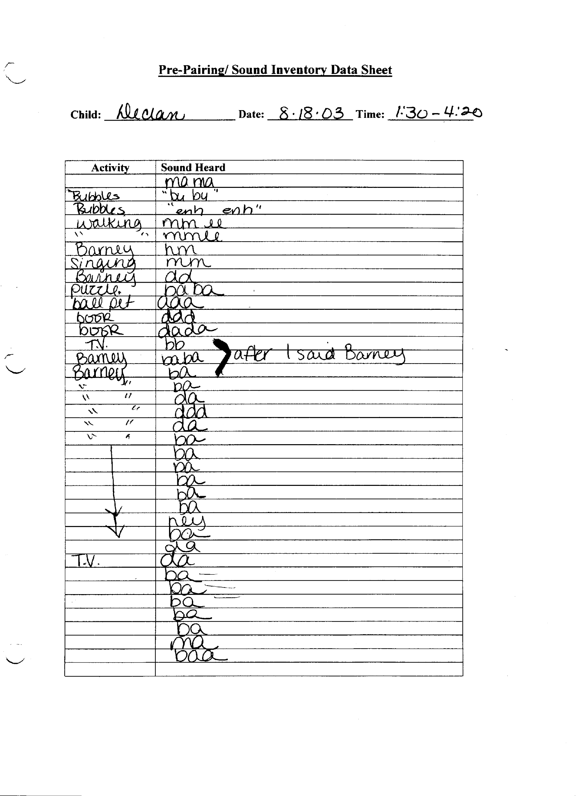

2 & 3. Articulation Inventory Across Operants & Record the type of errors.

ARTICUALTION INVENTORY ACROSS OPERANTS

Learner: _________________ Date: _______ Initials: _______ Page: ___ of _____

RECORDING:
For every response the instructor will:
- Record the specific response.
- Record the operant for that response
- For mands the prompt level necessary to evoke that response (“prompt level” column).
- Record what the learner actually says and errors (“what was said” column).

RESPONSE | Operant | Prompt (for mands only) | What the learner said and consistent errors
 | M T E I | V-ITEM-MO
 | M T E I | V-ITEM-MO
 | M T E I | V-ITEM-MO
 | M T E I | V-ITEM-MO
 | M T E I | V-ITEM-MO
 | M T E I | V-ITEM-MO
 | M T E I | V-ITEM-MO
 | M T E I | V-ITEM-MO
 | M T E I | V-ITEM-MO
 | M T E I | V-ITEM-MO
 | M T E I | V-ITEM-MO
 | M T E I | V-ITEM-MO
 | M T E I | V-ITEM-MO
 | M T E I | V-ITEM-MO

4. Kaufman Assessment as an Echoic Profile

Kaufman Speech Praxis Assessment Sheet

Child’s Name: _____________DOE: ______ Evaluator:___________________

CVCV Simple Repetitive Syllables
Word | Correct Y or N | Approximation
mama
papa
dada
neigh neigh
wuh wuh
moo moo
boo boo
baa baa
peep peep
tweet tweet

VC Initial Consonant Deletion
Word | Correct Y or N | Approximation
eye
on
up
out
in
eat

oat
arm
ouch
ant

CV Consonant - Vowel
Word | Correct Y or N | Approximation
day
two
me
tea
pea
dough
bay
bow
knee
no
new
boo
bee
whoa
tie
toe
pie

VCV Vowel- Consonant – Vowel
Word | Correct Y or N | Approximation
open
Apple
Obo
Oh no
Oh boy
o-kay

CV1CV2 Repetitive syllables with vowel change
Word | Correct Y or N | Approximation
mommy
puppy
daddy
baby
bubble
potato
people
banana
turtle

C1V1CV2 Simple Bisyllabics
Word | Correct Y or N | Approximation
honey
money
pony
bunny
penny
noodle = /nudou/
needle =/nidou/
poodle = /pudou/
puddle = /pudou/
paddle =/paedou/
beetle =/bidou/
bottle =/badou/
hippo
teddy
muddy
dirty =/duti/
potty
tuna
tuba
panda
happy
tummy
marble = /mabou/
table = /tebou/
dino = /dinosaur/
handle = /haendou/
Toby
Mona
Heidi
Paddy

CVC (Assimilation)
Word | Correct Y or N | Approximation
mom
dad
bib
tot
toot
pop
peep
nun
noon
nine

CVC Bilabial Assimilation
Word | Correct Y or N | Approximation
mop
beam
map
pom
boom
peep
poop

CVC Tip-alveolar Assimilation
Word | Correct Y or N | Approximation
dot
tin
tan
neat
nut
ton
knot
knit
toad
gnat
note
teen
date
tune
don’t

CVCVCV Simple Polysyllabics
Word | Correct Y or N | Approximation
banana
tomato
potato
domino
tornado
petunia
Bandana
Ohio
Idaho
Indian
animal
piano

C1V1C2V2 plus CVC
Word | Correct Y or N | Approximation
bottle top
honey pot
bunny hop
pony ride
panda bear
teddy bear
paddle boat
table top
tummy hurt
happy day
dirty hat
muddy boot

/m/ synthesis
Word | Correct Y or N | Approximation
man
map
mop
meat
moon
mad
mean
mitt

/t/ synthesis
Word | Correct Y or N | Approximation
top
tan
toot
tie
tin
toe
time
tape
tap
ton
team
/b/ synthesis
Word | Correct Y or N | Approximation
ball
boat
bye
bat
bow
bone
bean
bun
barn
boot
bite

/d/ synthesis
Word | Correct Y or N | Approximation
down
den
dot
deep
dip
done

/h/ synthesis
Word | Correct Y or N | Approximation
hot
home
hide
ham
hurt
hand
heat
hat

/n/ synthesis
Word | Correct Y or N | Approximation
knot
knit
nap
nip
nab
knee
night
knob
note

/w/ synthesis
Word | Correct Y or N | Approximation
one
warm
wand
wind
wheat
white
whine
wipe
wide
whip

/k/ final (Advanced)
Word | Correct Y or N | Approximation
pack
poke
pick
park
peek
book
bike
beak
bark
neck
knock
duck

/k/ initial (Advanced)
Word | Correct Y or N | Approximation
cook
kick
cake
coke
cork
cup
cow
coop
cap
can
corn
cane
comb
cab

/f/ final (Advanced)
Word | Correct Y or N | Approximation
off
puff
knife
tough
wife
wolf
cough
rough

/f/ initial (Advanced)
Word | Correct Y or N | Approximation
fan
fat
fun
food
foot
phone
four
fin
feet
farm
fit
fight

/s/ final (Advanced)
Word | Correct Y or N | Approximation
mouse
house
piece
bus
bass
toss
face
nice
dice
kiss
mess
race

/s/ initial (Advanced)
Word | Correct Y or N | Approximation
sun
soup
soda
soap
sip
sad
sand
suit
sit
sign
sword
sock

III. TEACHING METHODS

- Manding and
- Differential Reinforcement of Vocalizations during Manding

DIRECTIONS FOR RECORDING & GRAPHING VOCALIZATIONS DURING VOCAL AND SIGN -MANDING

RECORDING:
For every mand the instructor will:
- Record the reinforcer that the learner mands for (“reinforcer” column).
- Record the prompt level necessary to evoke that response (“prompt level” column).
- Record what the learner actually says (“what was said during mand” column).
  - If the vocalization during the vocal-mand is clear, deliver the reinforcer.
  - If the vocalization is not clear the instructor will then run up to 5 echoic attempts for better articulation, recording exactly what the learner said (or not) for each.
    - If during the 5 echoic trials the learner’s articulation is better, the instructor will differentially reinforce the learner depending on the trial. That is, if the learner required all five echoic trials the instructor will reinforce but not as much (magnitude) if the learner had achieved better parity during an earlier trial. That is, the learner will receive more of the reinforcer if less echoic trials were required.

DIFFERENTIAL REINFORCEMENT OF VOCALIZATIONS
DURING VOCAL MANDING

Learner: ____________________ Date:__________ Instructor: ________________

Reinforcer | Prompt Level | What was said during mand | Echoic 1 | Echoic 2 | Echoic 3 | Echoic 4 | Echoic 5
 | V ITEM MO
 | V ITEM MO
 | V ITEM MO
 | V ITEM MO
 | V ITEM MO
 | V ITEM MO

SAMPLE MAND DATA SHEET FOR VOCAL LEARNER
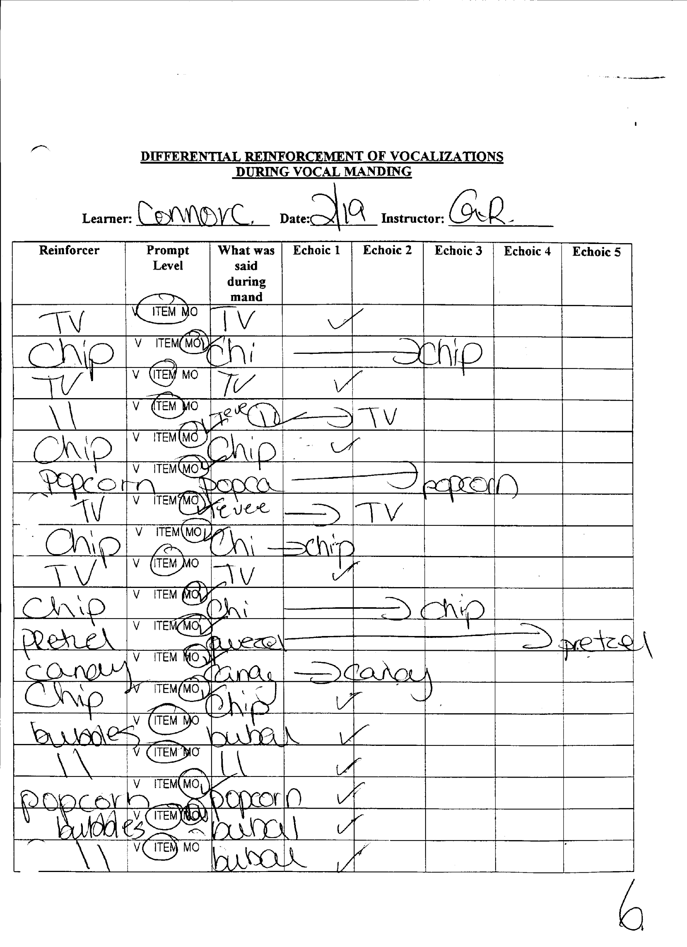

DIFFERENTIAL REINFORCEMENT DURING SIGN-MANDING

Learner: ____________________ Date:__________ Instructor: ________________

Reinforcer | Prompt Level | What was said during signing | Echoic 1 | Echoic 2 | Echoic 3 | Echoic 4 | Echoic 5
 | FPP PPP GP V ITEM MO
 | FPP PPP GP V ITEM MO
 | FPP PPP GP V ITEM MO
 | FPP PPP GP V ITEM MO
 | FPP PPP GP V ITEM MO
 | FPP PPP GP V ITEM MO
 | FPP PPP GP V ITEM MO
 | FPP PPP GP V ITEM MO
 | FPP PPP GP V ITEM MO
 | FPP PPP GP V ITEM MO
 | FPP PPP GP V ITEM MO
 | FPP PPP GP V ITEM MO
 | FPP PPP GP V ITEM MO
 | FPP PPP GP V ITEM MO
 | FPP PPP GP V ITEM MO
 | FPP PPP GP V ITEM MO
 | FPP PPP GP V ITEM MO

SAMPLE MAND DATA SHEET FOR NON-VOCAL LEARNER USING SIGN

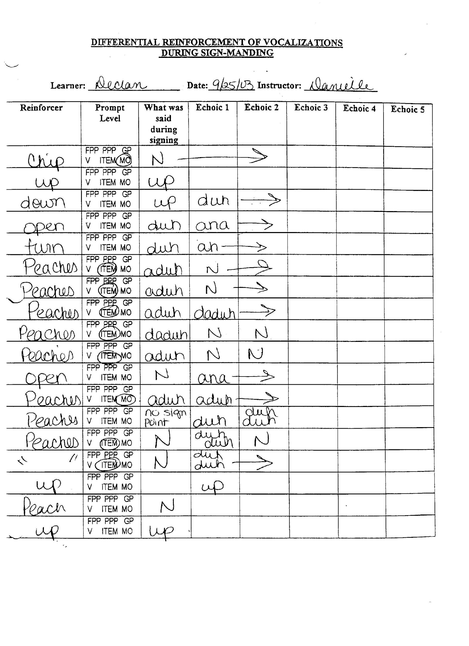

GRAPHING:
At the end of the session the instructor will graph:
- Spontaneous versus prompted mands.
  - Calculate the rate per minute for both mands that were prompted versus mands that where spontaneous (solely under the control of the MO) by dividing the frequency for each by the total number of minutes spent manding.

- Overall prompt level needed to evoke each mand for that day.
  - After the session the instructor will calculate the most frequent prompt level needed for all of the mands for that day and graph this prompt level on the graph.

- Percentage of vocalizations that was intelligible on first mand attempt.
  - After the session the instructor will calculate the percentage of vocalizations that were intelligible while manding by dividing the number of trials when the learner was clear when manding on his/her first attempt (i.e., those trials where the learner mands for a reinforcer and the vocalization was clear when the learner manded) by the total number of mands for that day.

- Percentage of vocalizations that improve during the echoic procedure.
  - After the session the instructor will calculate the percentage of vocalizations that improved during the echoic procedure by dividing the number of trials where the learner’s vocalization improved during any of the 5 echoic trials by the total number of trials (i.e., one trial is counted for all five, if necessary) when the procedure was implemented for that day.

SAMPLE PROMPTED AND UNPROMPTED MAND GRAPH
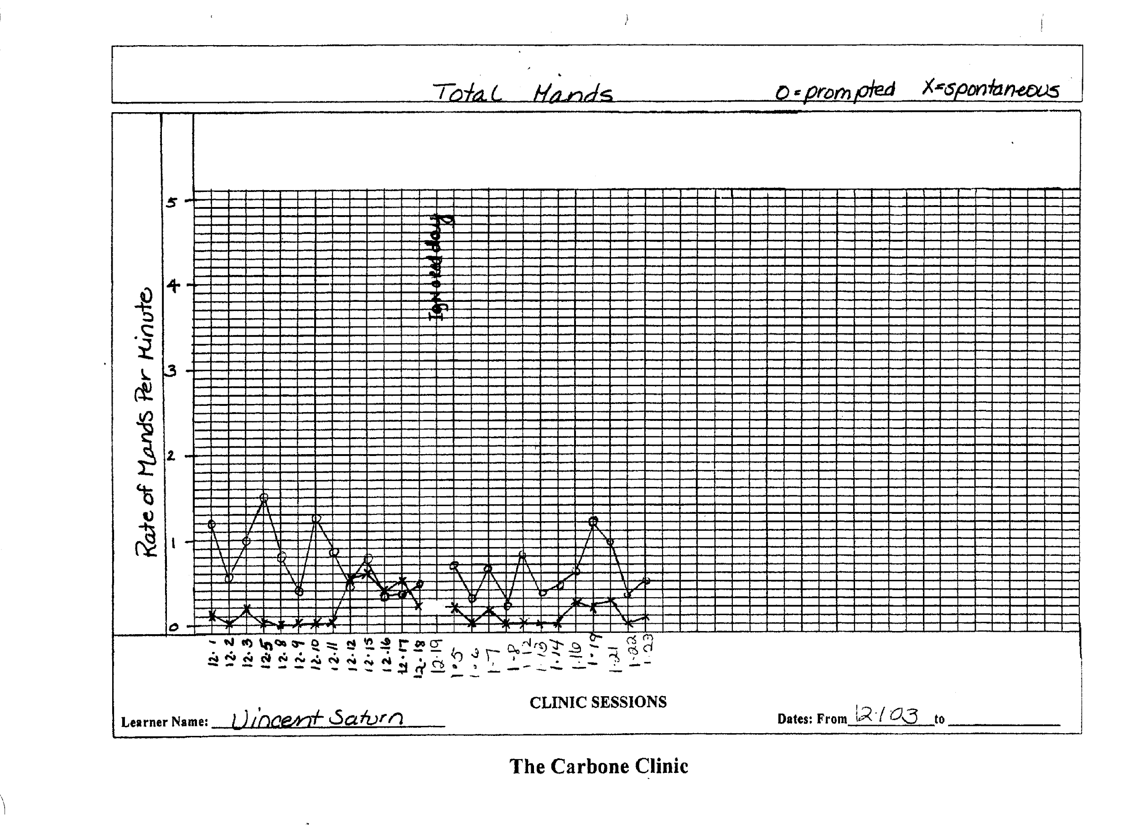

SAMPLE MAND PROMPT LEVEL GRAPH
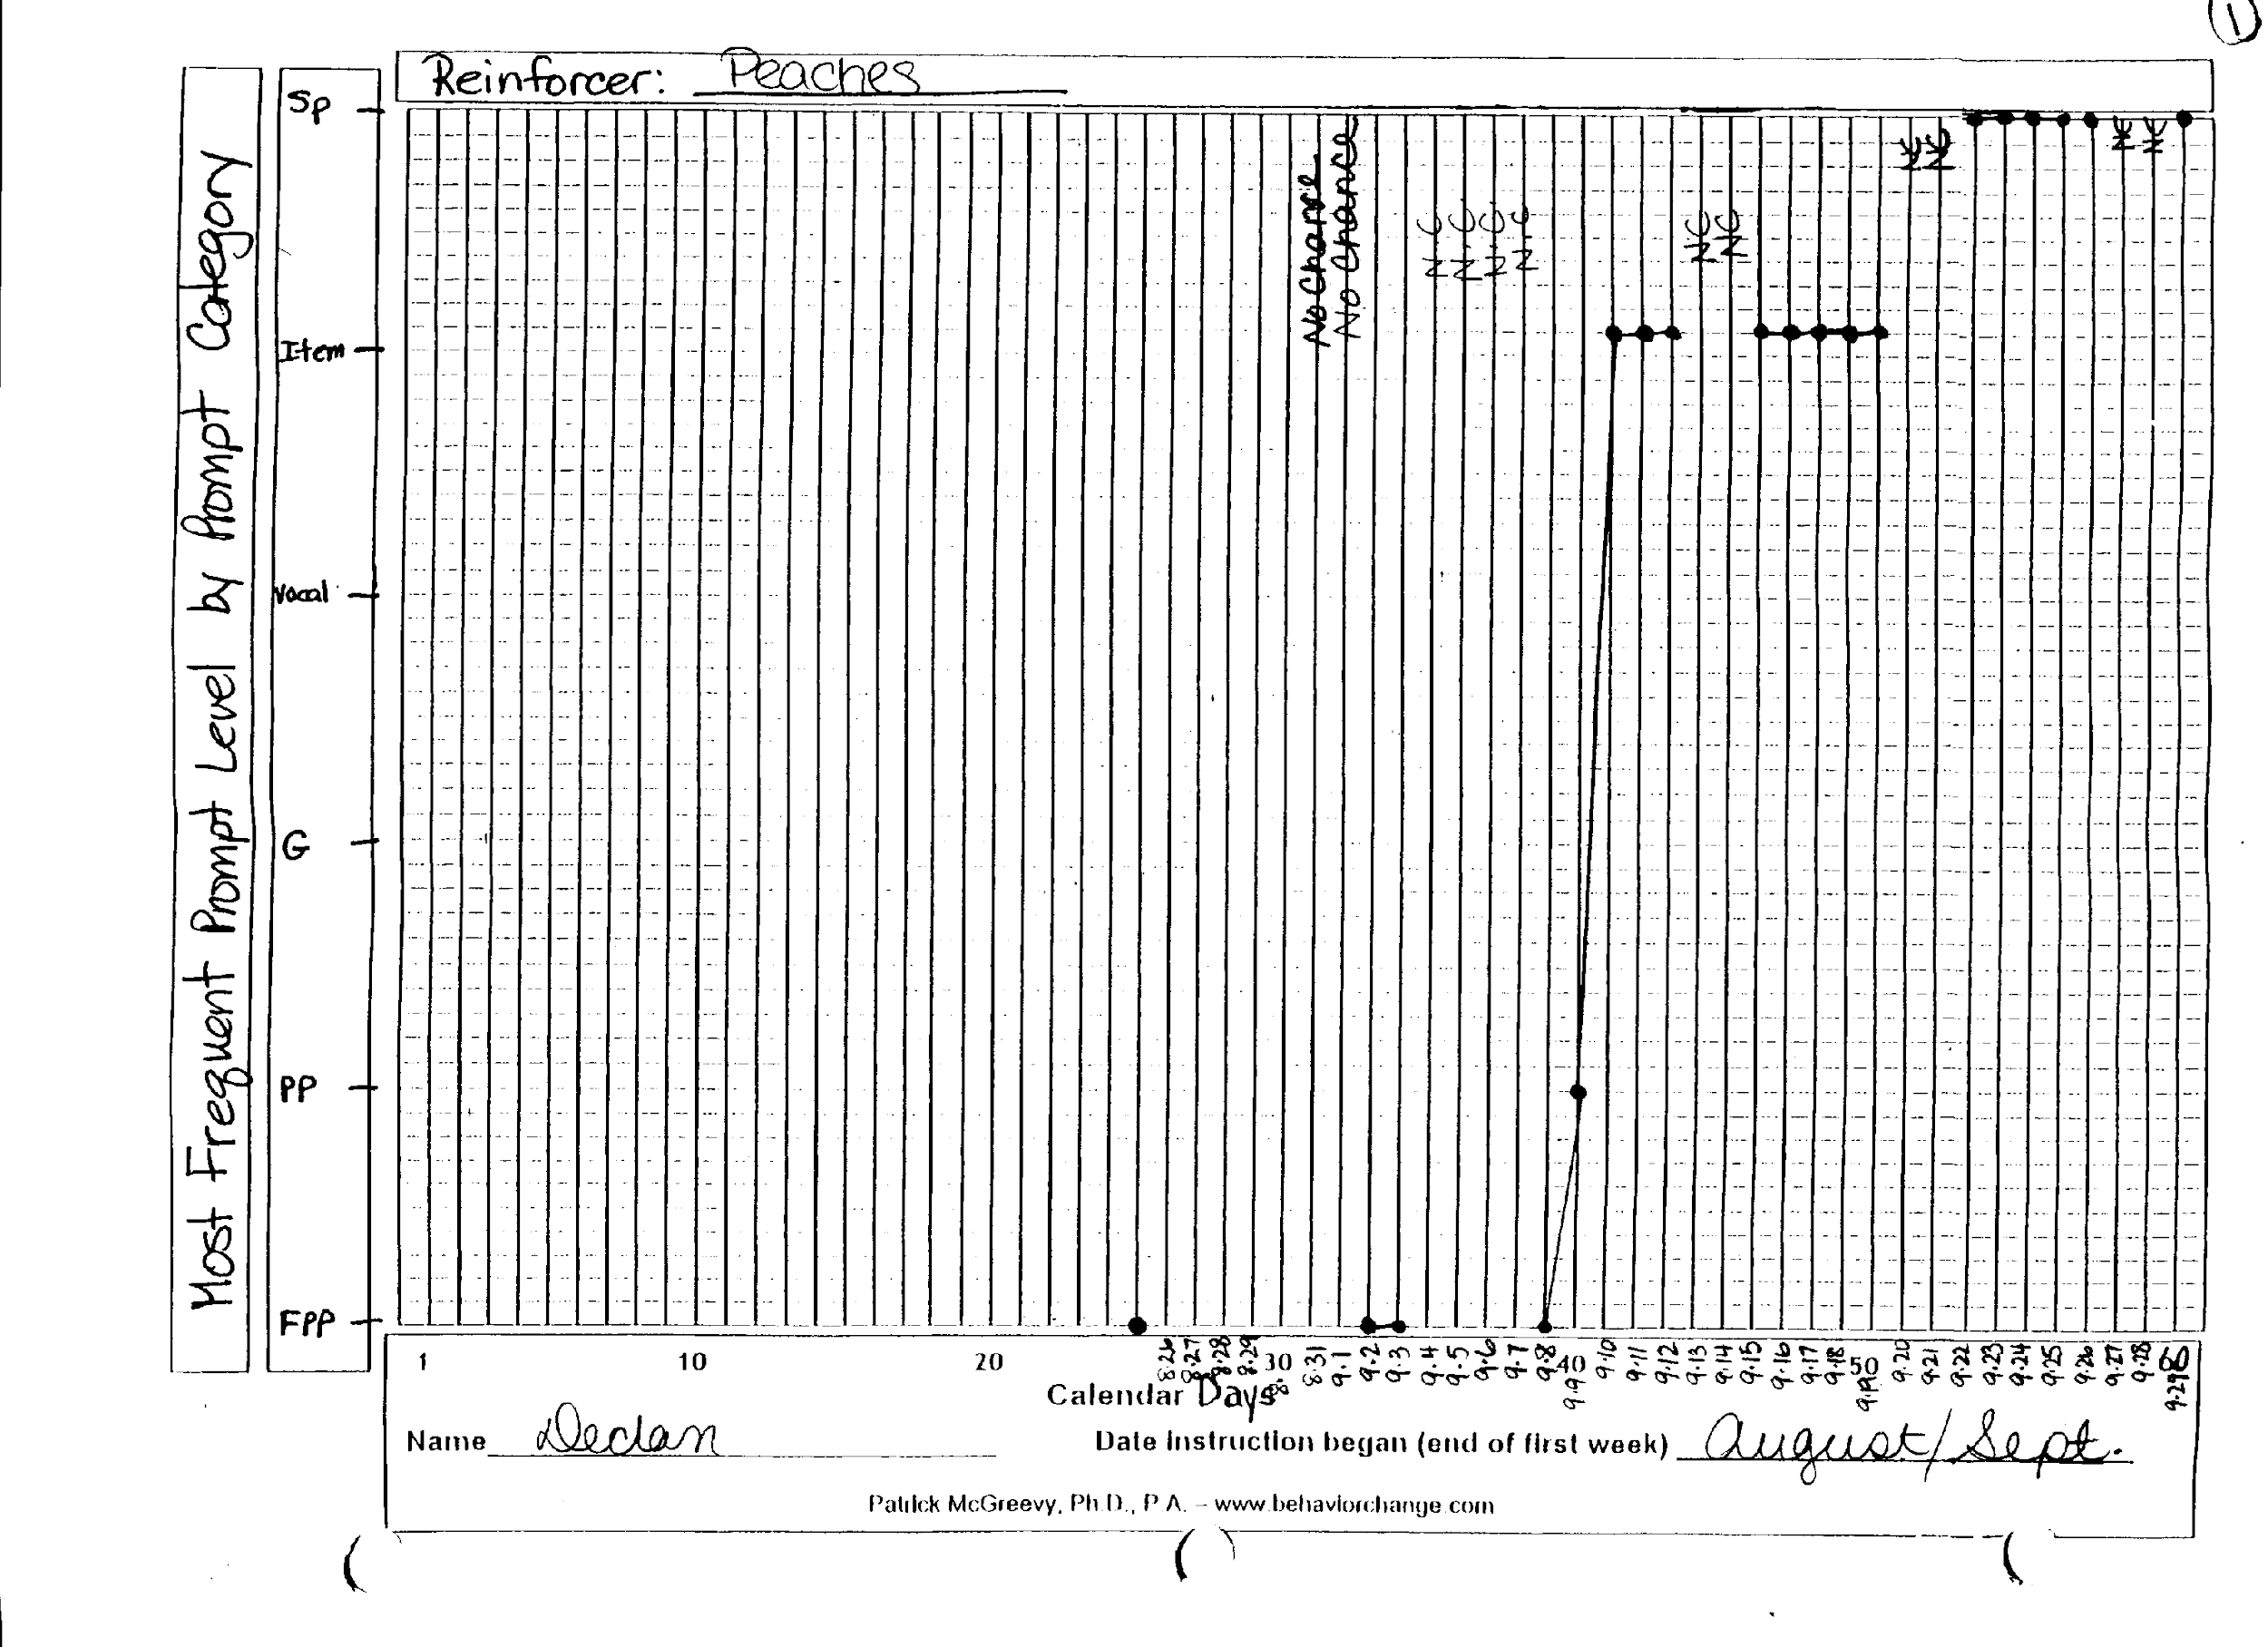

SAMPLE VOCALIZATION AND IMPROVEMENT GRAPH
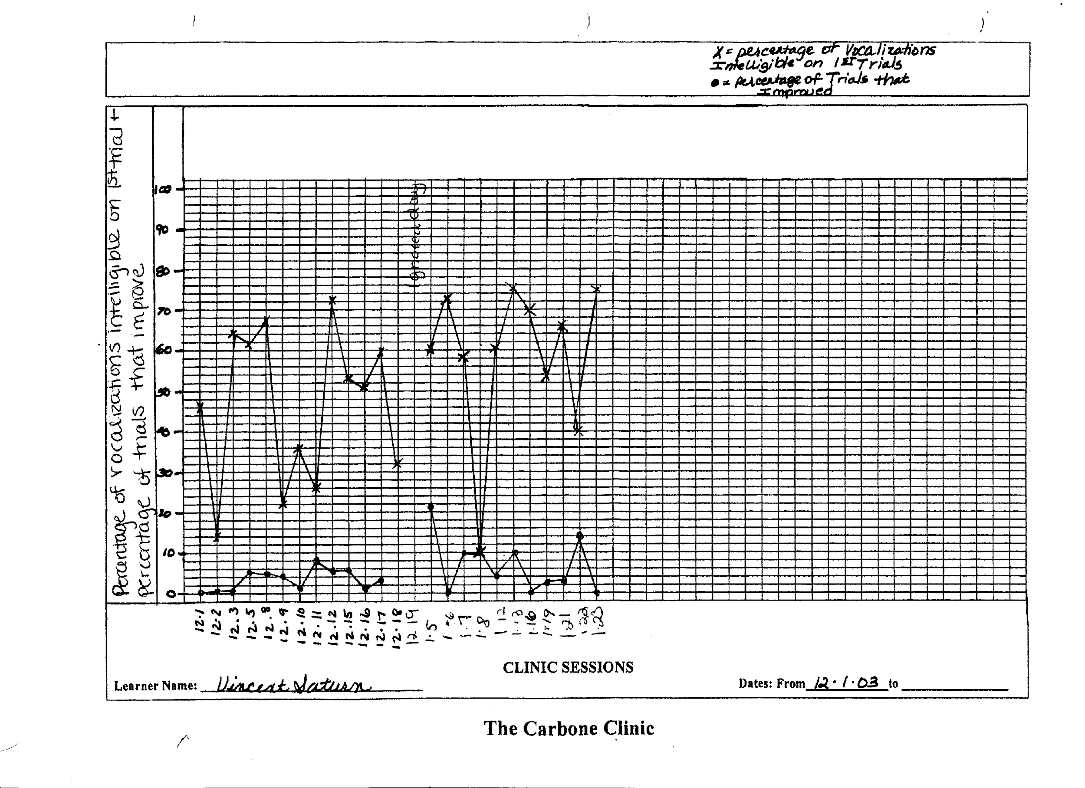

3. Automatic Reinforcement Procedure

Step one-Inventory of Sounds

Pre-Pairing/ Sound Inventory Data Sheet

Child: _______________________ Date: _______________ Time: _______________

Activity | Sound Heard

SAMPLE INVENTORY OF SOUNDS FORM

Step Two- Stimulus-Stimulus Pairing Procedure

Automatic Reinforcement Procedure

Child: ______________________ Target: _______ Date: ________ Time: _________

Procedure:
- Present target sound 3 times or greater with a 1 sec. delay between each presentation.
- If the child echoes the sound during any one of the presentations reinforce and do so abundantly.
- If after the final presentation of the trial the child doesn’t echo the sound, reinforce anyway but not as much as you might it they echoed back the target sound.
- If the child emits any other sound during your presentation of the target sound continue with presenting the target until you get to the final presentation, again reinforce anyway but not as much as you would if it were the target sound.
- Take trial by data on what the child said if anything in the space below the trial number (see below).

1 | 2 | 3 | 4 | 5 | 6 | 7 | 8 | 9 | 10
11 | 12 | 13 | 14 | 15 | 16 | 17 | 18 | 19 | 20
21 | 22 | 23 | 24 | 25 | 26 | 27 | 28 | 29 | 30
31 | 32 | 33 | 34 | 35 | 36 | 37 | 38 | 39 | 40
41 | 42 | 43 | 44 | 45 | 46 | 47 | 48 | 49 | 50
51 | 52 | 53 | 54 | 55 | 56 | 57 | 58 | 59 | 60
61 | 62 | 63 | 64 | 65 | 66 | 67 | 68 | 69 | 70
71 | 72 | 73 | 74 | 75 | 76 | 77 | 78 | 79 | 80
81 | 82 | 83 | 84 | 85 | 86 | 87 | 88 | 89 | 90
91 | 92 | 93 | 94 | 95 | 96 | 97 | 98 | 99 | 100
Key: “+” target sound “---“no sound “o” other sound

STEP THREE: MEASURING SUCCESS
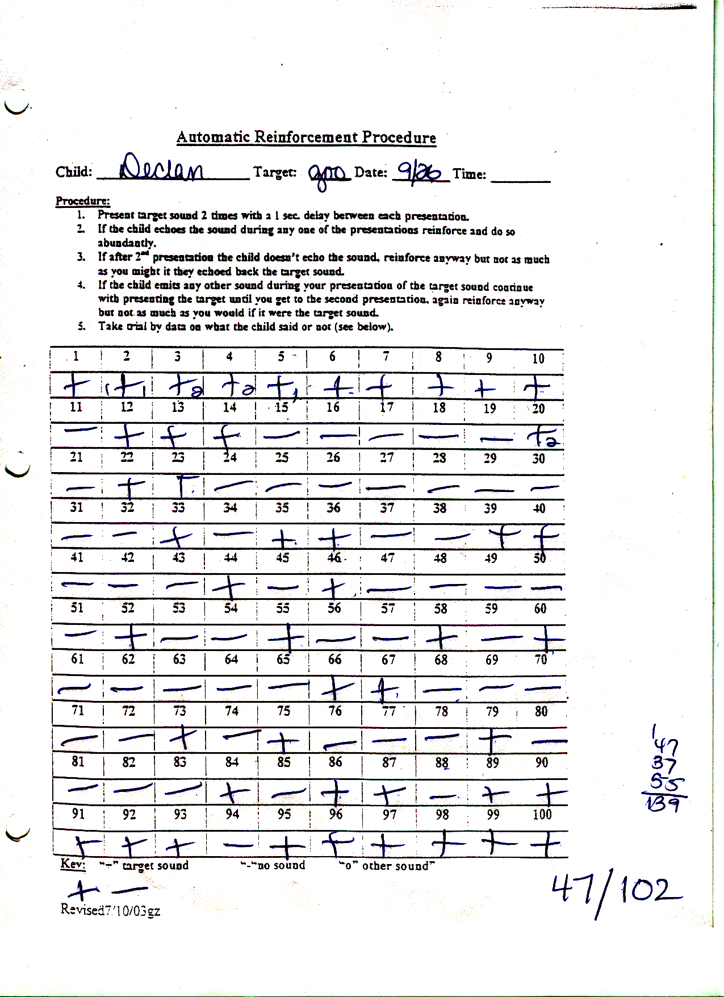
SAMPLE STIMULUS-STIMULUS PAIRING FORM

PERCENTAGE OF TARGET RESPONSES
MUH

CUH

GOO

DURING ARP PROCEDURE

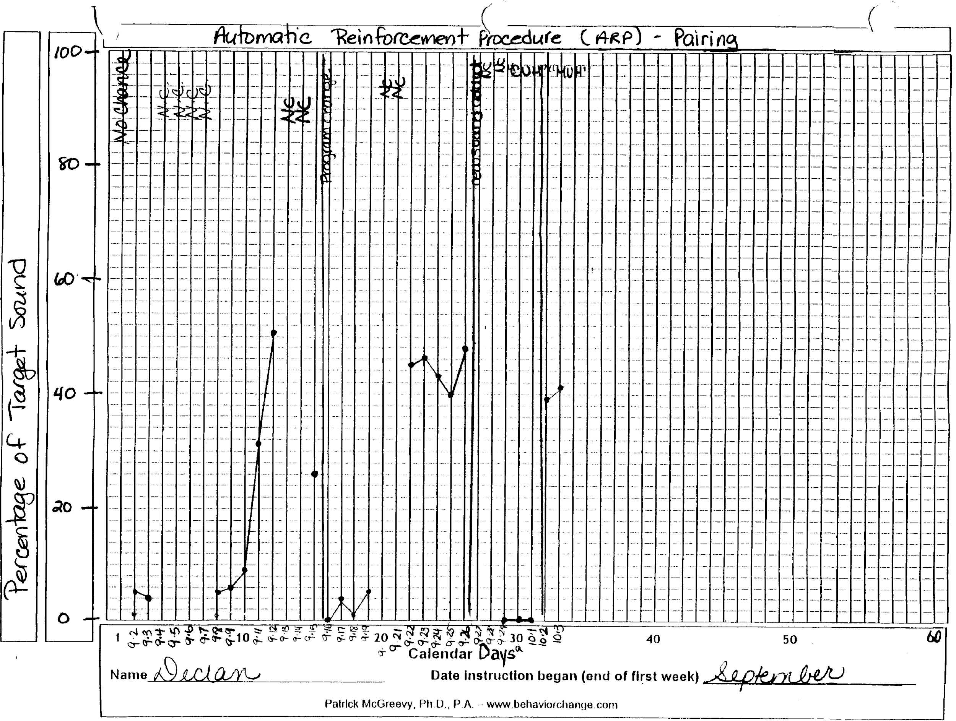

DUH

BUH

STEP FOUR: DEVELOPING THE ECHOIC FROM STIMULUS-STIMULUS PAIRING PROCEDURE

SAMPLE ECHOIC DATA SHEET OF SOUNDS
DEVELOPED THROUGH ARP
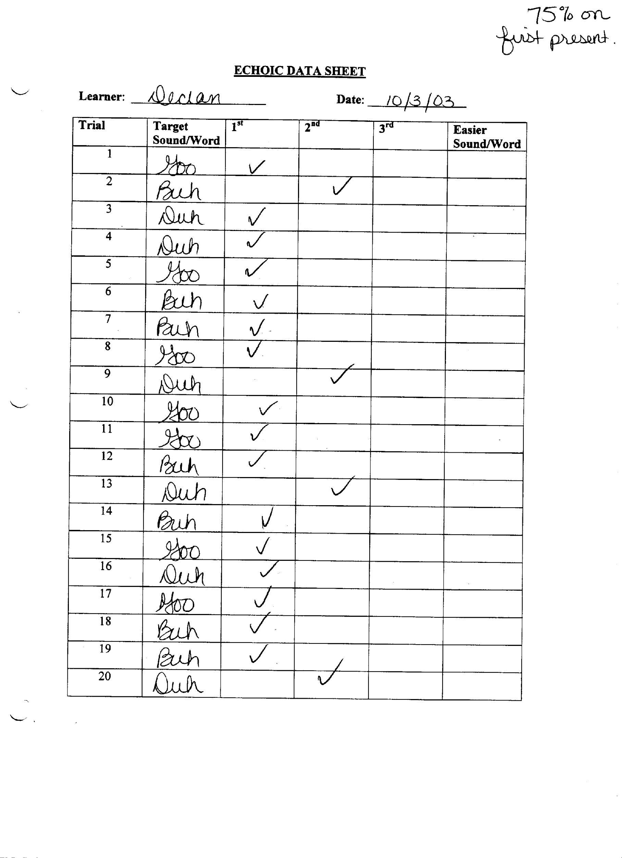

SAMPLE ECHOIC GRAPH

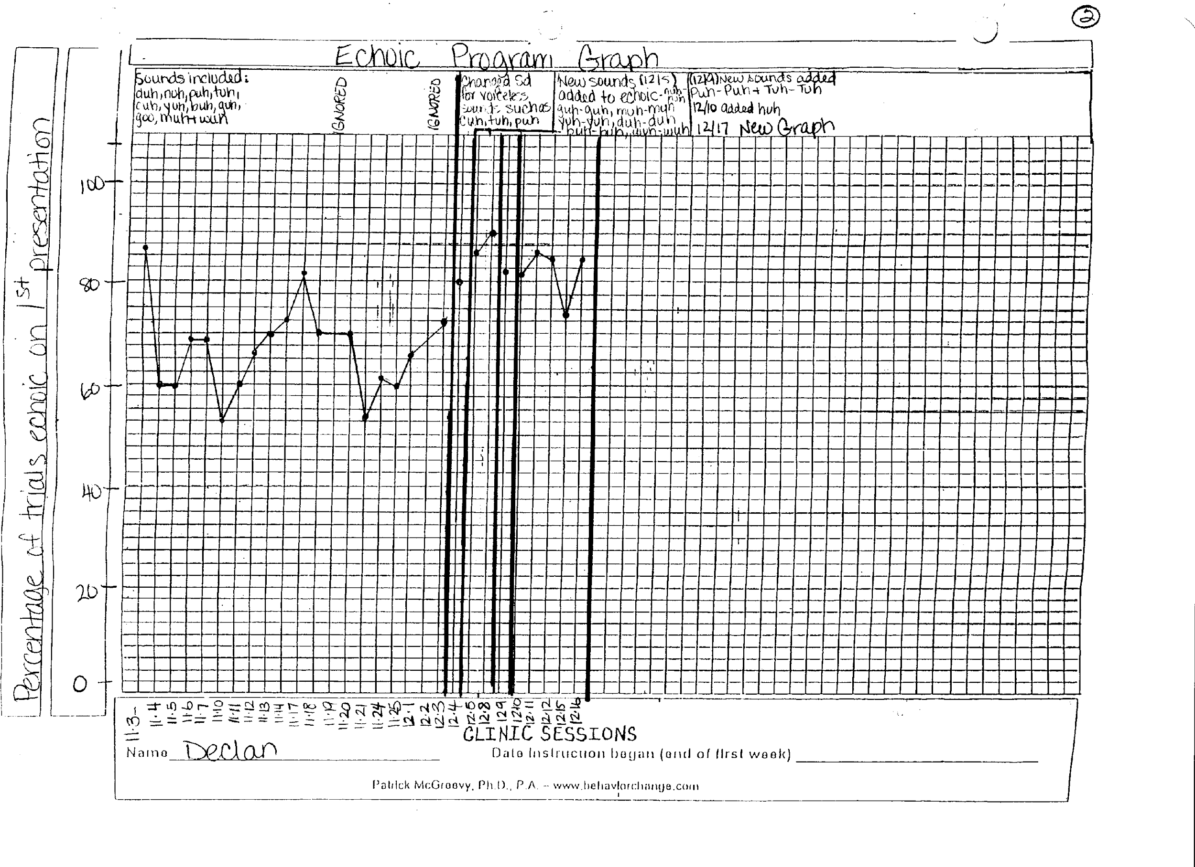

4. KAUFMAN ECHOIC TEAHCING PROCEDURES

SAMPLE KAUFMAN ECHOIC PROBE DATA SHEET
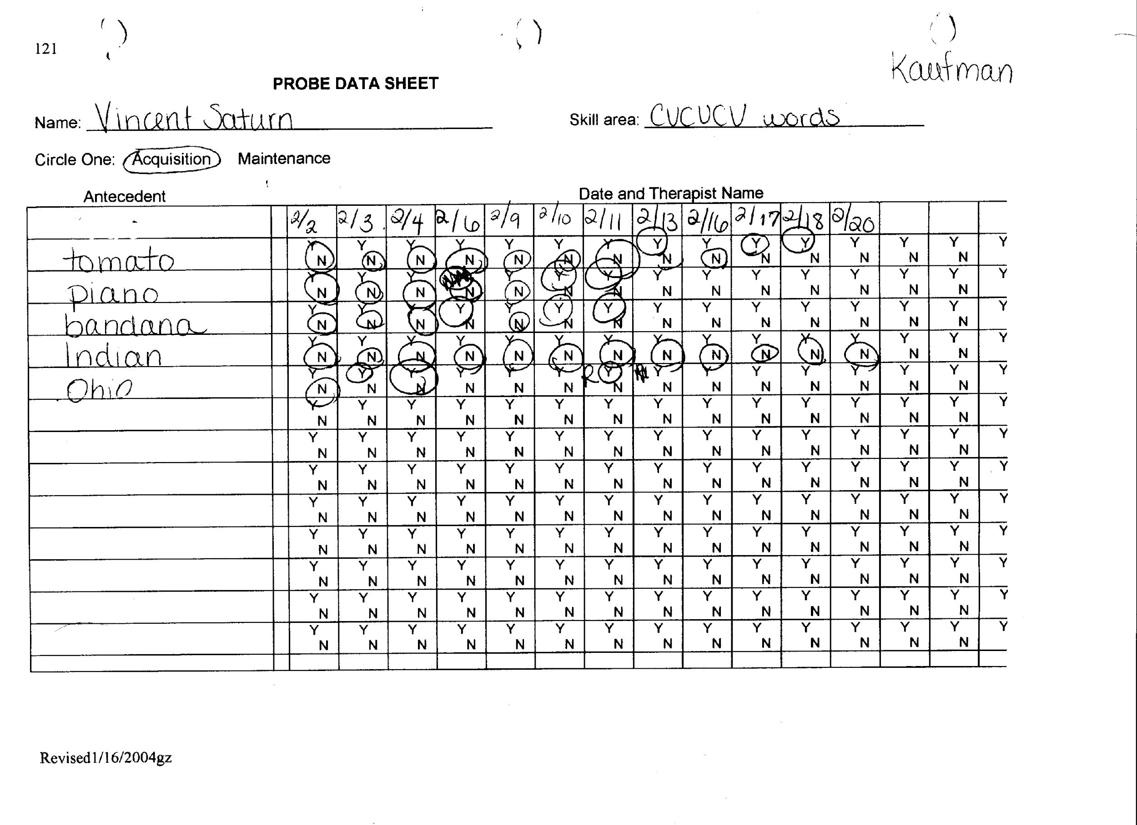

Below is what appears on the CVCVCV Kaufman card for tomato. Note how the word is broken into word shells. The recording procedure is to present the word shells for the words in the appropriate category and mark the shell on which parity was achieved for that day. Note the * indicates the shell which met parity for the day.

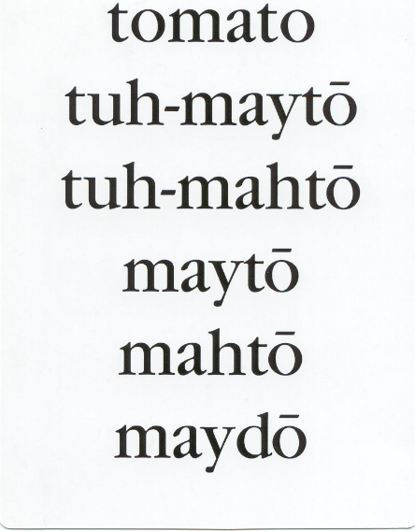
*

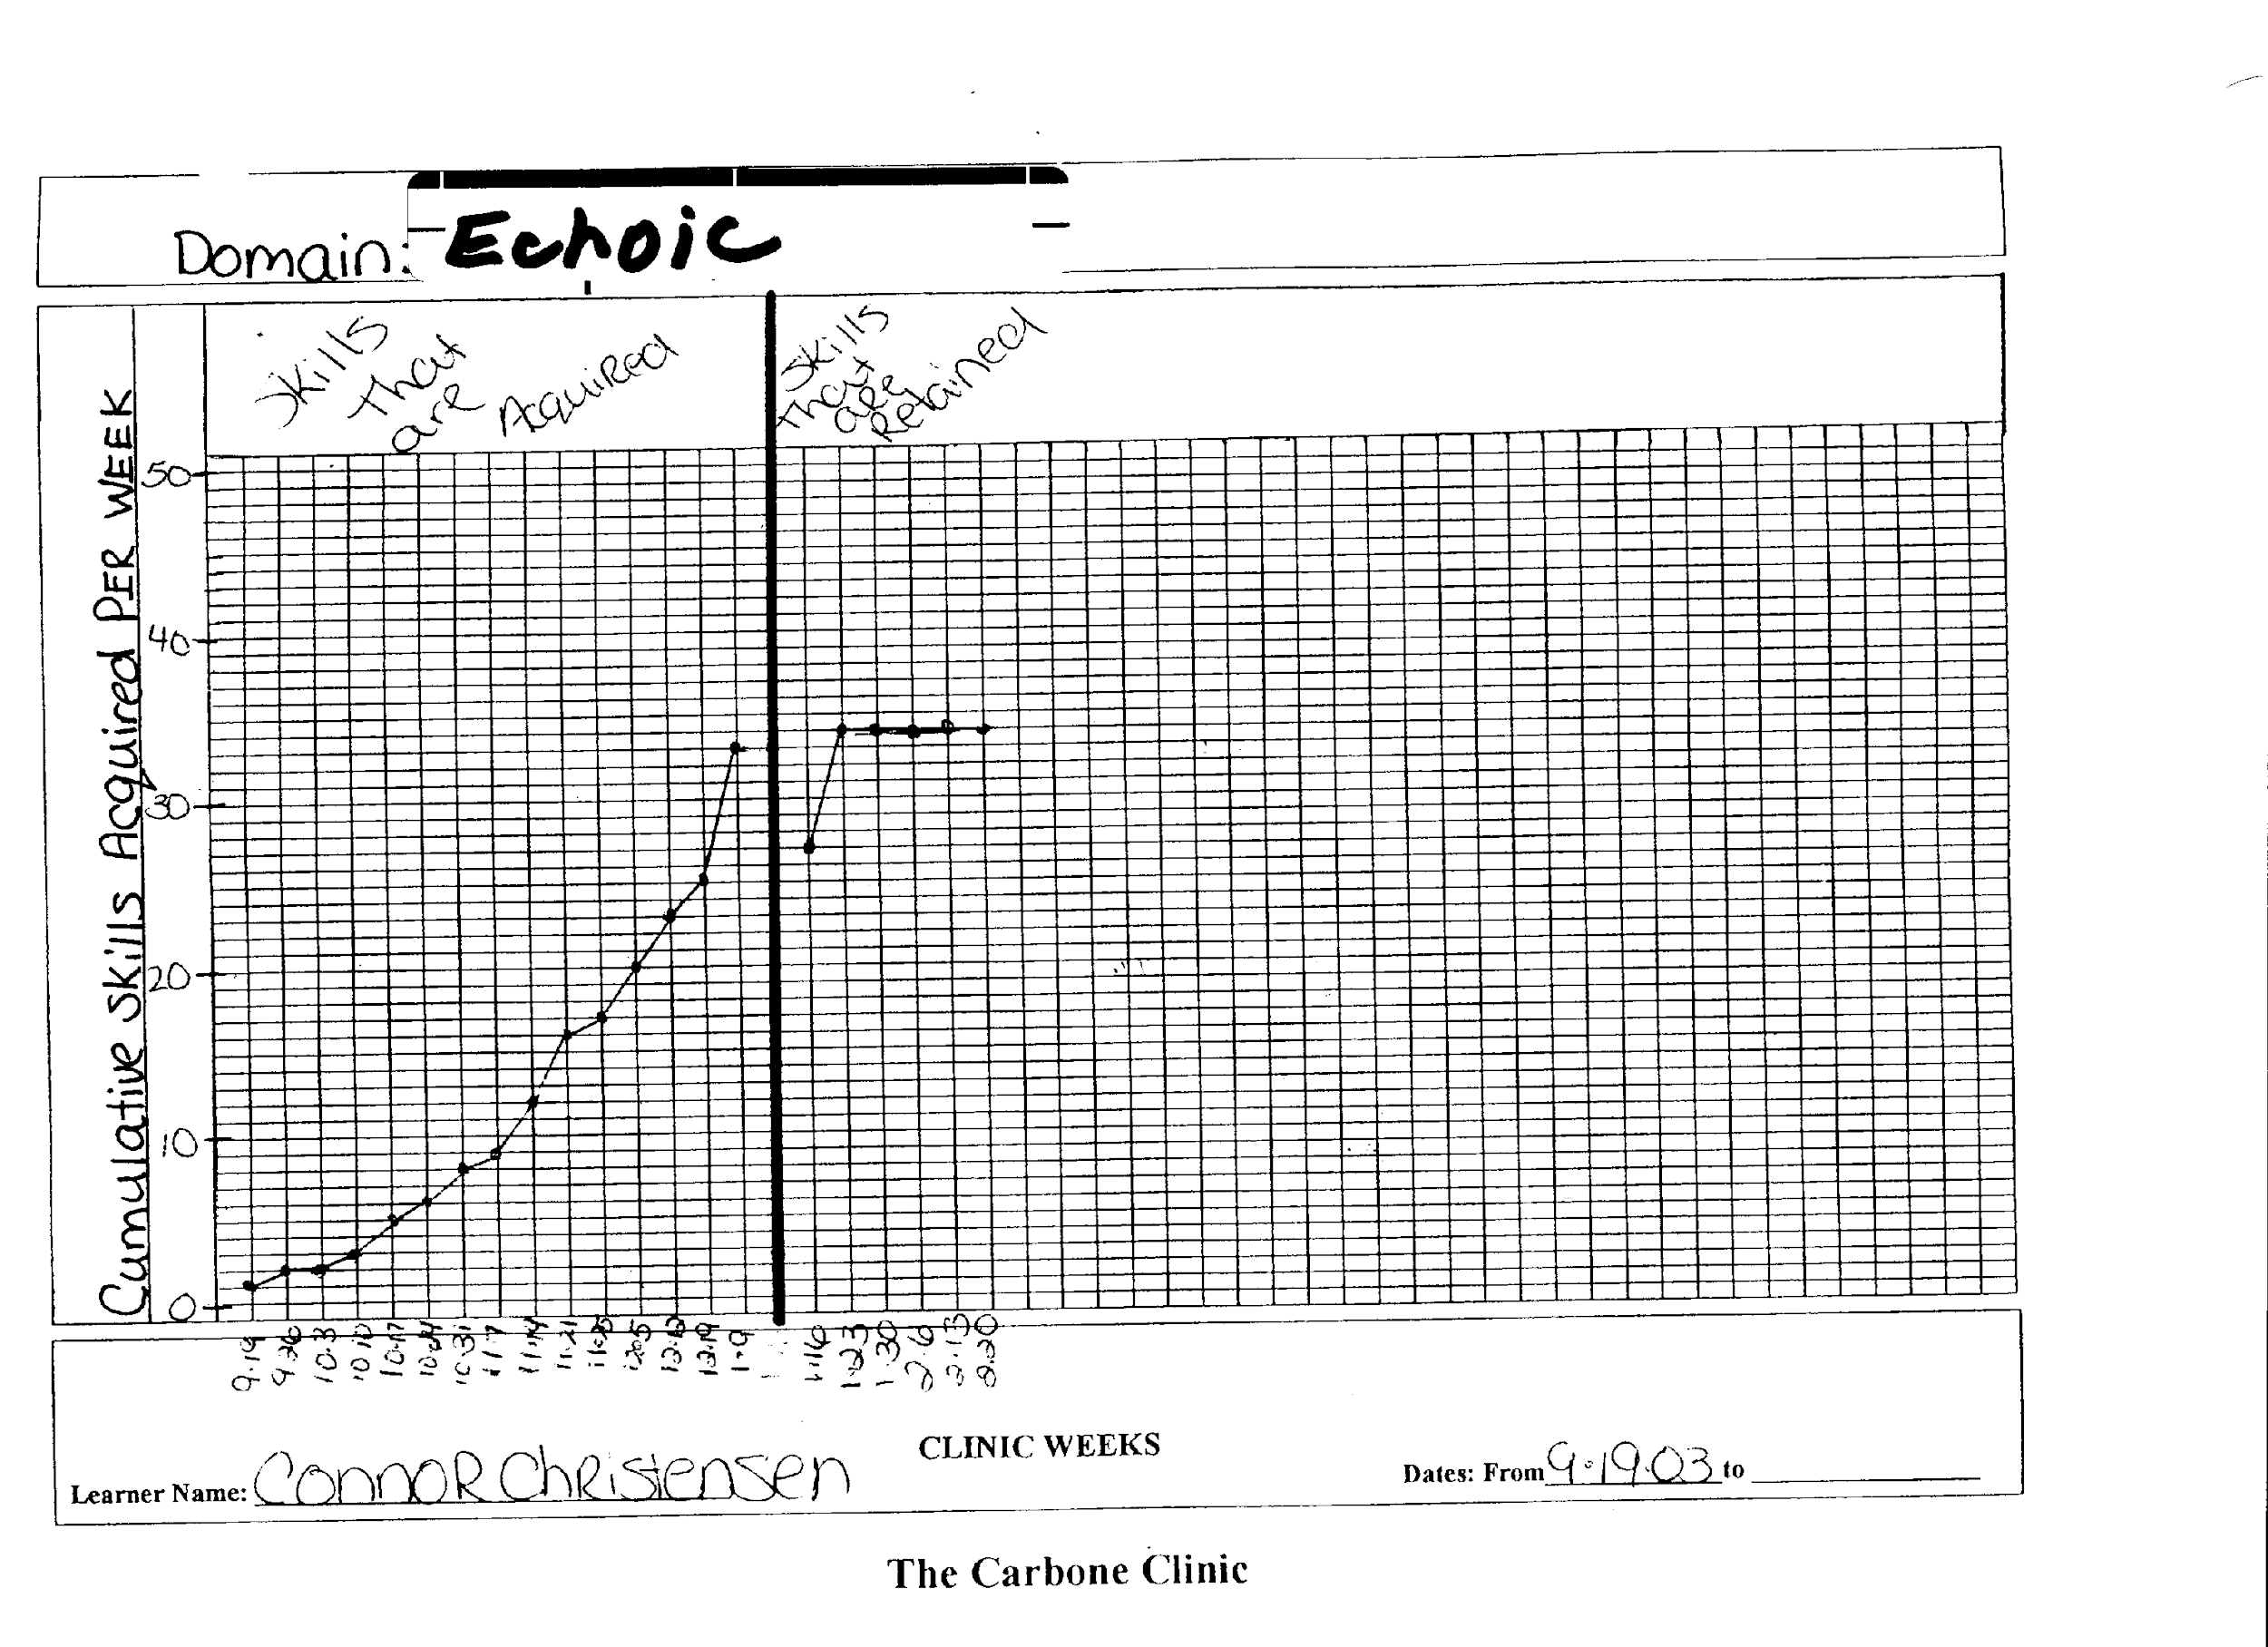
WEEKLY CUMULATIVE GRAPH OF KAUFMAN WORDS MEETING CRITERION ON THE COLD PROBES.

SAMPLE PAGES FROM THE KAUFMAN ECHOIC PROTOCOL COMPLETED WITH A LEARNER VINCENT.
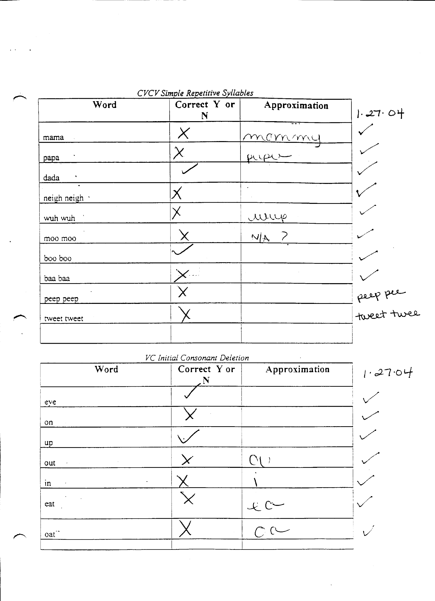

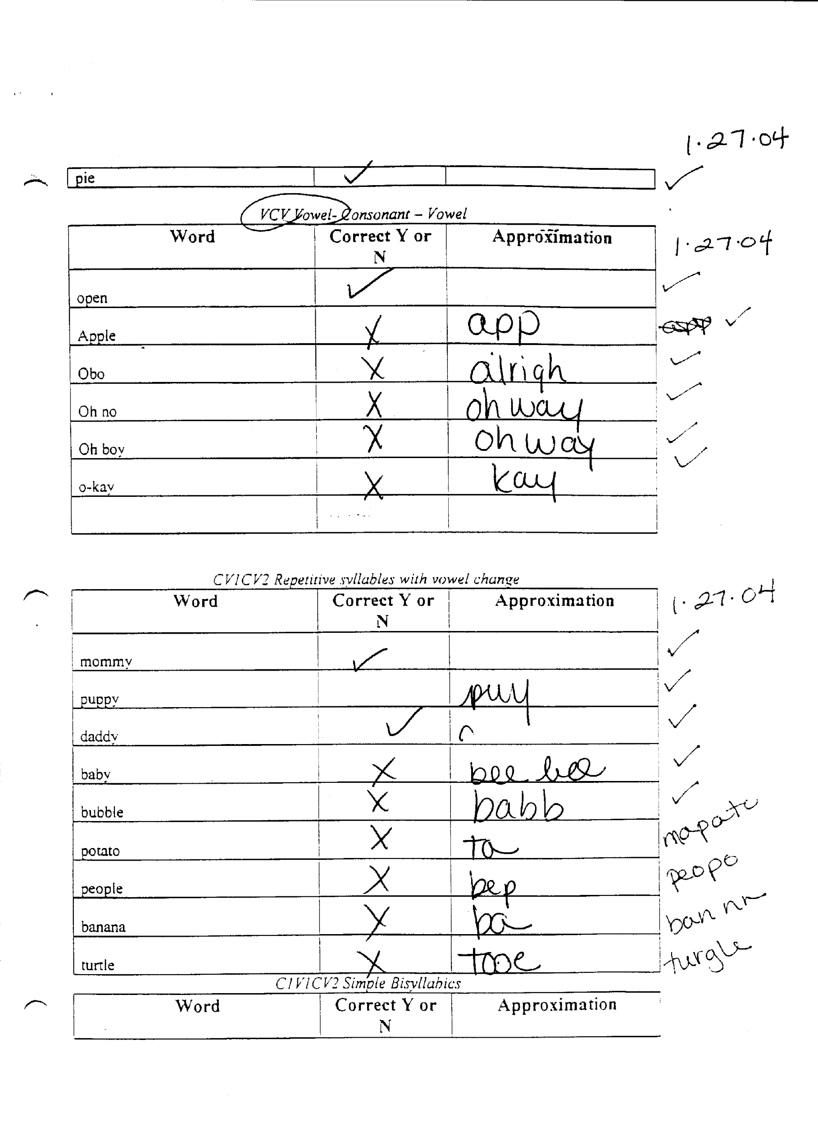

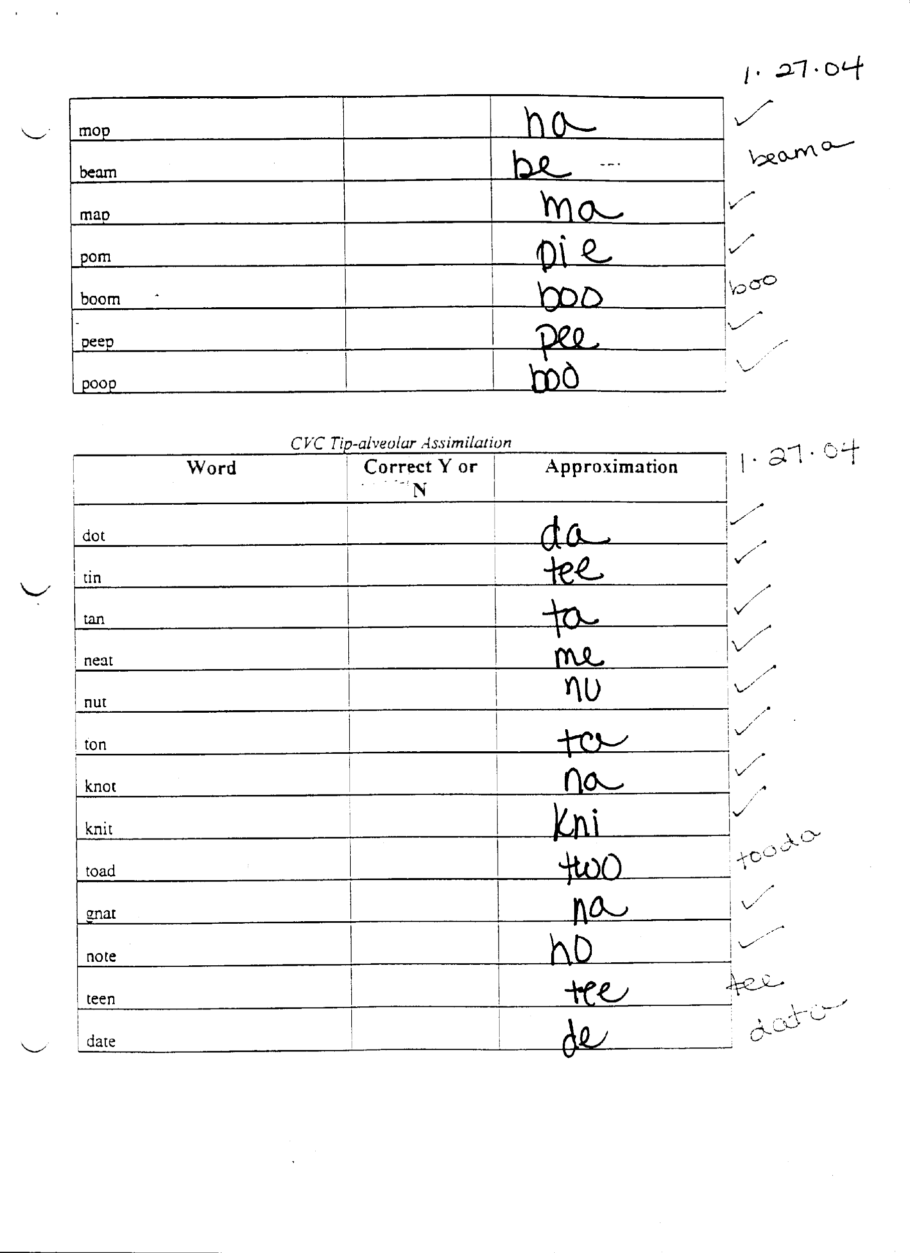

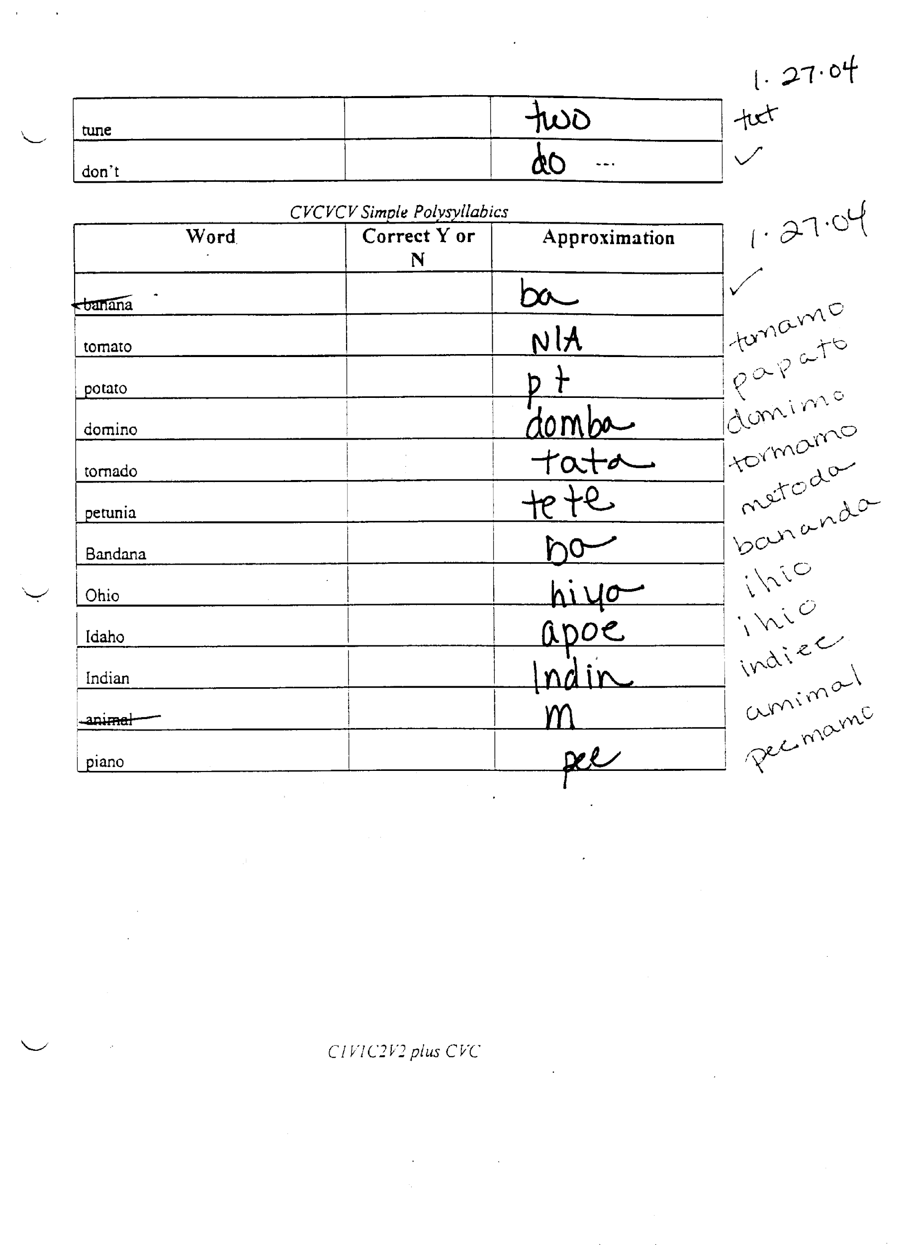

5. ECHOIC PROCEDURE: Not Kaufman

Implement procedures as described above in non-Kaufman echoic section. Targets in this section will mainly be chosen from the mands and other operant categories that are demonstrating low intelligibility. Use the probe data sheet and the graph that is recommended in the Kaufman section.

