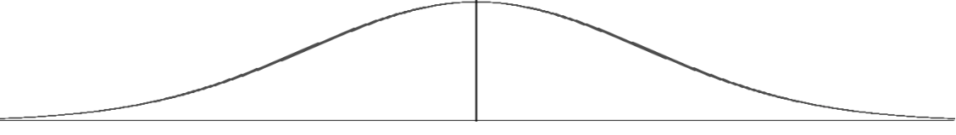

Escalation Cycle: Student and Staff Responses
(adapted from Bounds, 2003)

Calm  -Accepts feedback  -Ignores distractions  -Completes tasks | Triggers  -Conflicts  -Demands  -Changes in routine  -Lacks social skills | Agitation  -Argues  -Refuses  -Runs away  -Withdraws socially  -Paces | Acceleration  -Questions authority  - Argues  -Whines/Cries  -Threats  -Verbally abusive | Peak  -Aggressive  -Destroys property  -Injures self  -Runs away  -Screams | De-Escalation  -Withdraws socially  -Denies behavior  -Avoids discussion  -Sleeps | Recovery  -Subdued  -Defensive  -Avoids discussion  -Attempts to correct problem | Return to Calm  --Listens  -Accepts feedback  -Accepts praise  -Responds  appropriately

Specific Staff/Adult Responses
Prevention  -Reduce distractions  -Provide quite space  -Establish clear expectations  -Praise compliance  -Plan ahead for  transitions | Prevention & Redirection  -Identify patterns  -Teach app. response  -Rehearse appropriate response  -Reinforce app.  response | Reduce Anxiety  -Show empathy  -Redirect and modify  -Provide choices  -Provide space  -Offer calming strategies  -Brief interactions | Safety  -Do not engage  -Remove triggers  -State bottom line  -Provide choices  -Use calm but stern tone  -Non- threatening | Crisis Intervention  -Repeat bottom line  -Repeat choices  -Follow through with plan  -Emergency Safety Interventions | Remove Excess Attention  -Avoid discussion of behavior  -Provide simple and concrete directions | Re-Establish Routines  -Provide more structure and movement  -Reinforce compliance  -Give simple debrief | Discussion  -Restate expectations  -Discuss replacement behavior  -Give encouragement

Appropriate Responses to the Seven Phases of the Escalation Cycle
Managing the Cycle of Acting-Out Behavior in the Classroom (Colvin, 2004)

Phase 1: Calm
Classroom Structure & Quality Instruction
- Supervise, reduce distractions, and provide quiet space.
- Establish and teach CLEAR expectations and acknowledge and praise compliance.
- Establish routines to decrease downtime and disruptions.
- Plan ahead for transitions and entry and exit routines.

Phase 2: Triggers
- Identify the situation where the behavior is likely to occur.
- Use pre-correction to teach appropriate response. Rehearse the expectations, prompt or remind students as needed, provide specific praise and reinforcement.
- Work with all staff and faculty to teach and reinforce social skills.
- Group social skills, anger management, community services.

Phase 3: Agitation
- Show empathy: recognize the student’s problem and communicate concern.
- Redirect and help the student become engaged in activity, lesson or task (passive or movement).
- Provide choices.
- Provide space in a quiet area or allow students to disengage briefly or put their heads down.
- Use proximity or brief interactions; show acceptance.

Phase 4: Acceleration
- Pause and Assess- “Is this an emergency situation?”
- Avoid escalating the student’s behavior.
- Pausing rather than responding immediately shows students that while they may be out of control, staff are calm and controlled.
- Use a calm but serious tone.
- If the situation escalates, withdraw and follow school procedures for emergency situations.

Phase 5: Peak
- Focus on student and staff safety (limit interactions for safety purposes).
- Notify necessary staff of situations and provide directions for response.
- If needed, evacuate others.
- Contact appropriate assistance.

Phase 6: De-escalation
- Once escalation is over, allow student space to calm down, under supervision.
- Provide independent work that is fairly easy to complete to help regain focus.
- Debrief and document the incident to provide data for ongoing planning for safety.

Phase 7: Recovery
- Help student return to normal activities and engage in learning.
- Continue with planned consequence and do not discuss or negotiate.
- Acknowledge cooperative and appropriate behavior.
- Encourage and support student in changing problem behavior.

Reference:
Colvin, G. (2004). Managing the cycle of acting-out behavior in the classroom. Eugene, OR: Behavior Associates.

