Staff Recognition Plan for Reducing ESI
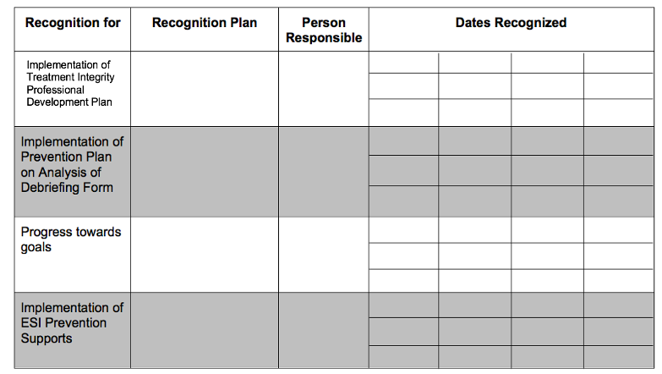

Adapted from Huckshorn, K.A.; LeBel, J.; Caldwell, B. (Eds.) (2018). Six Core Strategies©: Preventing Violence, Conflict and the Use of Seclusion and Restraint in Inpatient Behavioral Health Settings. An Evidence-based Practice Curriculum Training Manual. Originally developed with the National Association of State Mental Health Program Directors (2002-2009): Alexandria, VA. All rights apply to use of these author edited material

s.

