What are ready hands?
- Ready hands, is a hand position, in which someone interlaces their fingers in front of them.
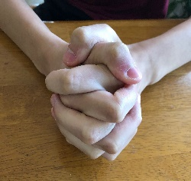
- In some cases, it may be changed based on individual need such as placing hands on top of one another, holding a fist with the opposite hand, curling fingers around each other without fully being interlaced, etc.
Examples:
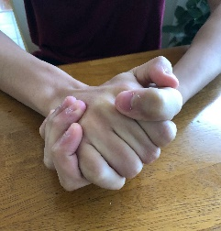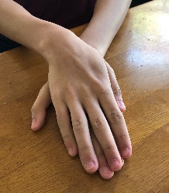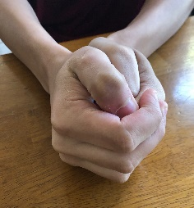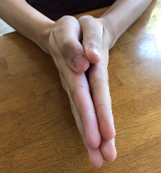
Why teach ready hands?
- The ready hands position is a “ready to learn position”. It is compatible with cooperation during any activity that requires a person to be relatively still.
- Problem behavior often involves movement of hands and limbs away from the center of the body. For example, hitting, grabbing, hair pulling, throwing, swiping objects, etc.
- The “Ready hands” position can prevent and interrupt problem behavior that involves use of the hands and arms
- Moving hands together and interlacing fingers is incompatible with movement of hands away from center of body. When a child correctly responds to a parent saying, “ready hands,” they place their hands in a position that don’t allow the problematic positions to occur at the same time.

How to teach ready hands

Your goal is to be able to say “ready hands” to the child, and they then respond by putting their hands in the correct position. There are two steps to teaching this skill; phase one involves teaching the child to imitate the ready hands position. Phase two involves teaching the child to follow the directions “ready hands.”

Phase One
- If you child can already imitate you when you say “do this” while showing them ready hands position, then skip to phase two.
- Begin with teaching the child to imitate when you show them the ready hands position.
- Begin by saying “do this,” while you show the ready hands position for your child to copy and quickly guide the child’s hands to the imitate the ready hands position.
- Next, say “do this,” while you show ready hands again. This time, look to see if the child can put their hands in the position without you touching them.
- Briefly distract your child: this could be as simple as having your child imitate something else you do, or attend to something else around the house “look at the dog!”
- Check for independence: Say “do this,” while you show ready hands again without using a physical prompt
- When the child imitates you doing ready hands, make things better for them. Immediately praise them and provide some fun interaction. This can be done at any point that your child imitates you, even after a physical prompt if they are just learning the skill. As the child becomes more independent in imitating you doing ready hands, you can provide fun consequences only for imitating ready hands without any help. When you make things better immediately following the behavior and that behavior happens more often in the future, the consequence is called reinforcement and we would say you reinforced the behavior!

- It’s ok if your child makes a mistake when learning to imitate ready hands. Simply guide your child hands to their sides and ask them to imitate again, but this time provide physical guidance, so that they don’t make the mistake again. After correcting them with the physical guidance, continue with the rest of the steps: model ready hands without physical guidance, distract them, and check for independent responding. If they respond correctly, reinforce!

- If they make errors on steps 2 and 4 (when you have them imitate with no help from you), then do not remove all your help. Instead, when you run these steps, provide some physical guidance (enough so they get it right), but not as much physical guidance as in step 1 so that you are working in small steps to take away your help until they can do it completely on their own. In this case, you would reinforce every time they do it with less help. The less you help, the better the reinforcement should be.

Phase Two
- After your child can successfully imitate your ready hands position, they are ready to learn to respond to you telling them to show you “ready hands”
- The first step involves saying “Ready hands” or “Show me ready hands,” while showing the child ready hands. Since you already taught the child how to imitate ready hands, this should be easy for the child to do. The help you provide in this case is just modeling the behavior, but no physical guidance should be necessary.
- Next, ask the child to show “ready hands” again. This time do not show the child how to do it. In other words, do not use imitation along with the direction “Ready hands.”
- Briefly distract your child by asking them to do something that is easy for them to do, and can be done quickly.
- Check for independence: Say “Ready hands” and check to see if your child can follow the direction.
- Similar to teaching your child to imitate the ready hands position, it’s ok if mistakes occur when you’re teaching the child to follow the direction “ready hands.’ Again, briefly stop, repeat your direction, and repeat your direction followed by providing the model for your child to imitate ready hands. Then, ask the child to follow the direction again with no imitation help. Next, distract the child by asking them to do something easy, and last, check to see if they independently follow the direction. Just remember, more independence in following the direction should get more, or better, reinforcement from you!

Considerations for teaching ready hands
- Strike when the iron is cold! -- That is, teach the ready hands position when your child is not engaging in problem behavior. Ready hands is a response that should be paired with improving conditions! Practice the skill often and make it fun for your child to learn this skill.
- Practice! Practice! Practice! – Find time throughout the day to teach and practice the ready hands position. Even after your child is able to respond quickly and independently, it’s important to practice ready hands when they are not engaging in problem behavior, so that the ready hands position stays paired with improving conditions.
- Once the child has learned to follow the direction “ready hands,” you will need to occasionally practice the skill and provide occasional reinforcement.
- The purpose of teaching this skill is so you a have a tool to help with preventing and interrupting problem behavior when it is about to occur or has just occurred. If you have taught your child to put their hands in the ready hands position when you tell them, then they will likely do it in circumstances such as:
  - When they are reaching for something, you don’t want them to touch.
  - Then are getting ready to hit someone or something.
  - They are reaching for objects on a shelf in a store.
- The ideal is that you use it to prevent more than to interrupt or redirect problem behavior. So if we look at the three examples above, the ideal would be that you use ready hands:
  - As you are walking by the item you do not want them to touch before they reach for it.
  - When you see the first signs of when your child might be about to hit. For example, if your child tends to hit when someone takes something from them, you can use ready hands as soon as someone is removing an item from the child.
  - As you enter the aisle in the store that has items your child might reach for, before they have a chance to reach.
- Hopefully by teaching your child to readily follow the direction “ready hands”, you will have a helpful way of making life easier for you and for your child!

