Treatment Integrity

Janine Kesterson, Ph.D., BCBA-D, NCSP
State Trainer, TASN-ATBS

Treatment Integrity

Treatment integrity refers to degree to which interventions are implemented as designed. This includes accuracy and consistency with implementing interventions from one person to the next. Research has suggested the need for treatment integrity and student outcomes to determine intervention effectiveness (Sanetti &Fallon, 2011). Federal mandates such as the No Child Left Behind Act of 2001 have emphasized students’ academic aptitude and teachers to be held accountable for progress. In addition, recent demands for high levels of accountability in our education system and has placed increased pressure on educators to use evidence-based practices (DiGennaro, Martens, & Kleinmann 2007).
What we know about treatment integrity is there are two types of errors; error of omission and error of commission. Error of omission is failing to implement the treatment. This could be because the person just does not want to implement the treatment or the person just made an error. Error of commission is treatment is implemented at the wrong time. Staff may have reinforced at the beginning of the intervention but not at the end. We also know there are five factors that may affect treatment integrity. The five factors are adherence, quality of delivery, program differentiation, exposure, and participant responsiveness. Adherence is following specific steps and procedures. Quality of delivery is considering the type of skills needed to perform the task, can staff make choices in the middle of programing, and can staff make decisions (i.e. Did the student get the answer right or wrong and give praise or corrective feedback)? Program differentiation is about the distinction from one program to the next. If staff is implementing reinforcers every 3 minutes for no self-injurious behavior and staff is giving reinforcers every 5 minutes for no aggressions. This may confuse staff and they may not implement the intervention with integrity.
Exposure is the length, frequency, and duration of the session. If the intervention/session is too long staff may follow the plan at the beginning but drift off near the end of the session. Staff may also be less consistent if they are having to reinforce a student every minute instead of every five. Participant responsiveness is level of engagement in the student and interventionist. If the student is not engaged in the activity, staff are less likely to follow it consistently. If the staff thinks it is not going to work or is really struggling with the student (i.e. Student targeting staff with aggressions) the staff may not follow the intervention consistently.
Reasons why staff often make errors after training is due to adaptation and program drift. Adaptation is the conscious change to content or method of delivering an intervention. Staff are adding, changing, and omitting parts of the program/intervention. This could be prior to implementation or after. Program drift is staff are unaware of deviation from original intervention. A staff makes a minor change by accident then everyone does it, and it becomes normal part of the program/intervention.
When completing treatment integrity checks teachers will find out why staff are making mistakes. It is either a skill deficit or performance deficit. Skill deficit may be not enough training, staff did not understand the program/intervention, or simply the task is too difficult for staff to implement. Performance deficit is lack of motivation or simply staff not wanting to implement the program/intervention. In figure 1, there is a flow chart that helps you decide what the problem is and what to do next.
Treatment integrity is very important in schools due to the significant emphasis on the MTSS model. Many students are evaluated for special education based solely on their success or failure on academic or behavior interventions. Teachers are responsible for implementing interventions with integrity, but it is ultimately the job of the practitioner to ensure integrity is preserved. Many research studies suggest teachers fail to implement interventions with high accuracy and consistency despite having intensive training (DiGennero, et al., 2005). Examples of intensive training may include didactic instruction, modeling, coaching, and immediate corrective feedback. If there has not been any integrity checks to ensure integrity of the interventions a student may be classified for special education incorrectly.
Treatment integrity is also very information in special education. Students have IEPs to monitor progress on specific goals. These academic and behavior programs are often measured without any treatment checks. Often, in special education, staff are trained very little on programs they implement and some paraprofessionals receive no training at all. This leaves a lot of questions in the air about a failing intervention. Is it the student not making progress or is staff not implementing it properly?
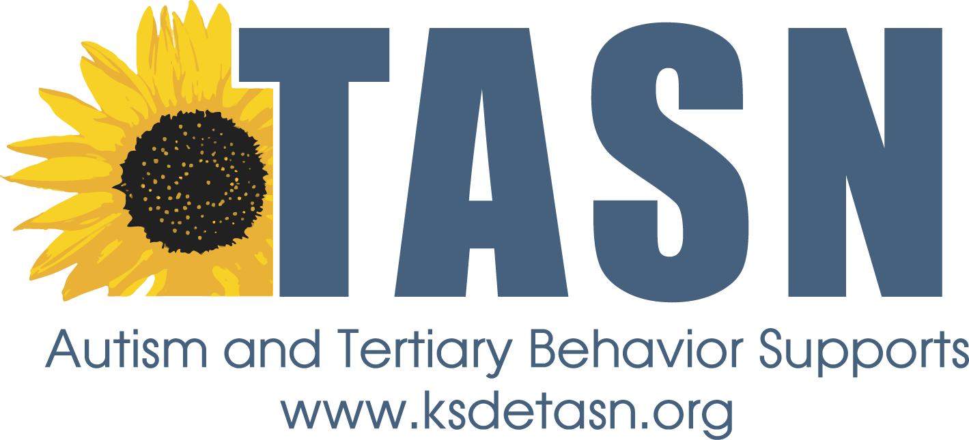
Overall, it is important to complete treatment integrity checks to ensure effectiveness of interventions and student outcomes are due to the actual intervention and not staffs inconsistencies. To find out more about treatment integrity see the references and sources below.
TASN Autism and Tertiary Behavior Supports is funded through Part B funds administered by the Kansas State Department of Education's Early Childhood, Special Education and Title Services. TASN Autism and Tertiary Behavior Supports does not discriminate on the basis of race, color, national origin, sex, disability, or age in its programs and activities. The following person has been designated to handle inquiries regarding the non-discrimination policies: Deputy Director, Keystone Learning Services, 500 E. Sunflower, Ozawkie, KS 66070, 785-876-2214

Used with permission from Detrick (2014).

Resources and More Information
DiGennaro, F. D, Martens, B. K., & Kleinmann, A. E., (2007). A comparison of performance feedback
procedures on teachers’ treatment implementation integrity and students’ inappropriate behavior in special education classrooms. Journal of Applied Behavior Analysis, 40, 447-461.
Detrich, R. 2014. Treatment integrity: Fundamental to education reform. Journal of Cognitive Education
and Psychology 13, 258-271.
Durlak, J. A., & DuPre, E. P., (2008). Implementation matters: A review of research on the influence of
implementation on program outcomes and the factors affecting implementation. American
Journal of Community Psychology, 41. 327-350.
Moncher, F. J., Prinz, R. J., (1991). Treatment fidelity in outcome studies. Clinical Psychology Review, 11,
247-266.
No Child Left Behind Act of 2001, Pub. L. No. 107-110 (2001).
Sanetti, L. & Fallon, L. (2011). Treatment integrity assessment: How estimates of adherence, quality, and
exposure influence interpretation of implementation. Journal of Educational and Psychological Consultation, 21, 209-232.

Book:
Sanetti, L. M. & Kratochwill, T. R. (Ed.). (2014). Treatment integrity: A foundation for evidence-based
practice in applied psychology. Washington, DC: American Psychological Association.

Websites:
http://www.treatmentintegrity.com
http://www.ncbi.nlm.nih.gov/pmc/articles/PMC2846589/
http://www.rtinetwork.org/getstarted/evaluate/treatment-integrity-ensuring-the-i-in-rti

TASN Autism and Tertiary Behavior Supports is funded through Part B funds administered by the Kansas State Department of Education's Early Childhood, Special Education and Title Services. TASN Autism and Tertiary Behavior Supports does not discriminate on the basis of race, color, national origin, sex, disability, or age in its programs and activities. The following person has been designated to handle inquiries regarding the non-discrimination policies: Deputy Director, Keystone Learning Services, 500 E. Sunflower, Ozawkie, KS 66070, 785-876-2214

