INTRAVERBAL WEBBING PROTOCOL

(Adapted from Carbone Clinic)

This protocol is used to teach advanced intraverbal skills while avoiding rote responding.

Pre-requisite skills:
- Many Tacts (at least 200-250)
- Demonstrating pretend actions, identifying pictures of actions, labeling ongoing actions and pictures of actions (most relevant for filling in phrases or responding to questions regarding the function of items).
- Identifying and labeling parts, features and properties of items (most relevant for filling in phrases or responding to questions regarding the parts/features of items)
- Tacting class of items or tacting the item when provided with the class (most relevant for filling in phrases or responding to questions regarding the class of items)
- Having a solid base of these skills will avoid rote responding in the intraverbal skill. For example, some children may be able to respond “car” when asked to name something with wheels, but may not know what wheels are.

Steps for Intraverbal Webbing:
- Pick 3-4 known tacts from different categories
- Develop the relevant feature, function, and class (FFC) phrases for each tact (make sure these are appropriate/functional for student)
- Write these phrases on an FFC summary sheet (optional)

Example:
Car Bed Ball Cat
Convergent | Divergent | Convergent | Divergent | Convergent | Divergent | Convergent | Divergent
Something you drive is a | What do you do with a car? | Sleep in a | What do you do with a bed? | You throw a | What do you do with a ball? | You pet a | What do you do with a cat?
Something you ride is a | What do you do with a car? | Something with pillows is a | A bed has | You bounce a | What do you do with a ball? | What has a tail? | A cat has a
Something with wheels is | A car has | Something with blankets is a | A bed has | You kick a | What do you do with a ball? | Something with whiskers is a | A cat has
Something with wipers is a | A car has | Something with a mattress is a | A bed has a | You catch a | What do you do with a ball? | Something with fur is a | A cat has
Tell me a vehicle | A car is a | Tell me a furniture | A bed is a | Something round is a | A ball is | Tell me an animal | A cat is an
 |  |  |  | Tell me a toy | A ball is a

Note: You want to teach response generalization and response stimulus at the same time.
Stimulus Response/Stimulus Response
A car has… “wheels”
Tell me something w/ wheels… “car”

- Develop a separate skill tracking sheet for feature, function, and class
- Once these first FFC’s are mastered you will begin the webbing process.
- Pick the concepts that you wish to teach (from FFC’s taught). From the examples above these could be: things that have wheels, vehicles, furniture, things that are round, toys, animals, things with tails.
- You will keep pictures needed to prompt the responses for each concept you are teaching separated by tabs in a small index card box. The concept tabs should be organized in alphabetical order for easy access of pictures if and when needed.
- The student should already have one response to each of these (taught above). We will now begin to add new responses to each of these concepts (one at a time). As the students masters responses, he/she will be required to name all the previously learned items when asked for them one at a time. For example: “tell me a vehicle”….”car”. Yes, “tell me another vehicle”….”train”…….
- As you add on new items to the concept you will also teach the FFC’s of that item.
- Eventually the student will know several responses for each concept and, therefore, be able to have a back and forth “conversation” with these responses. (see example below)

Example of Webbing Script:

Teacher: Student:
Tell me a vehicle Car
Tell me another vehicle Bus
A bus is the color Yellow
Tell me something else that’s yellow Banana
A banana is a Fruit
Tell me another fruit Apple
What color is an apple? Red
Tell me something else that’s red Wagon
A wagon has Wheel
What else has wheels? Bike

- It is helpful to create summaries of what the student already has mastered (as a prompt for the instructor) so that at any given point you can present the questions to the student and have a few exchanges (see below for sample webbing binder)

Teaching Procedure for First Member of each Concept/Response Class
- Present the intraverbal fill-in with a “0” second delay prompt
- Immediately run a transfer trial with no prompt or a faded prompt
- Intersperse 1-3 easy skills and return to the intraverbal fill-in with no prompt (or a faded prompt)
Error Correction Procedure for First Member of Concept/Response Class
- Error responses include incorrect responses, repeating responses, or not responding within 2 seconds.
- If an error occurs, immediately re-present the intraverbal fill-in with a “0” second delay prompt
- Immediately run a transfer trial with no prompt or a faded prompt
- Intersperse 1-3 easy skills and return to the intraverbal fill-in with no prompt (or a faded prompt)
Teaching Additional Members of a Response Class
- Present the student with the intraverbal fill-in and allow them to respond with previously mastered targets.
- Once they have provided all mastered responses, repeat the intraverbal fill-in and prompt with the tact for the new target with a “0” second delay prompt and reinforce the student.
- Repeat these two steps at least once and up to two additional times in the session.
- After the prompted trials, run a probe trial during which you DO NOT prompt the target response.
- If the student provides previously mastered responses and the target response, reinforce abundantly!

Error Correction Procedure to use once you start to expand the response class (more than one response)
- Error responses include:
  - Incorrect responses
  - Self-correction
  - No response within two seconds
  - Repeating responses
  - Omitting a previously mastered response
- If an error occurs, provide a 3 to 5-second time out which includes turning your face away from the student and withholding attention. During this time you will retrieve pictures for concept student errored on from webbing card sort.
- Follow one of these procedures based on student history and error patterns:
  - Allow student to emit responses that were correct and prompt the incorrect with the tact (picture)
  - Teach all members errorless (with tact prompt) if student has history of emitting further error responses once errors are made.
  - May need to re-teach each member until all members are included in response.

Teaching Materials:
Card Preparation:
- For single response intraverbals:
  - Prepare a blue card with the verbal S^{D} in quotation marks and the expected response (underlined) on the front of the card.
  - Paste a picture of the picture you will use to prompt the intraverbal with a tact (when possible)
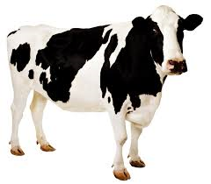
Front: “ Moo says a __” Back:
Cow

http://www.pattan.net/

- For concepts with two or more members:
- Write the verbal S^{d} on a blue 3x5 card and list responses that will be targeted within that concept
- As student masters each item, it should be highlighted on the card
- If student emits a response for a novel item not currently targeted, mark with a plus (+) as shown below:
- If you have two consecutive probes correct response for a novel item, it should be highlighted on card and considered mastered
- Responses emitted that are not on card can be added in at any time
- Once student can emit multiple novel items, mark the right bottom corner with word “Novel” and add card to easies
Once student can emit multiple novel items, mark the right bottom corner with word “Novel” and add card to easies

“Tell me an animal”
Dog Cat
Novel responses Pig⁺ ⁺ Horse
Cow Elephant
Zebra⁺ Giraffe
Novel

Card Organization
- Pictures to prompt response classes will be organized in a separate box in corresponding tab for concept/categories, which should be alphabetized for quick access
- Each tab will include pictures of all mastered items

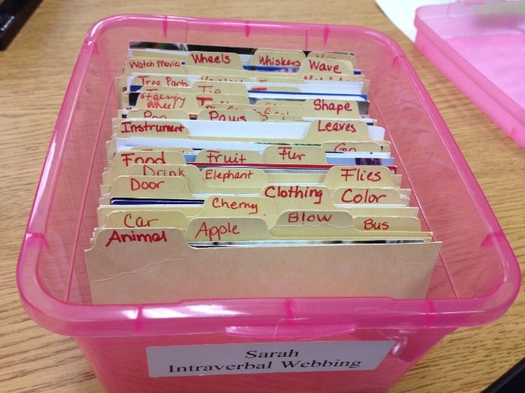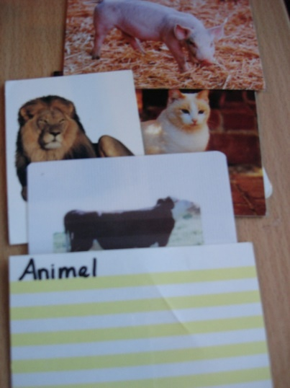

http://www.pattan.net/

Webbing Map Summaries:
- Set up a binder or folder with a web map for each concept
- Concept is written in the center of the map and responses in first row of circles closest to center
- Other responses for each member are then written in the outer most circles
- Arrows indicate mastered responses (2 way arrows means student has both the convergent and divergent response)
- Outer responses for which student has other members mastered can be highlighted to indicate you can move to that concept

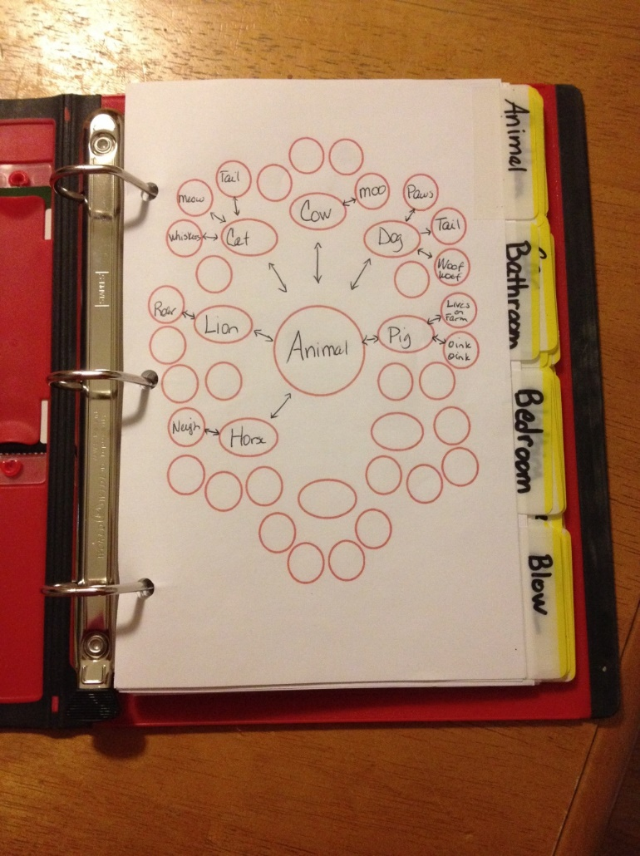

http://www.pattan.net/

Sample:
Wipers
Vehicle
Door

Car

Vehicle
Toy

Wheels

Train

School Bus

Stop Sign

Vehicle
Yellow

