Part 4: Student Supports

Table of Contents:

*Social Supports: Rationale and Resource 2
*Power Card Examples 3
*Social Narrative Example 4

Social Supports: Rational and Resource

Why use supports such as Social Narratives or Power Cards?

Social Narratives have been established as an evidence based practice for students with autism by the National Professional Development Center (NPDC) and are one of the easiest, most versatile supports teachers or families can create for children with Autism Spectrum Disorders. This packet contains some examples of these types of supports, and it’s important to note that they are simply examples.

These types of supports need to be individualized to each student’s specific abilities and learning needs. Some benefits of using these types of social supports include:

*They are easy to create.
*They are easy to individualize.
*They are easy to implement.
*They provide information on social situations and social cues.
*They provide strategies on how to respond appropriately to specific social situations.
*They can be used in academic or nonacademic settings.
*They can be made with apps, software, symbols, real photos, words, and more.

For more information on these types of social supports, the National Professional Development Center has an excellent module that contains an overview, step-by-step directions on how to create a social narrative, research, and directions on how to implement using a social narrative. Go to http://autismpdc.fpg.unc.edu then click on “Evidence Based Practices” and scroll down to “Social Narratives”.

Power Card Examples
Riding the Bus to School

This year I will be riding the bus to school. Buses have rules for kids. It is important to follow the bus rules. Nemo knows it is important to follow the rules. I will be like Nemo and follow the bus rules. Here are the bus rules:
- Sit in your seat.
- Keep your seatbelt on.
- Keep your hands in your lap.
- Have a quiet voice.
- Listen to the bus driver.
- Say “Thank you” when I get off.
Following the bus rules makes everyone happy. I will follow the bus rules!
Going Back to School
I may be nervous or scared when it’s time to go back to school. Reba gets nervous sometimes, too. If I get nervous or scared at school, here is what I can do:
- Ask for a break.
- Take a deep breath.
- Get a drink of water.
- Take a quick walk.
It is okay to be nervous or scared. Even Reba gets nervous or scared. I will use my choices at school to feel better.

Social Narrative Example

Going Back to School
On Wednesday, August 24, I will be going back to school at Lincoln School.
Here is my school:
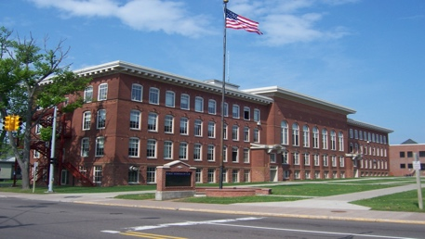
I may be both nervous and excited about going back to school. This is normal. Many kids feel nervous and excited about going back to school.
This year I will have a new teacher. Her name is Mrs. Holt. I will meet her at school. Here is a picture of Mrs. Holt:
I will also have other new teachers. Their names are Mrs. Miller, Mrs. Lawrence, Mr. Wagner, and Mr. Greene. I will meet them at school, too.
I will have a new classroom. Here is a picture of my new classroom:
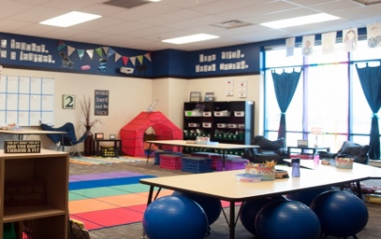
If I start to feel nervous about school, I can talk to my mom or dad. I can look at pictures of my classroom and school. I can even go visit the school sometime. It is okay to be nervous.
When I go to school, I will make new friends. This is a good thing. I will meet other kids who are in 4th grade like me.
Going to school might be scary, but it will be okay. I will go to the school before school starts to look at the school and meet my teachers. I can talk to my mom or dad when I start to feel nervous about school.
Going to 4th grade will be fun. I will like my new teachers and my new class. I will make new friends. I will have a great time in 4th grade!

