Part 1
Back to School Information for Families
Table of Contents
Welcome! 2
Meet the Staff 5
Communication & Contact Information 8
Arrival and Departure Times 9
Class Activities 10
Policies 12
Rules & Expectations 13
My Classroom 14
School Supply List 15

About this packet:
I am so excited about the upcoming school year and I can’t wait to be your child’s teacher! The packet you are receiving has four parts:
- Part 1: Information about me, my classroom, school staff, policies, etc.
- Part 2: Information I want from YOU to help me get to know you and your child.
- Part 3: Information about our Home-School Binder.
- Part 4: Social Supports to help prepare your child for his or her transition back to school.

Welcome!
2016-2017 School Year
Mrs. Holt’s Class

School logo could go here
Early Visitation:
Some of my students need extra opportunities to visit the school and classroom before school starts. I will be contacting each of you to see if you would like to bring your child in a few times before school starts to get acclimated to the building and classroom. We will also be holding a back to school “Meet and Greet” on August 22 from 6:00-8:00 p.m. Please watch for more information about this event.

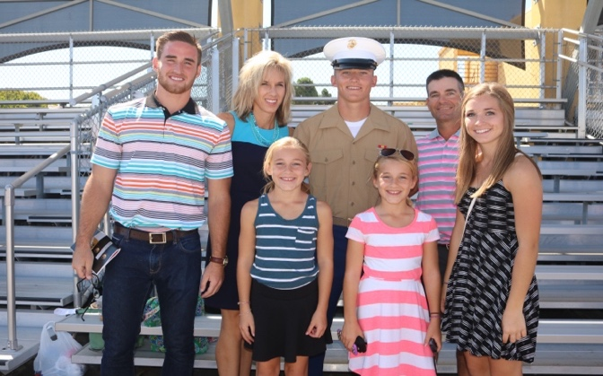
About me:

I have been teaching at _____ for the past 6 years. I received my bachelor’s degree from Emporia State University, my master’s degree from Fort Hays State University, and have completed the Early Childhood, Classic, and High Functioning Autism Certificates from Pittsburg State University.

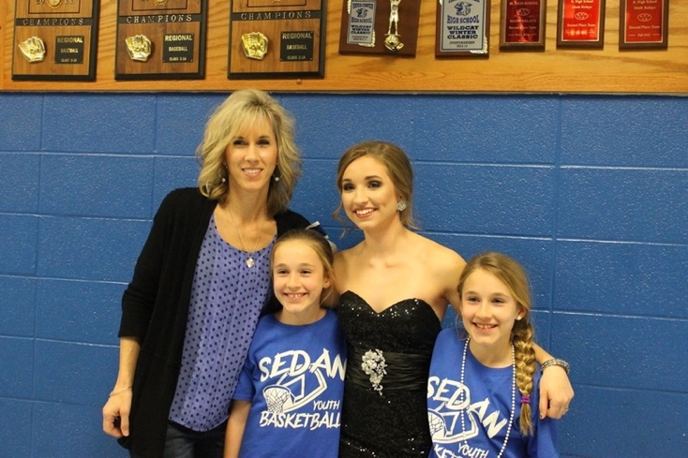
My family:

I have 5 children: Casey is 23, Tyler is 20, Haley is 16, and twins Madison & Melody are 11. My husband, Mick, is a high school science teacher and coach in the town where we live.

Why I teach:

I grew up attending a school with a severe needs special education class. Even as a little girl I wanted to help these students and be their friend. Fortunately, I had teachers who let me spend my “free time” in the SPED room and this is where my love for special education began.

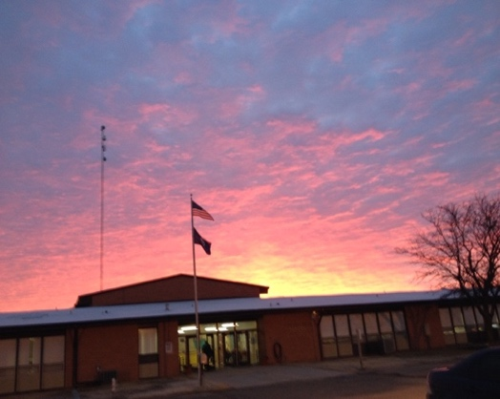

Please watch for information regarding the following prior to the first day of school:

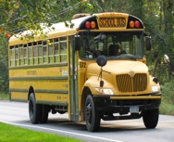Transportation
- If your child rides a district bus you will be contacted by transportation staff about pick up and drop off times and locations. If you do not receive a call from them by August 22, please call (000)000-0000.
- If your child is transported by a family member I will contact you with drop off and pick up times and locations.
- If your child is transported through the special education cooperative you will be receiving a call from __________. If you do not receive a call by August 22, please call (000)000-0000.

Enrollment
All students will be receiving enrollment packets in the mail by August___. You may mail your enrollment packet back to the district office or turn it in to district staff in person at the high school on August 8 or 10 between the hours of 8:00 a.m. and 4:00 p.m. In this packet you will receive information on fees, school supply lists, free & reduced meals, a welcome letter from our principal, and online enrollment information. You will have several forms to fill out online. If you do not have internet access, please let me know.

School Supply Lists
You will receive a school supply list in your enrollment packet. You are not required to buy everything on this list. I am including a supply list for my class that is specific to the needs of the students in my class. You may purchase items for both classes if you wish, but most of the time my students do not need or use the items on the general education lists.

Meet the Staff

Classroom paraprofessionals:
In my class we have five paraprofessionals. We also have a speech and adapted physical education paraprofessional who work with the students a couple of times a week. All of the paraprofessionals have had training in the elements of Structured Teaching, Mandt, CPR and First Aid, and medical training for seizures and administering medications.

Staff photos here
Mrs. Johnson has been a para for three years. She is married and has four children. She loves working with kids who have special needs and in her free time likes to spend time with her family, cook, and read.

Staff photos here
Mrs. Jones has been a para for six years. She has three sons. She loves to help children become as independent as possible. In her free time she goes to a lot of ballgames!

Staff photos here
Mr. Wilson has been a para for 10 years. He is married and has two grown children. He also works at a local group home. In his spare time he enjoys fishing and working on his car.

Staff photos here
Mrs. Whitehair has been a para in a private facility for two years and is joining us this year. Mrs. Whitehair enjoys spending time with her family, reading, and going on road trips in her spare time.
Staff photos here
Mr. Smith has been a para for two years. He is married and has 3 young children. In his spare time he likes to spend time with his family.

Meet the Staff (cont’d)

Related services providers:
Your child may also be working with related service providers, many of whom you have already met at IEP meetings. Here are the current providers who will be working with the students in my class:

Staff photos here

Mr. Green is our Adapted Physical Education (APE) teacher. He provides an APE class for us once a week and is in charge of setting up our swimming and bowling schedule

Staff photos here
Mrs. Burke is our APE para. She assists Mr. Smith with his classes and teaches individual sessions with some of our students.

Staff photos here
Mrs. Ralph is our Speech and Language Pathologist. She will be working with our students in one-on-one and group sessions.

Staff photos here
Mrs. Nelson is our speech and language para. She will be assisting Mrs. Ralph by working with some students individually and by leading group sessions.

Staff photos here
Mr. Munk is our Occupational Therapist. He will be working with individual students as well as assisting me by providing strategies for sensory needs, functional needs, and many other things.

Staff photos here

Mrs. Hofferber is our School Psychologist. She assists us with many things including, testing, behavior analysis & plans, IEP meetings, and more.

Meet the Staff (cont’d)

Country View staff:

Staff photos here
Mrs. Hedrick is our principal. She has been a principal for 12 years. She is married and has two grown children. In her spare time she enjoys reading and gardening.
Staff photos here

Mrs. McDaniel is our school secretary and she takes good care of all of us! When your child won’t be attending school due to illness or appointments, you will call her at (000)000-0000.
Staff photos here

Mrs. Tucker is our school Social Worker. She is in our building part-time and helps with many things including providing family resources, counseling, transition, and more.
Staff photos here

Mrs. Hills is in charge of Food Service. She also shares her kitchen with us and always has a smile for the students in my class.

Staff photos here

Mrs. Davis is our school nurse. She is in our building part-time and takes good care of all of us!

Staff photos here

Mrs. White is our Music Teacher. She has been a music teacher for 12 years and will be in our building part-time.

Staff photos here

Mrs. Lawrence is our Art Teacher. She has been an art teacher for 6 years and will be in our building part-time.

Staff photos here
Mr. Bragg is our P.E. teacher. He will be in our building part-time.

Communication & Contact Information

Our school staff understands the importance of open communication between home and school. You are welcome to contact me through face-to-face meetings, email, phone calls, and text messages. I am including my contact information below. This information will also be inside your child’s home-school binder.

My class newsletter, the school newsletter, and any updates to the district activity calendar will be sent home each month. We will also update our class calendar each month and this will be placed in the home-school binder. This year we are adding a closed Facebook group for my class so all of you have access to photos and events in which your child participates.

If you have other family members, parents, or guardians who would like to receive the class newsletter and calendar, please let me know.

My contact information:
School Phone: (000)000-0000
Cell Phone: (000)000-0000
Email: _____________________________
Facebook link: https://__________________

Arrival and Departure Times

Students who ride the district buses will arrive at school at 7:30. They will depart from school at 3:30. A para or I will meet the students who ride the buses at the bus or the front lobby, depending on the abilities and needs of the kids (we want them to be as independent as possible).

Students who are transported by parents or family members may arrive at 7:30 and need to be picked up by 3:30 unless you make other arrangements. If you are running late in the morning or after school, please let me know so we can adjust our schedules. Our paraprofessionals cannot clock in before 7:30 and have to clock out by 3:30 so please be mindful of these times as you are dropping off and picking up your child.

Students who are transported through the Special Education Cooperative may have different arrival and departure times due to the availability of transportation staff and the various drop off and pick up schedules. If your child’s school hours are adjusted because of transportation, this will be arranged by our cooperative director, ____________________, and will be discussed at your child’s annual IEP meeting.

Class Activities

Lunch Partners
Over the past few years we have been using a “lunch partner” system to help build relationships between the students in my class and other students in our school. This has become a popular activity and it has been exciting to see the students in our school learn about and use the visual supports, communication devices, and other tools used with students in my class to get to know each other. In the past I have used some of the older students to partner with students in my class and these students get a brief training on the schedules, work systems, visual aids, and communication devices that my students use. The partners will eat lunch with a student in my class for a set amount of days. We then rotate to other students so many students get the chance to be a lunch partner throughout the school year. We will be implementing this again this year. I will send home photos of your child with his lunch partner later in the year.

Field Trips
We take several field trips throughout the school year. Some of these are school-wide trips and some are specifically for my class. Many of our trips are taken on district buses, but there are some trips where I, or another district approved driver, may drive a district van. Regardless of what kind of trip we are going on, you will always receive a permission slip form with details of the trip. Some trips may require $3-$5. I will do my best to let you know ahead of time if a trip is going to cost money so that you can budget accordingly. Parents can attend many of our trips. I will let you know which trips you can attend, so you can adjust your work or home schedule. Before we go on any kind of trip I prepare the students for the activity by using social narratives, video modeling, visits ahead to the location, etc.

Community Based Instruction (CBI)
Our class participates in many CBI activities throughout the school year. This type of instruction allows us to work on skills that include: transitions, following a schedule and work system in settings other than school, social skills, communication skills, physical skills, and more. We will be participating in the following CBI activities this year:
- Aqua Therapy: Aqua Therapy is once a week on Wednesday afternoons. Students will need to have a completed Swimming Waiver Form, a swim suit, towel, and swim diapers (if necessary) by the second week of school in order to participate. Aqua Therapy is a great way to meet sensory needs, learn swimming skills, and get physical exercise.
- Bowling: Bowling will be the first Thursday of every month. Bowling is a fun way to get physical exercise, learn to take turns, learn waiting skills, and more.
- Grocery Store: At least once a month (days and times will vary) we will be going to Dillons to purchase our cooking and snack supplies. Each student will have their own list of items to look for. Students will learn to follow their list, check off what they need, help carry in groceries, and put them away. Students may purchase items of their own choosing with their own money (I will discuss this with you individually if your child is going to purchase items).
- Restaurants: Once a month we will be going to a local restaurant to practice appropriate restaurant skills, transitioning, money skills, etc. Generally, we go in the middle of the afternoon for a snack when the restaurants aren’t as busy. I will let you know a week or so ahead of time when and where we are going.

Policies

Class & Holiday Parties
This is where you could share any information about district policies regarding class and holiday parties. This might include whether families can bring homemade food, or only store-bought items. You could include non-identifying information on student allergies that affect what is brought in, how parents sign up to help with parties, when parties are held, etc.

Grading
This is where you could share grading policies of the various classrooms the students are in (your own, the general education classroom, “specials” classrooms, etc.)

Homework
This is where you could share your homework policy (if you have one), how often you send homework home, where to find the homework, and how you want to know that the families saw the homework (sign the student’s planner, initial the home-school notebook, etc.).

Agendas or Planners
This is where you could share information on the format of agendas or planners your school uses and how they are to be used. If your students do not use agendas or planners, then you could share with parents the system that you do use (calendar pages, notebook, etc.).

Rules & Expectations

My teaching philosophy is to have high expectations for all students. I believe children learn best through real-world experiences and practice. I use a combination of strategies that include the Structured Teaching framework, Conscious Discipline, Capturing Kids’ Hearts, and other philosophies to teach classroom rules, routines, and expectations. Our number one priority is safety and we have both a “safe place” (inside the classroom) and a safe room (outside the classroom) where students can take a break to regulate themselves. If a student’s actions jeopardize the safety of themselves, staff, or other students, procedures are in place to support that student. Some children have individual behavior plans. If your child has his or her own behavior plan, we will review and update that at the beginning of the school year.

Each day we will work on our classroom rules. These rules are taught, reviewed, and supported by using visual supports, verbal prompts, and modeling. Our rules are simple and we focus on what TO do instead of what NOT to do. For example, instead of saying, “don’t run” we would say, “Use your walking feet”. Our class rules include:

- We use walking feet.
- We use our listening ears.
- We use gentle touches.
- We use a quiet voice and kind words.

My Classroom

Note to Teachers: This is where you could explain how your own classroom is set up. If you are an Interrelated Teacher, you might explain how the students rotate in and out of your room, what types of schedules they use, if they use work systems, if you co-teach, etc. Below is an example of how you might your classroom structure:

My classroom is designed based upon the principles of Structured Teaching. At the back-to-school “Meet & Greet” I will be giving out more information on the principles of Structured Teaching and will show you how the classroom is set up. When we have our first family night this fall, I will provide time to show each family how their child rotates through the Structured Teaching schedule and will show the individual visual schedule and visual supports your child uses in my classroom, the general education classrooms, lunch room, etc.

You could add a picture of your classroom here.

School Supply List

- 4 boxes of tissues

- ½” three ring binder

- pocket folder with holes

- 1 zipper pouch that can be inserted into the 3-ring binder

- 1 box of quart size baggies

- 1 box of sandwich size baggies

- 1 box of gallon size baggies

- 1 package of Scotch packing tape

- 1 package of baby wipes

- Extra set of clothes to be left at school

- Swimsuit and towel to be left at school

- Hygiene items:
  - Toothbrush
  - Toothpaste,
  - Deoderant
  - Comb/brush

- Backpack

- Spiral notebooks (one to be kept in backpack for communication)

- Preferred snacks/drinks for the first couple of weeks (We will shop for these items later on in the school year.)

