Part 3

Home-School Binder
Table of Contents
Purpose 2
Contact Information 3
Example 4
Pictures of Home-School Binder 5

Purpose

Home-school communication is very important and open, honest communication between all members of the IEP team will help make your child’s school experience an even more positive one. In the Back to School Packet for the Teacher you will be asked to fill out a “Communication Survey”. I have found that some parents already have a preferred form of home-school communication, but others have liked the home-school binder that we put together. I have found this to be an easy way to keep track of information.

Contents:
- Phone numbers and contact information (inside of binder)
- Zipper pocket for money or small items that need to go back & forth
- Notebook or folder for communication log
- Two pocket folder for paperwork or homework that is “left at home” or goes “right back to school
- Tab 1: Monthly calendar of activities for my class, school calendar, and district calendar
- Tab 2: Monthly breakfast & lunch menus
- Tab 3: My class schedule and general education class schedule
- Tab 4: My class list and general education class list
- Tab 5: Current school & class newsletter
- Tab 6: Upcoming field trip permission slips and information

At the end of each month we will update the binders with the monthly forms. Please keep the binder in your child’s backpack.

Contact Information
(Cut and tape to inside of the Home-School Binder)

Phone Numbers:

Teacher Name: (000)000-0000
School: (000)000-0000
Coop: (000)000-0000
District Office: (000)000-0000
Bus Barn: (000)000-0000

Example

August 2016 Calendar of Events

Sun | Mon | Tues | Wed | Thu | Fri | Sat
 | 1 | 2 | 3 | 4 | 5 | 6
7 | 8 | 9 | 10 | 11 | 12 | 13
14 | 15 | 16 | 17 | 18 | 19 | 20
21 | 22 | 23 | 24  1st day of school! | 25 | 26 | 17
28 | 29 | 30 | 31  Pool

Pictures of Home-School Binder

- Outside of binder: If the student is able, let him or her illustrate the front cover. This could even be done at a back to school event or family night.
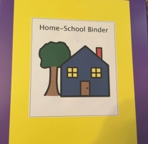
- Inside of binder: Contact numbers are here for easy access.
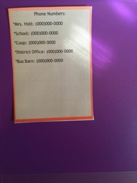
- Zipper Pocket: Placed in front of folder and tabs for an easy way to transport small items or money between school and home.
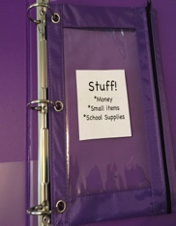
- Notebook to be used for communication.
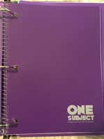
- Plastic folder for “left at home” and “right back to school”.
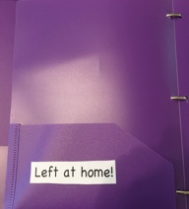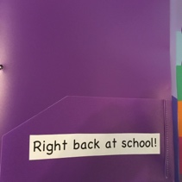
- Tabs: Tabs contain calendars, menus, schedules, class lists, newsletters, field trip forms, etc.
