It’s All About YOU! Using Behavior Analytic and Instructional Strategies to
Improve Student Outcomes
Implementation Support for Coaches and Teachers

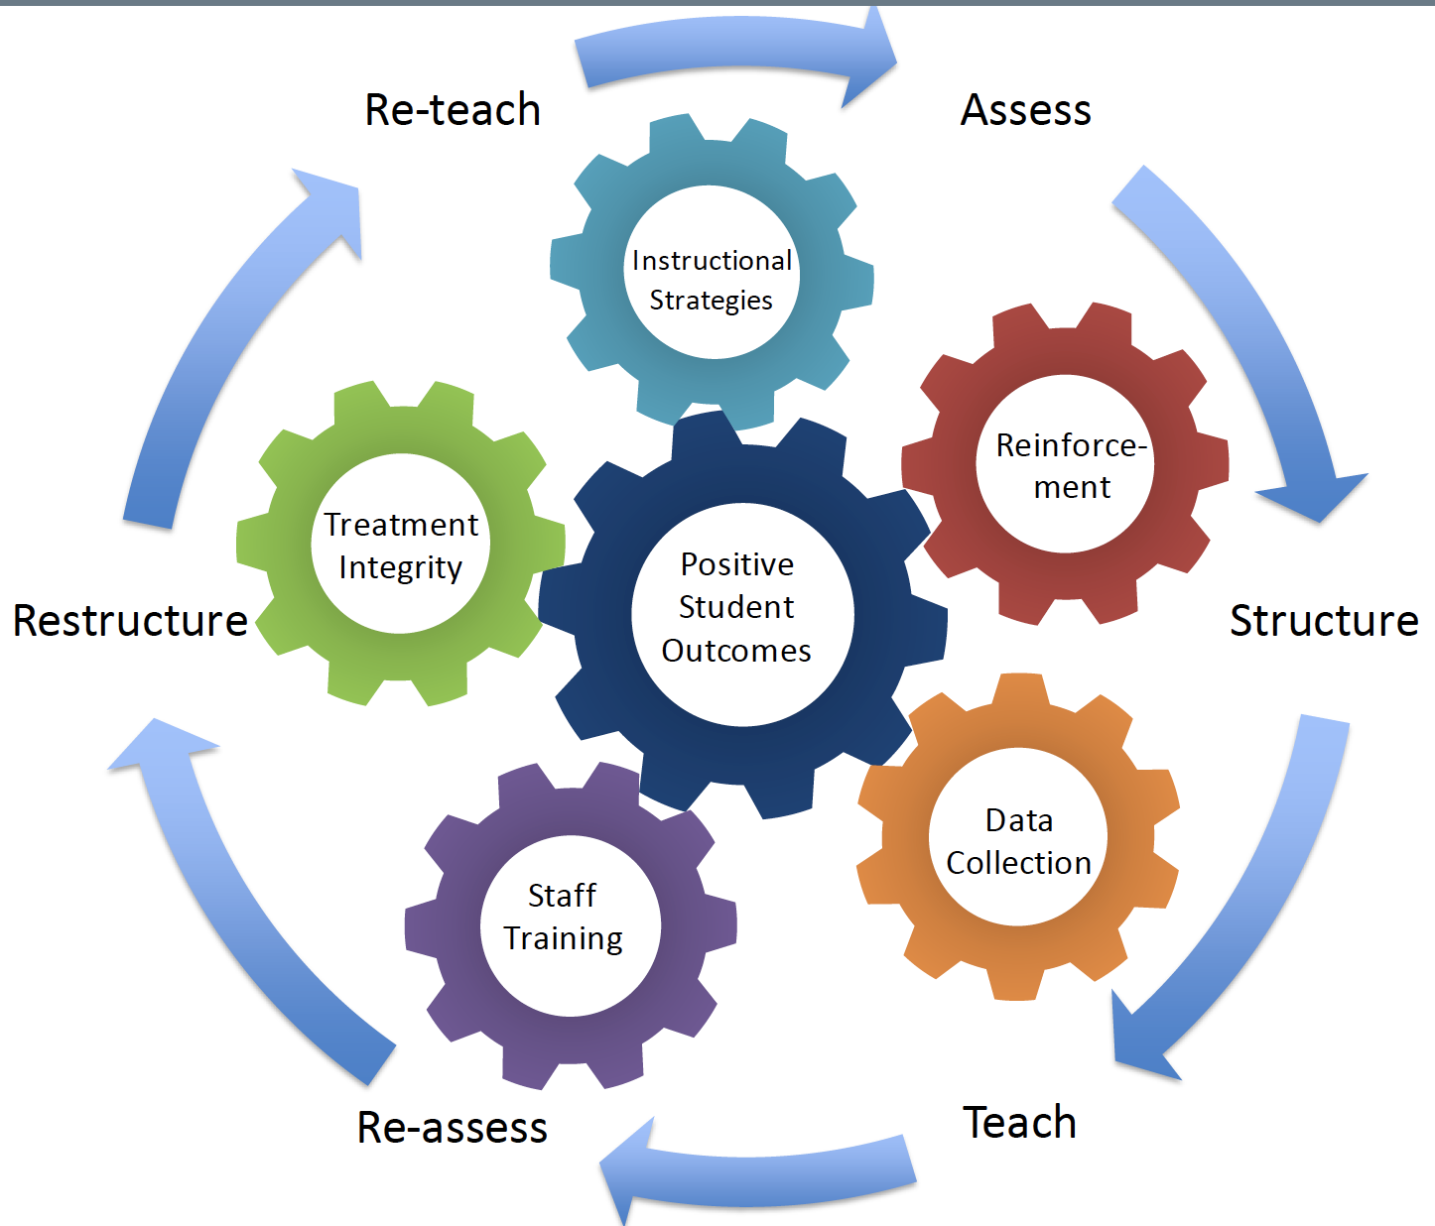
*When developing an implementation program, all components of the implementation cycle should be considered as part of the written program.

Components | Possible Strategies and Resources | Considerations | Selected Strategies and Materials Needed | Recommended Timeline Goal
Antecedent-Based Strategies  Evidenced-based strategies you can implement prior to problematic behavior occurring. | - Classroom Assessment  - ABC Data Collection  - Physical Structure  - Schedules  - Routines and Expectations  - High ratio of praise, 5:1 at minimum  - Opportunities to Respond  - Interspersing  - Behavior Momentum  - Pre-correction  - Pairing – relationship building  - Novelty  - Choice  - First/Then – Premack Principle  - Fast-Paced Instruction  - Functional Communication Training | - Individualized per student.  - Used within programs to prevent problematic behaviors.  - A combination of strategies can be implemented to strengthen the behavior. |  | Weeks 1 and 2
Skill Acquisition  Errorless teaching and errorless correction procedures are evidenced-based strategies that are used to teach new behaviors/skills. | - Levels of Prompting  - Prompt Fading  - Stimulus Prompts/Fading  - Task Analysis  - Chaining (backward, forward, total task)  - Shaping  - Simultaneous Prompting  - Time Delay  - Most-to-Least and Least-to-Most Prompting  - Replacement Behavior  - Generalization and Maintenance | - Individualized per student and utilizes age-appropriate materials.  - Requires data collection and graphing.  - Should not rely on anecdotal data collection only.  - A task analysis, set of procedures, or lesson plan should be evident in program books for each learner.  - Programs are implemented with consistency across all implementers.  - Programs are followed as written (treatment fidelity). |  | Week 2
Reinforcement  Delivered after a desired behavior to increase the likelihood of that behavior occurring again in the future.  Used to strengthen a behavior. | - Identify behavior/skill to reinforce  - Preference Assessments (Direct)  - Preference Assessments (Indirect)  - Set of procedures listed for reinforcement program  - Schedule of Reinforcement | - Individualized per student.  - Reinforcement procedure is listed on a written program or wall chart.  - A plan for fading reinforcement should be considered.  - Reinforcement is not a thing, it’s about the effect on the behavior.  - If the desired behavior isn’t increasing, whatever is being delivered as a consequence is not functioning as a reinforcer for that behavior. |  | Weeks 1-2
Measurement  Provides an accurate and reliable measurement of the target skill. Reliable measurement is achieved when the measurement tool can assess the skill the same way each and every time. | - Frequency and Rate  - Duration  - Latency  - Momentary Time Sampling  - Partial Interval Recording  - Whole Interval Recording  - Permanent Product  - Graphing | - Data is collected, graphed, and analyzed weekly.  - Easy to use-doesn’t interfere with teaching.  - Easy to train staff how to use.  - Shows crucial information for making decisions.  - Easy to summarize or graph.  - Easy for others to interpret.  - Consistency across time with other systems in the child’s life. |  | Week 2
Staff Training and Treatment Integrity  The process of improving rapport, effective communication, treatment fidelity, and implementing new teaching strategies with staff. | - Classroom Meeting Guidelines  - Staff Meeting Agenda  - SMART Goal Form  - Feedback Preference Survey  - Paraprofessional Classroom Guide  - Active Supervision Planning Tool  - Lesson Plan Guide for Paras  - Lesson Plan Guide for Support Staff  - Staff Cohesiveness and Training Plan  - Para Training Plan  - Outline for Requesting Training Time  - Behavior Skills Training Model (Instruction, Model, Rehearsal, Feedback)  - BST Planning Form Template  - Treatment Integrity and Feedback Form Template  - Performance Diagnostic Checklist - Education  - Staff Contextual Fit Survey  - Parent Social Validity Survey | - Should be ongoing and monitored.  - Fluency should be the goal.  - Have a shared philosophy.  - Show staff appreciation frequently.  - Back-up plan when staffing shortages arise. |  | Weeks 2-3

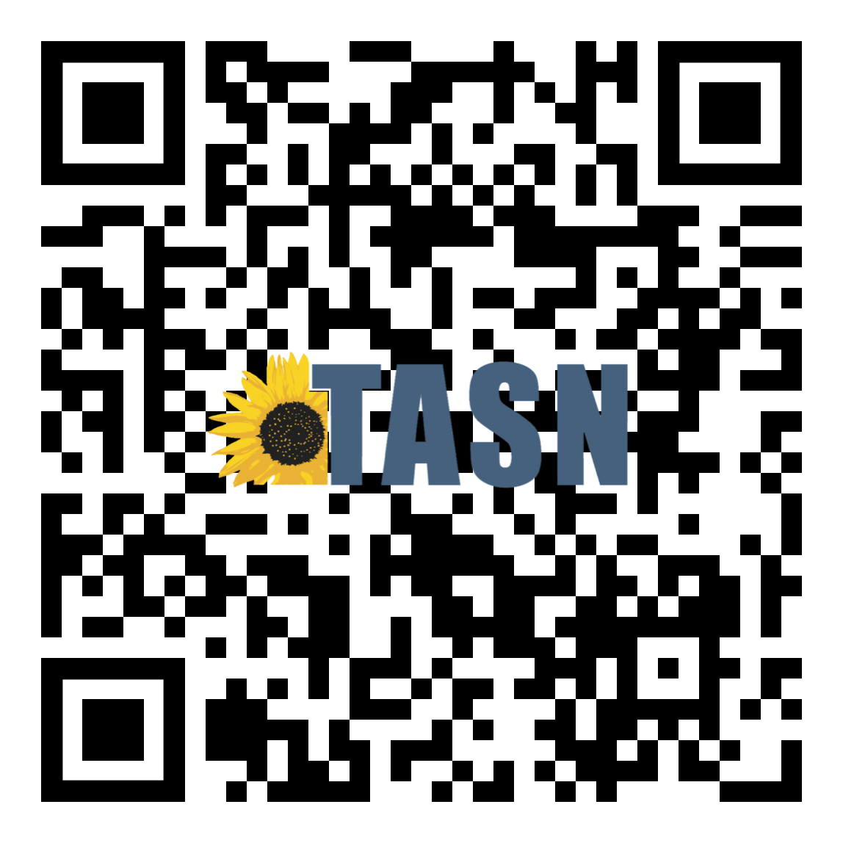
More information regarding this training can be found on the It’s All About YOU! Instructional Strategies Training initiative page.

To view the Comprehensive Strategies Toolkit, scan the QR code below.
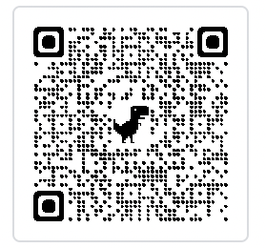

This tool can be used for self-reflection, and as a tool to provide feedback during observations.
PREVENTATIVE-BASED STRATEGIES
Strengths | Notes/Next Steps
Additional Resources on Initiative Page: https://ksdetasn.org/atbs/it-s-all-about-you

Staff works on relationship building and/or pairing.
Lesson plans are evident and specific.
Instruction occurs across multiple skill domains (communication, social, core content, adaptive, life skills).
Novelty is built into instruction.
Instruction is presented in a fast-paced format.
Tasks are interspersed using an 80/20 ratio.
Students are provided with a high ratio of opportunities to respond.
No student sits more than 5 minutes without instruction.
AAC devices or other communication supports are incorporated and used consistently.
Materials are easily accessible by person providing instruction.
All instructional materials are age appropriate.
Behavior expectations are explicitly taught.
Peer-related social skills are explicitly taught.
All staff is engaged in instruction/ preparation of activities when not on a scheduled break.
Staff members generally deliver the same directive only once then use prompts or feedback to ensure correct responses.
Staff delivers consistent feedback during instruction. At least a 5:1 ratio of praise is evident through instruction.
Pre-Correction is used for predictable errors of responding.
Staff uses data from preference assessment to select potential reinforcers.
Staff members demonstrate or plan methods to promote generalization.

This tool can be used for self-reflection, and as a tool to provide feedback during observations.
SKILL ACQUISITION
Strengths | Notes/Next Steps
Additional Resources on Initiative Page: https://ksdetasn.org/atbs/it-s-all-about-you

Each student has a program book (schedule, assessment, goals, data sheets, etc.)
Materials are well organized and ready to go.
There is a clear back-up plan when staffing shortages arise.
Staff use errorless teaching and error correction as directed on the teaching plan.
Reinforcement is delivered in alignment with the student's program.
All staff runs Behavior Intervention Plans consistently.
There is a system in place to communicate daily with parents.
Regularly scheduled staff meetings or training sessions are scheduled with staff implementing instruction and behavior plans.
Data is collected, graphed, and analyzed weekly.

Sample Reflection Questions
What is your vision for implementing these strategies?
How will this vision look for individual students and/or classroom?
Who might you go to for support as you implement this strategy?
What will you be looking for in your staff and students to determine if modifications need to be made?
How will you know you’ve seen the outcomes you expect?
TASN Autism and Tertiary Behavior Supports is funded through Part B funds administered by the Kansas State Department of Education's Special Education and Title Services. TASN Autism and Tertiary Behavior Supports does not discriminate on the basis of race, color, national origin, sex, disability, or age in its programs and activities. The following person has been designated to handle inquiries regarding the nondiscrimination policies: Deputy Director, Keystone Learning Services, 500 E. Sunflower, Ozawkie KS 66070, 785.876.2214.

