PC Boardmaker Tips
By-Dixie Teeter and Lindy McDaniel
dteeter@gmail.com and lmcdaniel5@kumc.edu

- Creating a board that has multiple pages.

Go to print set up and change the numbers in the height and width section. Do the math to make the size you are wanting. Height and width needed to be in multiples of 8 and 11s. For example for two landscape pages you would do a width of 22 and height 8 inches.
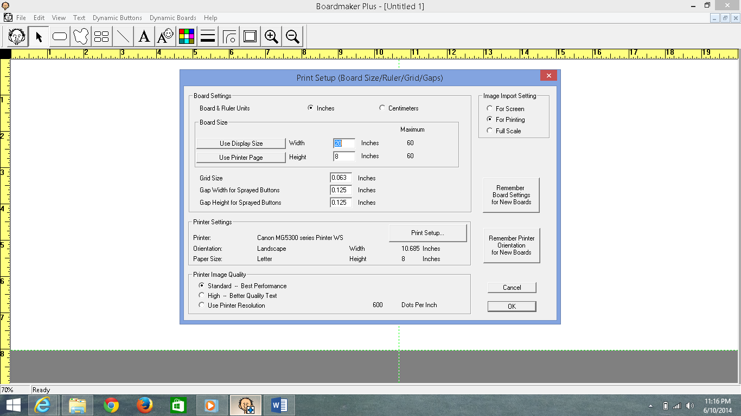

Then simply go to print setup ad change to landscape or portrait when needed.
*This feature can be used to make poster sized printables to cut and paste together or to make multiple pages for a social story or leveled worksheets.

2. Making side by side buttons (no gap).
Go to print set up and change grid size, and gap width and height to 0.
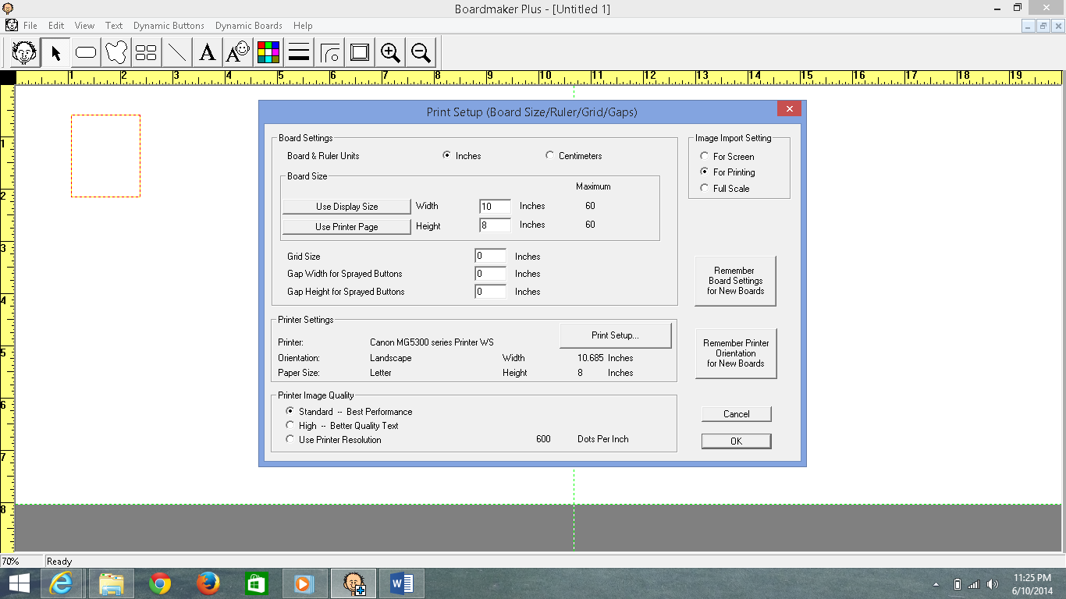

* This is a good feature for making icons for schedules and PECS as it will cut your cutting time in half. Icons with 0.125 grid size and gap are good for aided language boards and lotto games.

3. Spray and resize buttons.
Create a button. Select it and then spray it with the spray button. Select all buttons and press and hold control, function. Then go to the corner and drag to desired size.
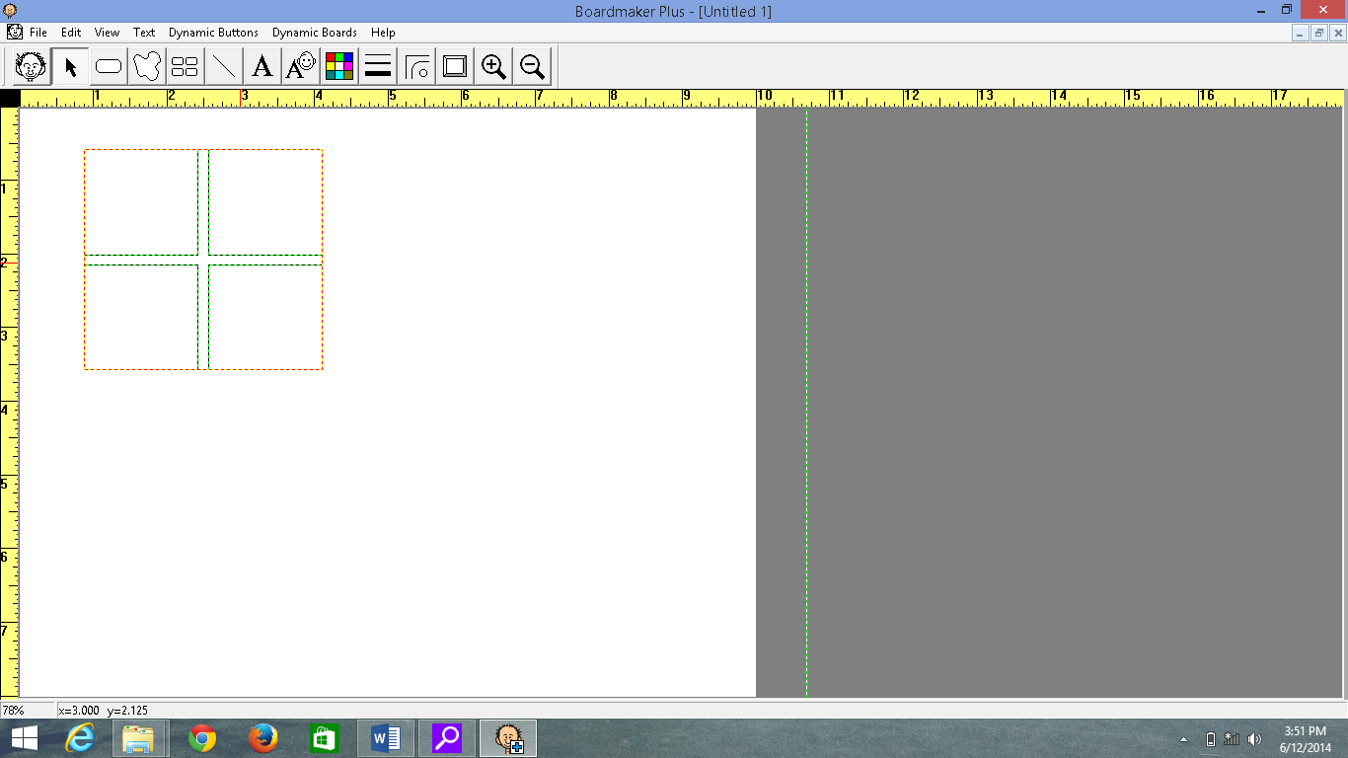
Select all buttons and push control, function. Then drop and drag the icons to make them bigger.
* This is good for changing large class visuals, and social narratives into individualized mini stories or power cards.
4. Making images black and white. Click your silly guy image and then click the tool button in the lower right corner. Then click black and white symbols and okay.
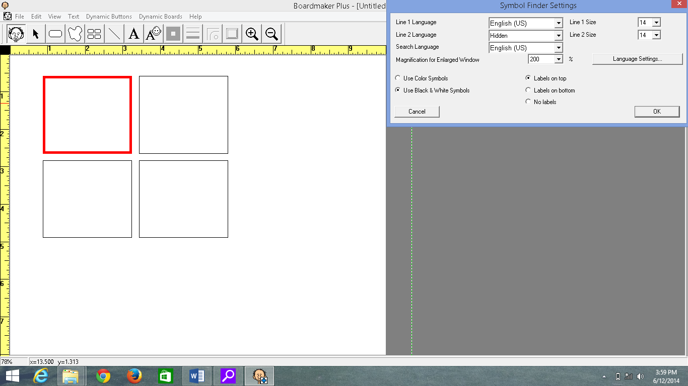
* This is good for creating worksheets and color sheets.

5. Import an image from your desktop or the internet. Google images or open a picture in your own picture files. Drop and drag them to a button or drop and drag them to your silly guy. If you drag it to your silly guy then it will permanently be in your library which is good for schedule icons and student photo. It saves you a lot of time!
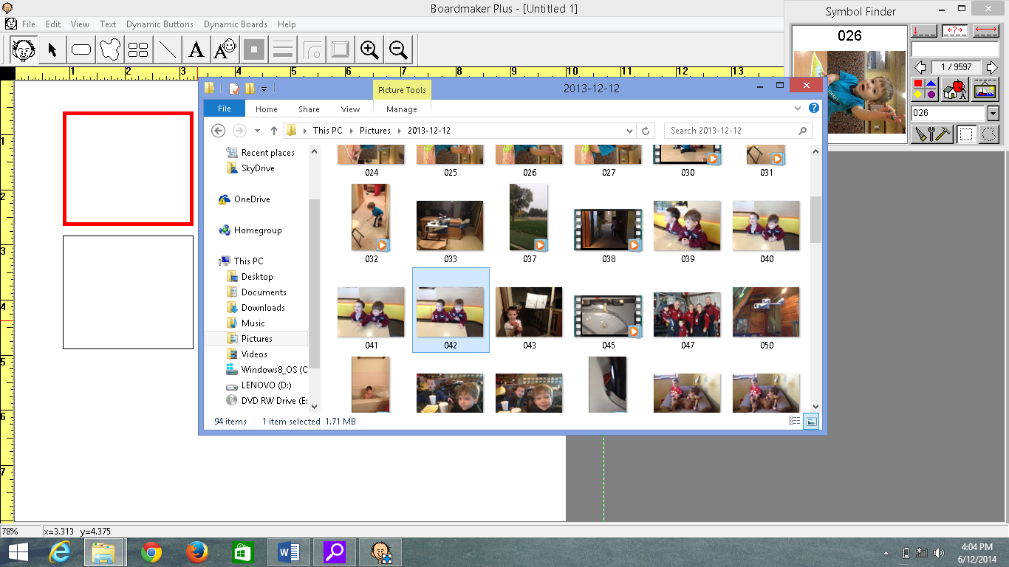

If you input to your library you have to assign it a name, and a category in order for it to be in the library. I usually assign other as it is quick and easy.
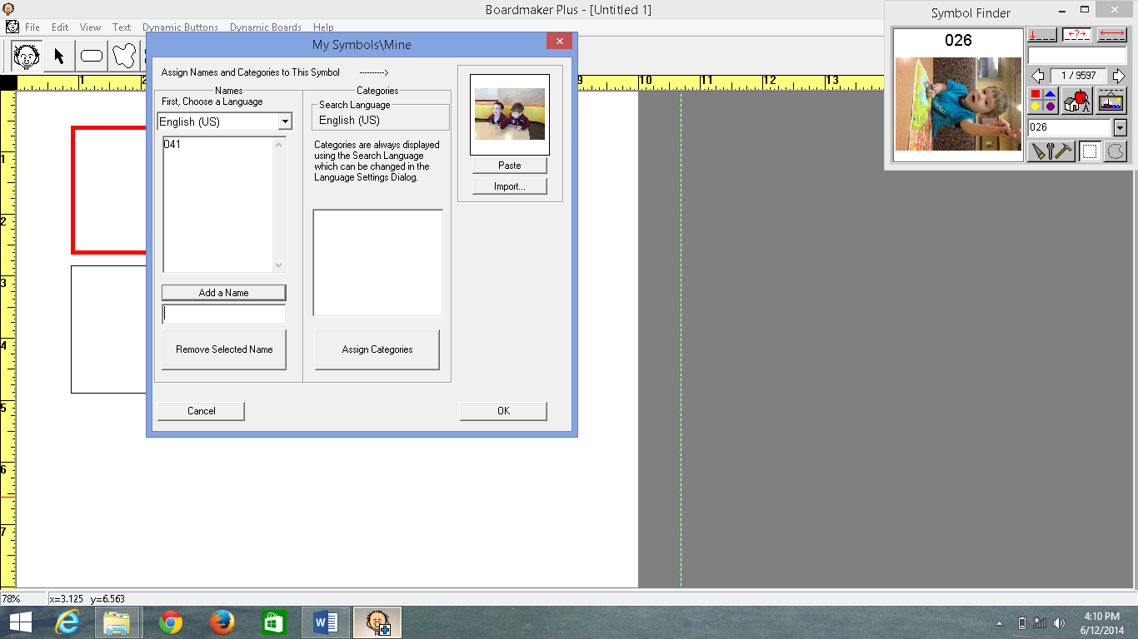

6. Changing boarder shapes or making no boarder. Select your button and change the width or shape.
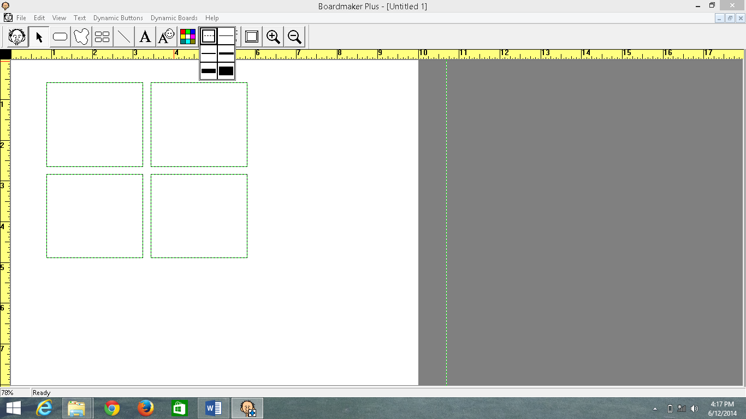
* Circles and curved boarders can be used to make tokens, other classroom posters, you can remove boarders all together by selecting the dash this is helpful when you want to cut materials on a cutting board in multiples rather than cutting one by one.

7. Changing to a PDF
Download Cutewriter PDF—it is a free download. Then go to file print, and print as cutepdf.
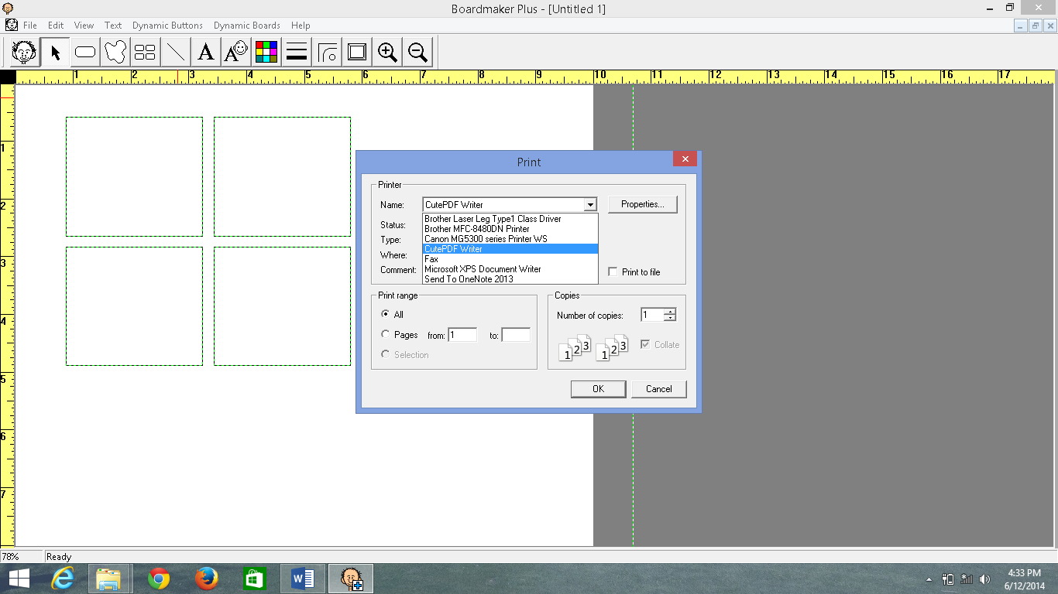

It will then have a screen that comes up that you need to select where you want to save (desktop, folder, etc).
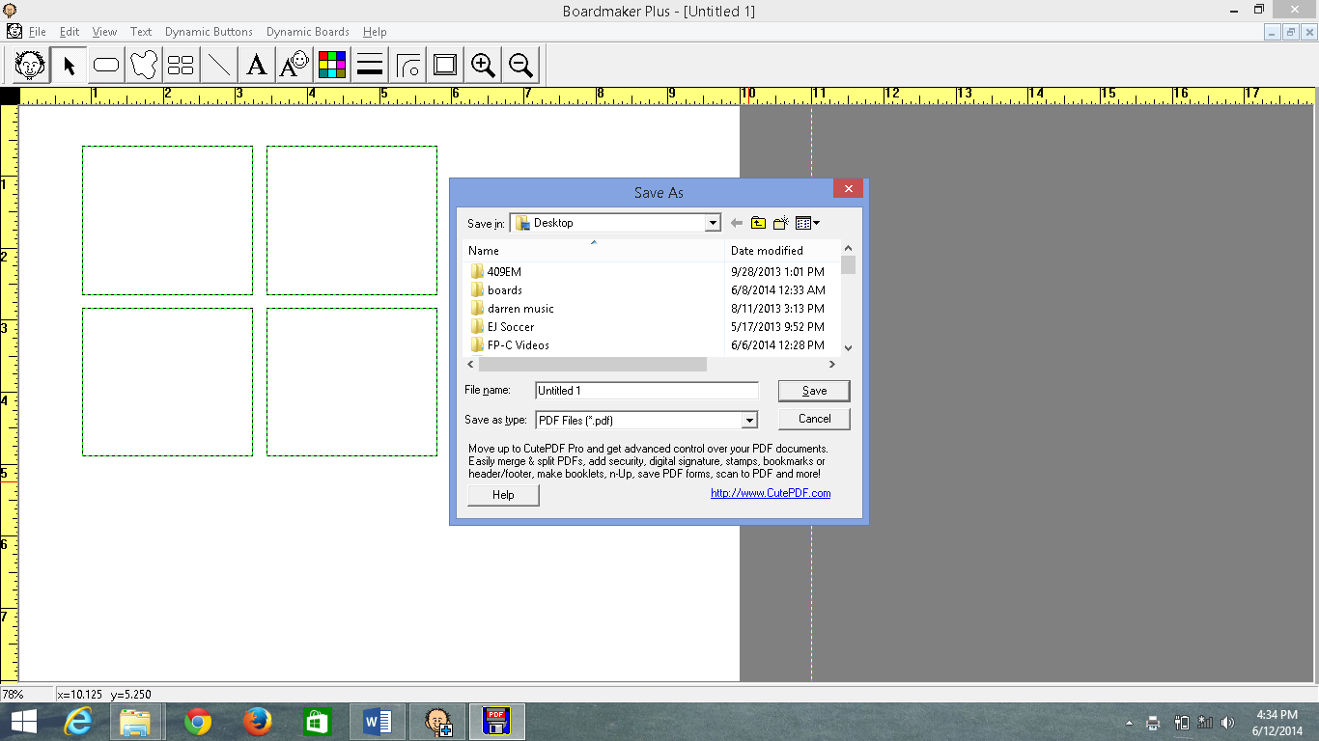
* Good for sharing a board with someone who doesn’t have Boardmaker.

3901 Rainbow Blvd. CCHD Building – Room 2017
Kansas City, Kansas 66160-2937
PH. (913) 588-5943· FAX (913) 588-5942

TASN Autism Supports and Tertiary Behavior Supports is funded through Part B funds administered by the Kansas State Department of Education's Special Education Services. TASN Autism Supports and Tertiary Behavior Supports does not discriminate on the basis of race, color, national origin, sex, disability, or age in its programs and activities. The following person has been designated to handle inquiries regarding the non-discrimination policies: Deputy Director, Keystone Learning Services, 500 E. Sunflower, Ozawkie, KS 66070, 785-876-2214.

