Issue 2
3/27/20

Self-Care for Educators Newsletter

Self-Care During the Coronavirus Outbreak

- Article: 6 Daily Questions to Ask Yourself in a Quarantine
- Resource: Practices to Address Educational Professionals’ Stress and Anxiety

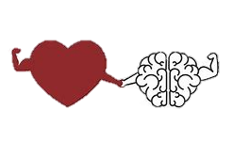
This Photo by Unknown Author is licensed under CC BY

Parenting During the Coronavirus Outbreak

- Article: Daily Schedule Advice for ADHD Families
- Resource: Printable Communication Supports

This Photo by Unknown Author is licensed under CC BY
Supporting Students During the Coronavirus Outbreak

- Article: Helping Children Cope with Stress During Covid Outbreak
- Resource: Choice Boards by Grade Level

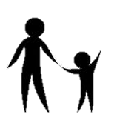

This Photo by Unknown Author is licensed under CC BY
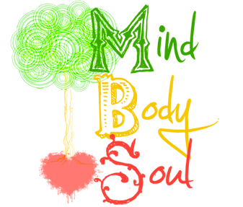

Feed your heart, your body, your mind, and your soul!

-Dr. Jane Nelsen and Dr. Kelly Gfroerer

This Photo by Unknown Author is licensed under CC BY

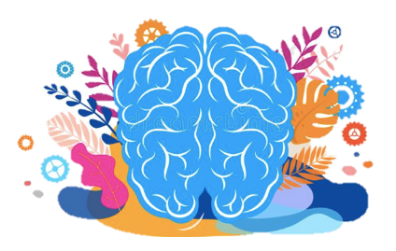
Strategies for the Mind
This Photo by Unknown Author is licensed under CC BY
Mindfulness
- Article: What are the Benefits of Mindfulness
- Resource: Just One Thing: Simple Practices

Breathing
- Article: Decrease Stress by Using Your Breath
- Resource: 10 Breathing Techniques

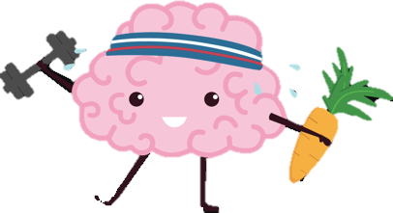
Strategies for the Body

Yoga
- Article: Yoga-The Benefits Beyond the Mat
- Resource: Cosmic Kids Yoga

This Photo by Unknown Author is licensed under CC BY
Nutrition
- Article: How to Eat Healthy
- Resource: Dietary Guidelines for Americans

Exercise
- Article: 10 Ways to Exercise as a Family
- Resource: Fitness Blender Free Videos

Sleep
- Article: Healthy Sleep Tips
- Resource: Apps to Improve Your Sleep

Strategies for the Soul

This Photo by Unknown Author is licensed under CC BY
Good for the Soul
- Article: 3 Ways to Rejuvenate Your Spirit
- Resource: 100 Ways to Nourish Your Mind, Body, Soul, and Spirit

Humor
- Article: Sustainable Self-Care for Funny Educator People
- Resource: 20-Second Parodies for Handwashing

Self-Care Spotlight

Recently we spoke with USD 475 middle school special education teacher, Molly Mosher, about the importance of self-care. Molly has been a special education teacher for six years and shares her life with her husband and two active children. In her free-time she enjoys living life to the fullest by watching everything her kids are involved in. Molly shares some self-care tips below:
Q: Describe what self-care means to you and how you balance the demands of your personal and school life:
- Self-care is not as simple as making sure that you have time to take a shower, shove some food in your mouth, and put on fairly clean clothes! It really is a much longer and more in-depth process. True self-care includes everyday things like eating and showering, but also includes planning for regular doctor/dentist appointments, spending time with people who matter the most, taking time to be by yourself, and even setting realistic goals for the future. Every year that I teach, the way that I balance my personal and teaching life changes. When my children were younger, I needed more time to be at home with them – but at that time they went to bed earlier so I had more down time to myself in the evenings to work. Now that they are older, I take advantage of staying at school when they have sports practices after school – and that time allows me to prep for the days that I have to leave immediately after school to attend their sporting events.

- Share some specific self-care strategies you utilize:
- Well, of course I get 8 hours of sleep each night, drink 64 ounces of water a day and work out for 30 minutes 5 days a week… no, not quite! On a good night (when my kids don’t have games or additional activities) I might get 6 hours of sleep, and a little melatonin helps me get that! I do constantly hydrate myself throughout the day, but it is with Diet Pepsi, and maybe one bottle of water. I have entered into a competition with myself for exercise. I am striving to close the rings on my Apple Watch every day- this ensures that I will have stood up enough, moved enough, and also will have gotten in at least thirty minutes of exercise. I have found that 30 minutes of exercise, if done right after school, allows me time to process through the things that were frustrating me or causing me stress while at school.

- How does humor factor into self-care? How about gratitude? Do you have specific practices you utilize to incorporate humor and gratitude into your life?
- It’s been said before – “if you don’t laugh about it, you will end up crying about it.” Although that might be drastic for all situations, it is true that it is always best to look for the positive in a situation or to laugh about the things that are ridiculous. This way of thinking is just more productive than looking for the negatives or the downside of a situation. I find that using social media (particularly Facebook – because I am too old to know how to use SnapChat or Instagram) helps me focus on humor and gratitude. When I see all the things that other teachers, or families, or even organizations like TASN are doing in the world I am able to tune into a sense of gratitude. Making sure to only use social media platforms for fun, happiness, and gratitude is important, though, because obviously it is possible to get caught up in a ring of negativity if it is not used correctly.

- Why is practicing self-care and having balance in your life necessary? Have you had experiences where you learned the "hard way" that you had to make changes in your life?
- Some of the “hard ways” that have forced me to balance my work and personal life have been fairly painful and/or expensive. The most recent is something that took place the week before spring break. My co-teacher had just begun her maternity leave and I was short para support, had two students who were exhibiting extreme behaviors, and my own children were starting spring sports practices that were scheduled around weather reports. A crown fell off one of my back molars and I literally put it in a zip-lock bag and into my purse – and there it still sits! I have yet to call for an appointment with a dentist (mostly now because of the coronavirus!) because I am always running. I obviously need to make it a priority to take care of my own health and teeth.

- What do you see as the benefits of practicing self-care- how does being a healthier YOU impact your family, your co-workers, your students, and their families?
- When I am the best Molly I can be my family, friends, students, co-workers, and even people just driving on the same roads experience a better life.

