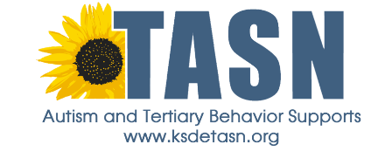

Observed Name: Observer Name: Date:

Steps of Implementation | Yes | No | N/A | Notes

Total Yes’ _________ divided by Total Possible _________ = ________% Treatment Fidelity

Positive Feedback | Corrective Feedback

Plan for Further Training to Meet Mastery Criteria of ___________%:
- Met mastery criteria and is ready to implement skill independently
- Next training date and time will be _______________________.

____________________________________ _____________________________________
Observed Signature/Date Observer Signature/Date
The contents of this (insert presentation, article, video, etc.) were developed under an agreement from the Federal Department of Education to the Kansas Department of Education. However, those contents do not necessarily represent the policy of the Department of Education, and you should not assume endorsement by the Kansas Department of Education or the Federal Government.
TASN Autism and Tertiary Behavior Supports is funded through Part B funds administered by the Kansas State Department of Education's Special Education and Title Services. TASN Autism and Tertiary Behavior Supports does not discriminate on the basis of race, color, national origin, sex, disability, or age in its programs and activities. The following person has been designated to handle inquiries regarding the nondiscrimination policies: Deputy Director, Keystone Learning Services, 500 E. Sunflower, Ozawkie KS 66070, 785.876.2214

