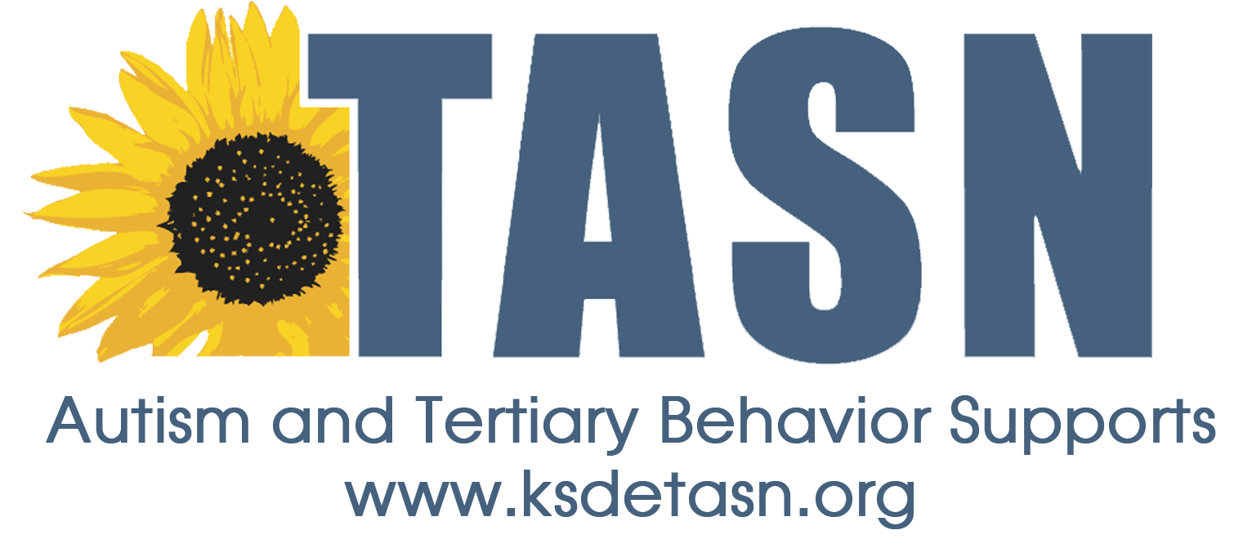

Transition to Adult Services and Accessing Community Supports

Transition Teaming Strategies

Data Based Decision Making

- Data Based Decision Making:

“Systematic, data-based decision making helps schools implement the most effective practices and instructional strategies.” (Noonan, 92)
  - Identify sources of transition-related data.
  - Decide what data your team should investigate.
  - Determine how data is related to transition education or services.
  - Distribute data to all team members.
  - Share ideas and discuss strategies based on the data that has been collected.

Collaboration

- Collaborate with the Community:

“Sharing information helps build a common vocabulary, provides an understanding of current practices, and gives individuals an opportunity to see the linkages between your work and theirs.” (Noonan, 22)
  - Communicate the focus of your work clearly and effectively.
  - Share information and request support through school and community resources such as school newsletters and local newspapers.
  - Present to and engage community organizations.

- Communicate Information About Transition to Families:

“Just as there are many different ways to educate students about community supports, there are many different ways to reach their families. (Noonan, 25)
  - Transition fairs
  - Conferences
  - Field trips
  - Agency-sponsored family trainings
  - Workshops for families and agencies
  - Host a monthly / quarterly parent meeting
  - Disseminate information to families
  - Utilize transition resource directories
  - Facilitate meetings between agencies, families, and students
  - Share information on adult service agencies, employment, and post-secondary education to students and families
  - Incorporate information into student’s classes
  - Host agency presentations
  - Arrange for experiences in the community

Building & District Supports

- Gain an Understanding of How Co-Workers Jobs are Related to Transition:

“To effectively collaborate with other organizations, you must first understand the strengths and limitations of your own organization and begin developing a collaborative environment.” (Noonan, 10)
  - Interview school personnel
    - Discuss:
      - Inclusion
      - Family involvement
      - Collaboration between general and special education
      - Transition planning

- Communicate and Coordinate Information About Transition to Co-Workers:

“Although educators share a common vision of supporting students to become ready for life after high school, working in isolation hinders the transition process.” (Noonan, 20)
- Present to and engage co-workers
- Provide information in a communal space
- Share new ideas with co-workers
- Invite the contributions of co-workers and capitalize on their areas of expertise

- Gain Administrator Buy In:

“Gaining support of school leadership is key to expanding interagency collaboration.”
  - Administrators allocate time and resources to support goals and student outcomes such as:
    - Academic achievement
    - Increasing graduation rates
    - Decreasing dropout rates
    - Improving community perceptions of the school
  - Stress how transition efforts can support the goals of your building and district

College & Career Readiness

- Assess Your School’s College and Career Readiness Practices:

“Career readiness comprises the aptitudes knowledge, and experiences that enable students to be successful in entry-level employment that allows for advancement.” (Noonan, 33)

“We define college readiness as the aptitudes, knowledge, and experiences that enable students to be successful in college or training programs.” (Noonan, 33)
- Know and access the Indicators of College and Career Readiness Survey (Gaumer Erickson & Noonan, 2013)
- Identify school assessment practices that support transition
- Know, understand, and teach the state social emotional learning standards
- Explicitly teach social competencies, social skills, and emotional regulation

Community Supports & Services

- Increase Awareness and Knowledge of Adult Agency Services:

“Research shows that effective transition activities are implemented by teachers who believe they are well prepared; developing a level of comfort with these services will help you feel empowered to provide improved transition services for your students.” (Noonan, 12)
  - Develop, access, or expand a list of community resources
  - Join community organizations

- Coordinate with Agency Representatives to Provide Transition Services:

“In order to have successful interagency collaboration, you must work with adult service providers to build trusting relationships.” (Noonan, 36)
  - Develop awareness of agency’s needs, limitations, and resources
  - Remain positive about collaboration
  - Understand the agencies mission and priorities
  - Connect students and families to community agencies

Professional Development

- Participate in Professional Development Related to Transition:

“It’s helpful to continue to expand your own knowledge and explore practices that have been effective in other communities.” (Noonan, 40)
  - Attend regional or state conferences
  - Join national organizations and attend national conferences
  - Subscribe to professional journals or newsletters

- Participate in Professional Development Sponsored by Community Agencies:

“Learning together with the local-level providers in organizations can help you understand their systems, priorities, and vocabulary.”
  - Attend training provided by community entities
  - Develop relationships with local community agencies and reach out with questions

Noonan, P. Transition Teaming: 26 Strategies for Interagency Collaboration. Arlington: Council for Exceptional Students, 2014.

