MONTHLY TEACHER RESOURCES
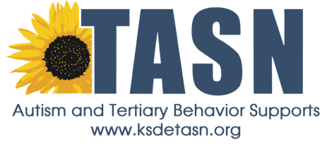
January 2015
Inclusion: Supporting Students in the General Education Classroom
By: Karine Gleason, Secondary Coordinator
------------------------------------------------------------------------------------------------------------

Inclusion is not just about placing an individual into a general education classroom. For inclusion to be successful, proper planning, preparation, and supports must be put into place. Skills (e.g., academic, social, communication, vocational, etc.) can be taught within the context of standard-based instruction when modifications to the curriculum are made. Research suggests that, “students with disabilities in inclusive classrooms show academic gains in a number of areas, including improved performance on standardized tests, mastery of IEP goals, grades, on-task behavior and motivation to learn” (National Center for Education Restructuring and Inclusion, 1995). Instead of thinking that it is necessary to get the individual ready for the regular classroom, we should be thinking about what is needed to get the regular classroom ready for the individual.
.... When inclusive education is fully embraced, we abandon the idea that children have to become "normal" in order to contribute to the world.... We begin to look beyond typical ways of becoming valued members of the community, and in doing so, begin to realize the achievable goal of providing all children with an authentic sense of belonging. (Kunc 1992)
This month we are sharing ideas for strategies that can be used to support students in the general education classroom.
- Work systems are a systematic means of organizing and presenting information. Using work systems allow the student to function independently across settings by visually answering four key questions: How much work?; What work?; When is the task finished?; What comes next?
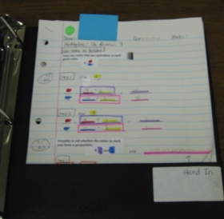
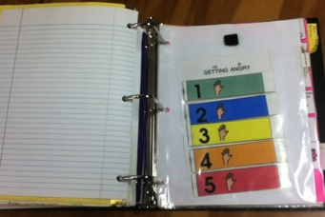
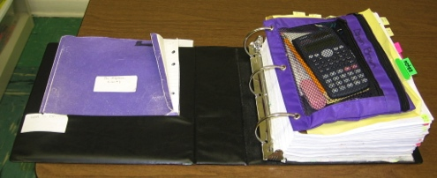
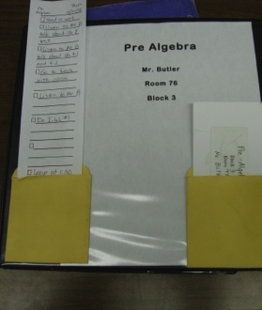
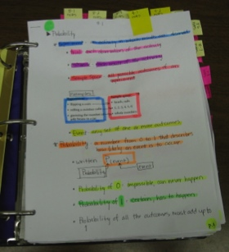

- The first example is a binder work system used for a variety of middle and high school students. The front of the binder includes class information, a pocket containing a schedule checklist for the class activities, and a pocket to place the card from the daily schedule. The inside of the binder includes a pocket labeled “Work to Do” which contains folders with the
modified class assignments, a pencil pouch with items needed specifically for that class, visual notes created to correspond to the assignments, visual strategies such as 5-Point Scales, social narratives, reward systems, etc., and a “Hand In” or “Finished” pocket in the back. Click the link http://kansasasd.com/webinararchive.php?aid=163 and use the password jan15 to view a student using a binder work system.

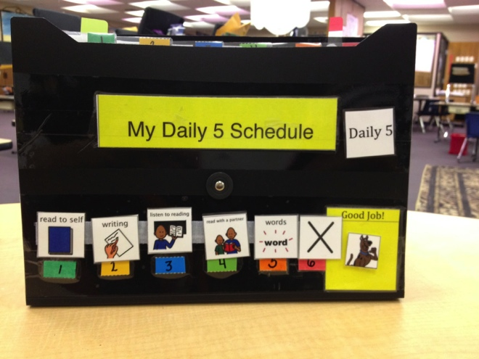
- Carla Schartz, a second grade teacher in Derby, created this folder work system. The schedule for Language Arts Daily Five is attached to the front of the folder using Velcro. A reward token is also included on the front. The student earns the token as soon as all the schedule icons are gone. The colored numbers on the schedule corresponds to the colored numbers on the tabs of the folder to show the student the order of the activities. The student pulls the icon off the schedule, places it next to the numbered tab, and completes the activity found in the pocket. All the materials needed for each activity are placed in the appropriate pockets.
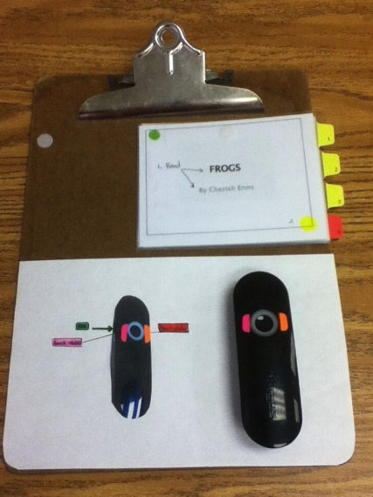
- Work systems can also be developed to assist students in participating in class projects. This work system assisted a student when sharing a PowerPoint presentation she created with her class. The system was created using a clipboard so the student could easily manipulate the materials. A booklet was created that included a snapshot of the presentation slides and cues for what to say and when to turn the page. Tabs were used to make it easier to turn each page and color-coded so the student had a clear understanding of when she would be finished. The remote was also color-coded and placed next to a visual that clarified the parts of the remote. The remote was attached to the system using Velcro. Click the link http://kansasasd.com/webinararchive.php?aid=162 and use the password jan15 to view the student using the work system.

- Curriculum modification “has been an effective way to create more accessible learning
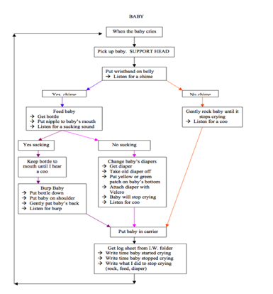
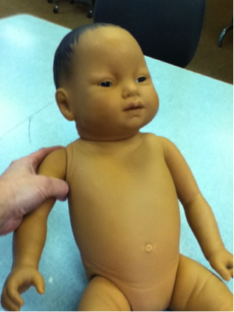
environments to support all students and their teachers in various educational contexts.” (Koga & Hall, 2009). In order to modify the general education curriculum and make it accessible to students with varying needs, visual structure must be added to each task or assignment using visual instruction, visual organization, and visual clarity.

- In this example, a student in a high school Family and Consumer Science Class (FACS) participated in the “Baby Think It Over “ project. The student was required to take home an infant simulator doll and care for it overnight. Written instructions for the care of the doll were organized in a flowchart format. The materials needed to care for the baby were then color-coded to correspond to the color-coding on the flowchart. For example, the pink arrows on the flowchart showing the steps necessary for changing a diaper corresponded to the pink tag on the diaper. This added visual clarity to help the student focus on the important details.
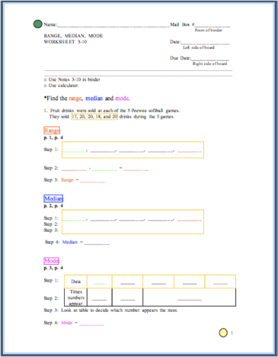
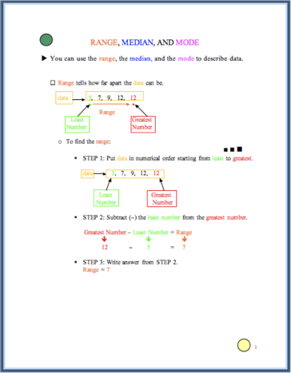
- This example shows how a math assignment was modified. Visual instructions in the form of notes were created to teach the steps required to complete the problems. The steps were separated and bulleted to visually organize the work. Color-coding the worksheet to correspond to the notes and including page numbers that indicated where the information could be found in the notes added visual clarity.

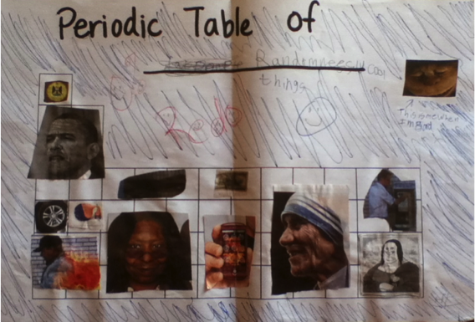
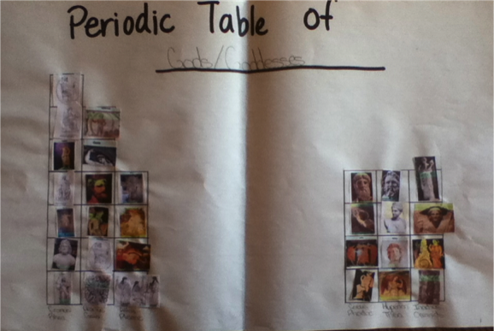
- Students in a Chemistry class were required to create their own periodic table using a theme of their choice. Not only was it difficult for this student to organize his thoughts, it was difficult for him to choose a theme. Again, visual instructions organized in the form of a written checklist were provided. Choices, using the student’s interests, were given to assist in making choices. A color-coded template was provided to assist the student with organizing his thoughts and creating his own periodic table. Check out the student’s “before” and “after” pictures that clearly show how adding visual structure can help the student reach his potential.
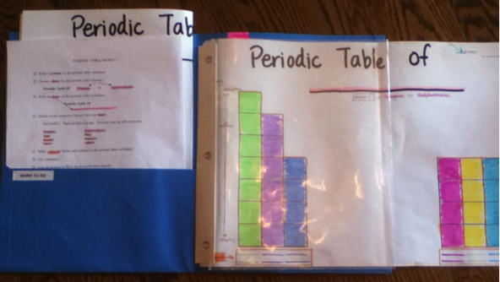

Before
After

TASN Autism and Tertiary Behavior Supports is funded through Part B funds administered by the Kansas State Department of Education's Early Childhood, Special Education and Title Services. TASN Autism and Tertiary Behavior Supports does not discriminate on the basis of race, color, national origin, sex, disability, or age in its programs and activities. The following person has been designated to handle inquiries regarding the non-discrimination policies: Deputy Director, Keystone Learning Services, 500 E. Sunflower, Ozawkie, KS 66070, 785-876-2214.

