

Issue 1

Self-Care for Educators Newsletter

Self-Care During the Coronavirus Outbreak

* Article: [How to Work with Your Mind to Stay Calm During this Pandemic](https://thebestbrainpossible.com/anxiety-mental-health-coronavirus/)
* Resource: [15 Ways to Practice Self-Care in the Time of Coronavirus](https://qz.com/1818622/how-to-practice-self-care-during-coronavirus/)

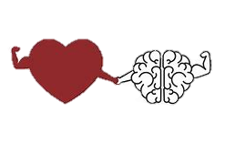

[This Photo](https://owl.excelsior.edu/writing-process/introductions-and-conclusions/) by Unknown Author is licensed under [CC BY](https://creativecommons.org/licenses/by/3.0/)



Parenting During the Coronavirus Outbreak

* Article: [How to Keep Your Routine with Kids at Home](https://redtri.com/how-to-keep-your-routine-with-the-kids-at-home/slide/1)
* Resource: [Free Resources for Students to Practice at Home](https://autismclassroomresources.com/free-resources-for-home-practice/)

[This Photo](https://owl.excelsior.edu/writing-process/introductions-and-conclusions/) by Unknown Author is licensed under [CC BY](https://creativecommons.org/licenses/by/3.0/)

Supporting Students During the Coronavirus Outbreak

* Article: [Talking with Children: Tips for Caregivers, Parents, and Teachers](https://store.samhsa.gov/system/files/pep20-01-01-006_508_0.pdf)
* Resource: [Social Stories from Breezy Special Ed](https://www.teacherspayteachers.com/Product/FREE-Coronavirus-COVID-19-Social-Story-5319239)



[This Photo](https://owl.excelsior.edu/writing-process/introductions-and-conclusions/) by Unknown Author is licensed under [CC BY](https://creativecommons.org/licenses/by/3.0/)

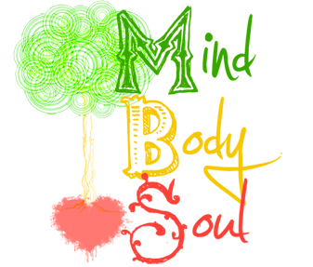

Feed your heart, your body, your mind, and your soul!

[-Dr. Jane Nelsen and Dr. Kelly Gfroerer](https://www.positivediscipline.com/articles/self-care-teachers)

[This Photo](https://owl.excelsior.edu/writing-process/introductions-and-conclusions/) by Unknown Author is licensed under [CC BY](https://creativecommons.org/licenses/by/3.0/)





Strategies for the Mind

[This Photo](https://owl.excelsior.edu/writing-process/introductions-and-conclusions/) by Unknown Author is licensed under [CC BY](https://creativecommons.org/licenses/by/3.0/)

Mindfulness

* Article: [How to Keep the Greater Good in Mind During the Coronavirus Outbreak](https://greatergood.berkeley.edu/article/item/how_to_keep_the_greater_good_in_mind_during_the_coronavirus_outbreak)
* Resource: [Overcoming Anxious Thoughts](http://yourskillfulmeans.com/knowledgebase/overcoming-anxious-thoughts/)

Breathing

* Article: [Why Breathing Exercises Help](https://www.lung.org/lung-health-and-diseases/protecting-your-lungs/breathing-exercises.html)
* Resource: [6 Breathing Techniques that Calm Your Brain and Body Instantly](https://thebestbrainpossible.com/breathing-stress-brain-calm/)

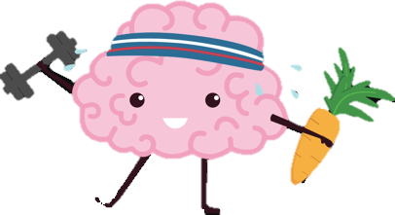

Strategies for the Body

Yoga

* Article: [The Benefits of Yoga](https://osteopathic.org/what-is-osteopathic-medicine/benefits-of-yoga/)
* Resource: [Do Yoga with Me](https://www.doyogawithme.com/)

[This Photo](https://owl.excelsior.edu/writing-process/introductions-and-conclusions/) by Unknown Author is licensed under [CC BY](https://creativecommons.org/licenses/by/3.0/)

Nutrition

* Article: [Importance of Good Nutrition](https://www.hhs.gov/fitness/eat-healthy/importance-of-good-nutrition/index.html)
* Resource: [How to Keep Your Immune System Healthy](https://www.eatright.org/health/wellness/preventing-illness/how-to-keep-your-immune-system-healthy)

Exercise

* Article: [Importance of Physical Activity](https://www.hhs.gov/fitness/be-active/importance-of-physical-activity/index.html)
* Resource: [30 Workouts Under 30 Minutes](https://www.buzzfeed.com/carolynkylstra/free-workout-videos)

Sleep

* Article: [Teacher’s Guide to Sleep-And Why it Matters](https://www.theguardian.com/teacher-network/teacher-blog/2014/nov/11/good-night-teacher-guide-sleep)
* Resource: [Improve Your Sleep Practices](https://insighttimer.com/meditation-topics/sleep)

Strategies for the Soul



[This Photo](https://owl.excelsior.edu/writing-process/introductions-and-conclusions/) by Unknown Author is licensed under [CC BY](https://creativecommons.org/licenses/by/3.0/)

Good for the Soul

* Article: [7 Ways to Soothe the Soul and Refresh Your Spirit](https://youqueen.com/life/7-ways-to-soothe-your-soul-and-refresh-your-spirit/)
* Resource: [30 Lyrics that are Good for the Soul](https://thoughtcatalog.com/madison-boston/2014/06/30-lyrics-that-are-good-for-the-soul/)

Humor

* Article: [Why having a Good Sense of Humor is Essential in Life](https://bigthink.com/personal-growth/humor-life-skill)
* Resource: [Laughter {A Fun and Easy Self-Care Strategy}](http://www.socialworkcommunity.com/2017/03/laughter-fun-easy-self-care-strategy/)