Part 4

Student Supports
Table of Contents
Social Supports 2
Social Narrative Example 3
Power Card Examples 4

Social Supports

Why use supports such as Social Narratives or Power Cards?

Social Narratives have been established as an evidence-based practice for students with autism by the National Professional Development Center (NPDC) and are one of the easiest, most versatile supports teachers or families can create for children with Autism Spectrum Disorders. This packet contains some examples of these types of supports, and it’s important to note that they are simply examples.

These types of supports need to be individualized to each student’s specific abilities and learning needs. Some benefits of using these types of social supports include:

- They are easy to create.
- They are easy to individualize.
- They are easy to implement.
- They provide information on social situations and social cues.
- They provide strategies on how to respond appropriately to specific social situations.
- They can be used in academic or nonacademic settings.
- They can be made with apps, software, symbols, real photos, words, and more.

For more information on these types of social supports, the National Professional Development Center has an excellent module that contains an overview, step-by-step directions on how to create a social narrative, research, and directions on how to implement using a social narrative. Go to http://autismpdc.fpg.unc.edu then click on “Evidence-Based Practices” and scroll down to “Social Narratives”.

Social Narrative Example

Going Back to School
On Wednesday, August 24, I will be going back to school at Lincoln School.
Here is my school:
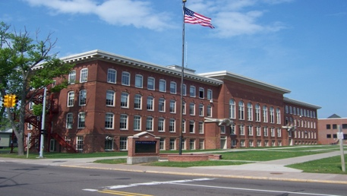
I may be both nervous and excited about going back to school. This is normal. Many kids feel nervous and excited about going back to school.

This year I will have a new teacher. Her name is Mrs. Holt. I will meet her at school. Here is a picture of Mrs. Holt:
I will also have other new teachers. Their names are Mrs. Miller, Mrs. Lawrence, Mr. Wagner, and Mr. Greene. I will meet them at school, too.

I will have a new classroom. Here is a picture of my new classroom:
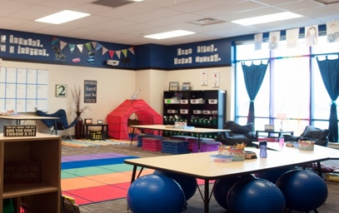
If I start to feel nervous about school, I can talk to my mom or dad. I can look at pictures of my classroom and school. I can even go visit the school. It is okay to be nervous. When I go to school, I will make new friends. I will meet other kids who are in 4th grade like me.

Going to school might be scary, but it will be okay. I will go to the school before school starts to look at the school and meet my teachers. I can talk to my mom or dad when I start to feel nervous about school. Going to 4th grade will be fun. II will have a great time in 4th grade!

Power Card Examples

