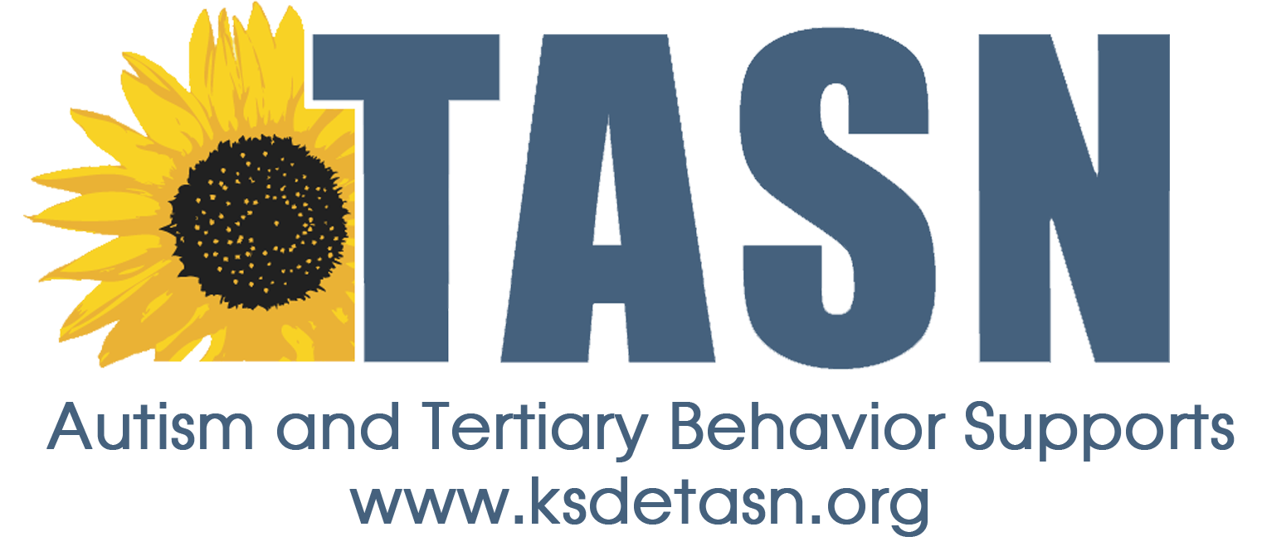
TASN ATBS SCHOOL MENTAL HEALTH INITIATIVE
WEBINAR STUDY QUESTION FORM

Webinar Title: Minding Your P’s and Q’s: Mindfulness in Education
Presenter: Kelly McCauley, LSCSW
Webinar Date: May 2, 2017, 45 minutes

To earn a Certificate of Attendance complete and submit the Webinar Study Question Form to JENNIFER HOUSER (jenh@tasnatbs.org ).

1. Name:
2. Email Address:
3. School District:
4. Role (Teacher, para, SLP, etc.):

Study Questions:
- The goal of mindfulness is to achieve perfection in attuning to the here and now, moment by moment with a sense of curiosity and non-judgment

T or False?

- Please circle all that apply, mindfulness has been shown to:
  - improve student attendance
  - lower need for exclusionary discipline such as suspensions or expulsions
  - improve academic performance
  - improve school climate by lowering feelings of hostility and increasing feelings of compassion.

